♫

*The American Tour *

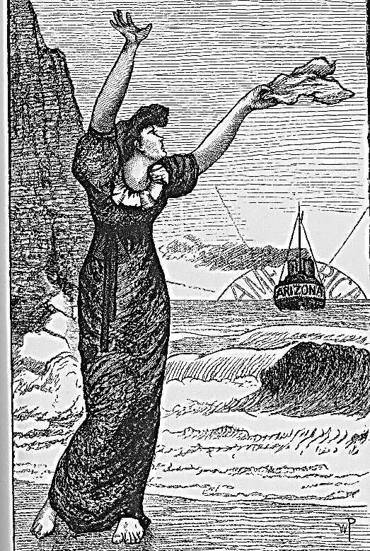

(1882)

Table of Contents

Prologue:
London Debut

The American Tour
I. Declaring my Genius
II. Meeting Walt Whitman
III. Introducing the Lecturer
IV. East and West
V. Coda: Back in London

Epilogue:
The Critic as Artist as Cowboy
The American Byron:
Hommage à Joaquin Miller

Prologue
London Debut
[1879-1881, a brash young ‘Professor of Aesthetics’]
1. .
Whither, goddess Career? I clutch
♫
The hem of the Pre-Raphaelites.
Rossetti and Morris are the lights
That guide me. I have the light touch.
I am the man Fate singled out
To lay down lilies for a Lillie, Langtry.
Man-about-town down Piccadilly
Walking, Him the town talks about.

(There goes that bloody fool, that blithe
Young idiot, Oscar Wilde! No harm. Words overheard whilst walking down
No harm. Why, I could even charm Oxford Street… I am getting known in this city.
Death to lay down his rusty scythe. )
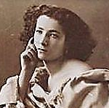
Armfuls of lilies do I bring
For Sarah Bernhardt the Divine,
The eternal Phèdre! and in fine
Bad verses I her praises sing.

(I filch her golden voice, of course,
Add it to my ensemble. Sir
Or madam, hypocrite Lecteur,
How much of what you are is yours?) I write a sonnet extolling Ellen’s performance
as Henrietta Maria in King Charles, written
And Ellen Terry to a wan by my cousin William Gorman Wills.
Lily I liken in her scene
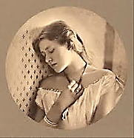
In the lone tent, a noble Queen
True to her doomed King and her man.

To this great artist, kindest, most
Gifted of actresses to grace
Our stage, I often raised (and raise
Again, with ghostly hand) a toast.
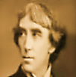
As for her partner, Henry Irving
(Her lover, as well): whom do I more
Admire? Ah, how his dark eyes bore
Into you! It is quite unnerving.)

2.
As London goes, so goes the nation…
I circulate from street to street
My epigram cartes de visite,
Polished express for circulation.

(Du Maurier’s using me as model
For his Punch caricature, Maudle,
Who sprawls on couches talking twaddle
With a chin that has grown a wattle.
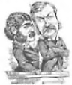
Svengali of pretentious nescience,
A tissue of pose and adipose?
I’m hardly fat—not yet! Who knows
Where he gets such disturbing prescience?)

In spite, because of such hilarity,
I’m famous, if for nothing else
Than being famous, which foretells,
Perhaps, my fate among Posterity.

3.
As fashion-god I set up shop, An authority, on women’s fashion, the other arts
Godsend indeed to D’Oyly Carte having been spoken for by sundry Pre-Raphaelites.
Who chooses me to puff the part
Of Bunthorne, the aesthetic fop,

Promoting Patience to our cousins
Across the sea. Publicity!
I know an opportunity
When it waves bank-notes by the dozens.

For it seems Sullivan has set me
To music, whilst Gilbert has made me
A clown. It’s time that someone paid me!
(They mock, but will not soon forget me.)

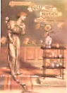
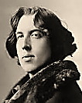
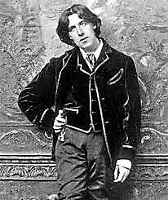
I. Declaring my Genius
♫

1.
Hey, Bob, look, isn’t that the Grand
Apostle of Art, you know, that silly
Guy in the opera, with the lily
In his, what, ‘mediaeval hand’?

A genius of my own anointing,
I reach New York. They gather round,
The press; and claim I said I found
The Atlantic Ocean ‘disappointing’—

Fulfilling their own expectations.
If ‘nothing is, but all things seem,’ Shelley, ‘The Sensitive Plant’.
Then be an interesting theme; —[Mr V]
Let others play the variations.

Fashion advice and compliments
Enchant the ladies. In knee-breeches
I venture into the far reaches
Of the too-utterly intense.

Now come detractors, fans, and followers
And every Barnum-and-Bailey gawker
♫
Who’d just as soon spectate a talker
As bearded ladies and sword-swallowers.

Calliope, your day has passed.
Descend to play the calliope
And lend this circus epic scope
With your train-whistles’ mighty blast!

2.
Tall at the centre of the whirl
Of agents, secretaries, admirers
And the idiot-questioning inquirers
From the Press, tossing them a pearl

Or two of comment, like spare change,
Crumpling a love-note, signed one ‘Hortense’,
I am a man of some importance—
But it all seems a little strange.

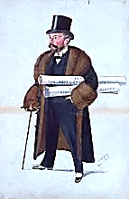
3. Risking the Wrath of Canada

For the first time in my young life
I am arrested! Well, a writ
Is issued for some breach: to wit,
Of contract. (Ah, the petty strife

Of commerce wears one down!) The great
Y.M.C.A. of Moncton say
I have ‘stood them up’. A check will pay D’Oyly Carte.
Away the looming legal threat.

4. An Apparition

Once in Nebraska I was taken
To see a prison. The men seemed
A ghost-crew Coleridge might have dreamed,
Dressed in their hideous striped garb. Shaken
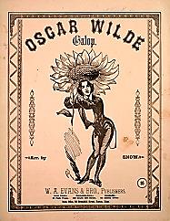
A little, I looked into a cell
And saw a Divine Comedy
Upon the table. Suddenly,
As if by some fantastic spell,

From the book rose an apparition .
Saying, You will read my works in Hell!
I knew that face, I knew it well:
Dante had damned me to Perdition.

Did it happen? Why should I doubt it?
I quickly hid my consternation,
Joined my companions’ conversation
And never spoke a word about it.

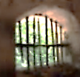
II. North and South
The old poet recalls the encounter,
which took place at his home in

1. Meeting Walt Whitman Camden, New Jersey.

You honored me with your pilgrimage,
For you were of the poets’ guild.
I understood your need to build
A profile and a public image.

I largely talked about myself,
Mused on the horrors of the War,
Showed you my house—were they a bore,
Those odd mementoes from the shelf?

You asked my ‘prosody’. ‘I write
Till I run out of margin, then
Drop down a line and start again’. That is, a type-setter’s prosody!
It made a man like you take fright,

This ‘method,’ but you didn’t dare
Grimace, or find the slightest fault
With kindly, venerable Walt.
Dandy and prophet—what a pair!

Before we parted I took down
A bottle of elderberry wine,
Reserved for special friends of mine;
That’s how familiar we had grown.

We drank our fill—no dainty sips!
But at the door, young camerado,
I think it pierced your fine bravado
When old Walt kissed you on the lips.

2. Charleston, South Carolina
After dinner in a stately mansion.
The scars of war are slow in healing.
My charming hostess has no doubt
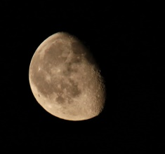
That my remark, when looking out
The window, must be full of feeling:
♫

How lovely is the moon! I sigh.
(Well, I suppose I rather mean it.)
Ah, Mr. Wilde, you should have seen it
Before the war! is her reply.

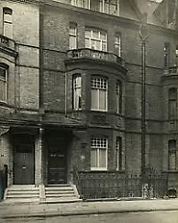
III. Introducing the Lecturer

Tonight I relive in delirium a moment from the lecture in Baltimore that I never gave. The theatre
manager, who with his high forehead, moustache, pallid complexion and melancholy eyes bears
an unsettling and slightly macabre resemblance to the long-dead Edgar Allan Poe, takes it upon
himself to offer some introductory remarks. A strange fugue state comes over me as I listen, and
the words he speaks become uncanny, and darkly prophetic, and directed at me… I believe it is
actually Hermes in a droll and somewhat malicious disguise who puts on this scene for me.

The House Beautiful.
1.
Ladies and gentlemen, the man
I am about to introduce
To you tonight puts out of use
Pat definitions. For how can

The truth be said of Oscar Wilde
When its own contradictory
Is also true? A mystery
Of opposites unreconciled

Is our young yet distinguished guest,
Whose soul is a House Beautiful
With such dark rooms and questionable
Corners… One makes one’s way as best

One can among the paradoxes
Of such a complicated man
Some think an insolent charlatan,
With his hairdressers and hat-boxes,

Others a genius, a sincere
Apostle of the improving arts;
A man of parts, of many parts—
And he will play them all, this queer,

Ungainly fashion-oracle,
This salesman for an operetta,
This walking Punch cartoon, this meta-
Physician of the Beautiful!

(At least a psychical observer
Foresees strange moods and attitudes
And most bizarre vicissitudes
For this ‘ass-thete’ whose languid fervor An unflattering coinage applied to me in a Chicago newspaper.

On its behalf touches us all, The New York Tribune gossip
Ever-so-lightly.) How define reported this squib: ‘Who was the
Such an excessive man? What line first aesthete?’ ‘Balaam’s ass, for
Does he not cross, this one they’ll call the Lord made him to(o) utter’.

The talk and talker of his nation,
The wittiest of raconteurs,
The most pretentious of poseurs,
A study in Degeneration, The title of a study of abnormal
psychology by Max Nordau, in
A husband and a family man, which, of course, I figure largely.
A gentleman, an Oxford scholar,
A hotel-haunter, rough-trade trawler,
Prospero, Ariel, Caliban?

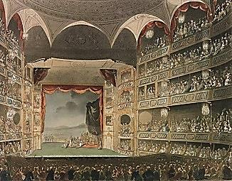
7
Mayfly of Mayfair. Master of
The West End Revels. A late-riser,
A literary theorizer.
A Lord of Language, Fool of Love.

A throw-back Irish bard, a prophet,
A captivating storyteller
Captured, then a jail-bird best-seller.
A sell-out whom true artists scoff at.

A plagiarizer like no fellow
‘I learn, by the way, that in America he may…
be criminally prosecuted, incarcerated, and
made to pick oakum, as he has hitherto picked
brains—and pockets!’—James McNeill Whistler
Before him, with cheek one admires
So much one calls his gas-lamp fires
Promethean, though the flame is yellow.

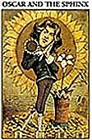
The most Augustan of Romantics,
Most decadent of Classicists,
A clown-god from the Celtic mists
Puzzling us with his subtle antics.

A Greek god cast among the Ostro-
Goths, too-too-utterly intense
Hierophant of the Decadence—
A cultivated Cagliostro,

Carlyle might say; poet, or rhymer, What would he have thought of the fact
A dedicated Hellenist, that I inherited his writing desk—and
A masochistic hedonist that it ended on the auction block?
And most rebellious social climber;

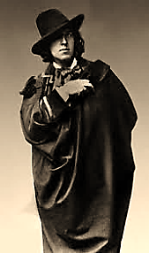
Agnostic, though with leanings Roman;
A socialistic snob, a fond
Connoisseur of the demimonde;
An intellectual; a showman.

He’s Bunthorne, or is thought to be.
Postlethwaite, to du Maurier. ‘Apostlethwaite,’ as another
Lord Henry, Basil, Dorian Gray. American journalist put it.
To Reading’s Governor, C.3.3.

Ah, who is he, essentially,
Whom Fate put such a lovely curse on?
Can there be said to be a person
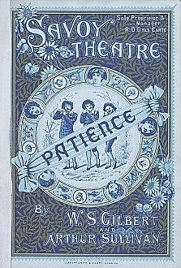
Behind the personality?

Or are we looking for the man
When we should really seek the boy
Who plays with danger like a toy
And quite confuses want with can?

There dawns on us the curious sense
That that which seems a self may be
A repertoire of selves that he
Puts on and off; where the pose ends

And the reality commences
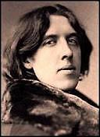
Is anybody’s guess. Who knows
What strange repose he finds in pose
And the avid turmoil of the senses?

2.
What makes him, then, so negatively
Capable of himself, his selves,
That like Shakespeare’s midsummer elves
Trip through his soul so ghostly-lively?

(He carries in himself the cast
Of a lost Shakespeare drama, tragic
And witty, full of myth and magic,
Bad lines unblotted, thick-and-fast

Plot complications, arch asides,
Stagy soliloquies with mixed
Motives and metaphors, unfixed
Meanings and morals, and those tides

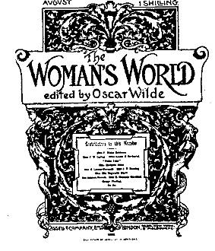
Of fortune washing in or out
To sea heroes and villains, Lear’s
Madness and Richard’s guilty fears,
Paulina’s faith and Hamlet’s doubt…

(In thinking’s inmost, silent sessions
He still performs before a mirror,
As if there were an overhearer,
A play of infinite regressions.))

3. Hermes charts my future, begin-
He goes to Paris, and returns ning with my trip to Paris soon
Resplendent in Neronian curls. after my return from America.
His wit darkens. He dips his pearls
In poisoned wine, and now he burns

With a more gem-like flame, and harder:
A youth has introduced him to Robbie Ross, Nov 1887.
The Love Uranian. With a true
Artist’s indifference and ardour
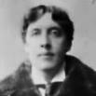
He holds an emerald to his eye
That dyes the tragic human scene
An interesting shade of green:
A glaucous sea-change. Now, to die

Seems more than ever to be rich
And strange, for Beauty, anodyne,
Weaves Death into its rare design
So curiously, he knows not which
‘Prison has had an admirable effect on Mr. Wilfrid Blunt as a poet’. From m review of his In Vinculis, Pall Mall Gazette, 1889.
Is realer, Life-in-Death or Death-
In-Life, when Eros, with a brain
For a heart, draws the sword of Pain
And Pleasure from its jeweled sheath.

He edits, for a while, a High
Society woman’s magazine,
Becoming of the fashion scene
Arbiter elegantiae.

Successful playwright then, he enters
A subtly undiscriminating
New Period: swaggering, dissipating
His eloquence on Cockney renters,

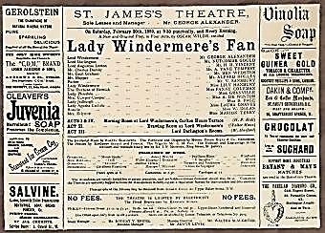
He makes himself, at last, a slave
To appetite. Then falls the ban,
And many think him but a man
Who would not, could not quite behave.

Oscar, the brightest of the bright. A dancing chorus
Oscar, the picker of the tar. performs this stanza.
Oscar, the rising, falling star.
Oscar, the posing so(m)domite.

Even his friends admit he’s given
To fibbing. ‘Not honest,’ is Shaw’s
Opinion—one with moral flaws
That win no Firsts with God in Heaven.

(But when said Shaw goes on a mission
To save a group of anarchists, Those charged and convicted in connection
One colleague only he enlists: with the Chicago Haymarket Riot of 1886.
Oscar alone signs the petition.)

‘A tenth-rate cad,’ says Henry James,
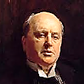
Sophisticated Innocent
Abroad… This Oscar never meant
A word he said, played frivolous games

With loved ones’ hearts and destinies,
Showed carelessness more cruel than malice,
Installed a brothel in the Palace
Of Art, made Beauty a disease.

4.
It dulls and narrows him, the pressure
Of lust; he riots, concentrated
On evil, with soul consecrated
To the pursuit of its own pleasure,

Ruat caelum… And fall it does,
The sky, and walls close in on one
So hungry for rebellion
And for acceptance that he was,

Finally, the victim of his own
Paradoxes; they paralyzed
And at the same time galvanized
The will that raised and brought him down,

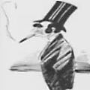
Leaving him with the shabby bliss
Of freedom to chase after street
Arabs—completed in defeat.
How to make sense of one who is

The genius that he pretends
To be, and yet pretends to be . The Screaming Scarlet Marquis, as
The genius that he is? Is he, limned by the pencil of Max Beerbohm.
Then, in an almost mystic sense,

The Ontological Sublime,
An irreducible, a surd,
Anomalous as purple, a word
For which the language has no rhyme?

5.
My friends, one of Style’s epic heroes,
The prophet of the Momentary,
Worshipper of a fritillary
And Magus of forbidden Eros—

A man of perfect verbal pitch, An Ideal Husband?
Musician of the word, the boast
Of his dear mother and the toast
Of every gathering to which

He manages to cadge an entry,
The darling and the spoil of Fate,
The deathbed joker and the great
Comedian of the nineteenth century,

I give you the to-be-reviled,
Incarcerated-and-exiled
Continent-wandering self-styled
Sebastian Melmoth, Oscar Wilde!
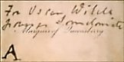
IV. East and West
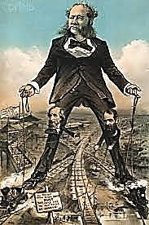
♫

1. The East Coast

When in my lectures I extolled
The workman’s honourable craft
The robber barons surely laughed:
Weren’t they the ones who had ‘bank-rolled’

The victory in the Civil War?
The Union was the prize they bought,
And it was rightly theirs, they thought,
Congress included. What a bore

Were my passé pre-Raphaelite
Homilies to the ones who owned
The James Gang-harried trains that groaned
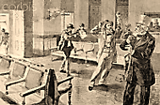
With freight and hooted day and night!

Captains of Industry, who’d captured
For the monotonous factory
The craftsmen their machinery
Put out of work were not enraptured

By my reformist program, which Garfield assassinated by Guiteau.
I slowly learned was actually
An unintended elegy
For a gone way of life. The rich

Were only interested in getting
Richer. The Northern Cause had sold
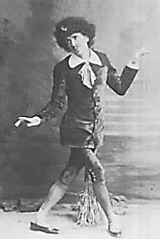
Its soul. Midas had turned to gold
The crimson of the war’s blood-letting.

So East Coast journalists, spokesmen
For the tycoons, wrote scurrilous lies
About me, mocked my clothes, my size,
Accent, message. With acid pen

They drew cartoons and caricatures
That showed me as a wilting sort
George Grossmith.
Of Bunthorne. One hack had his sport
Comparing me to the Wild Man

Of Borneo, with a sneer, no doubt,
At the Irishness I shared with poor
Immigrants. (All felt free to pour
Scorn on the primitive cartoon lout

They chose to think the typical
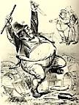
Irishman was.) Why brand me, though,
So highly evolved, as a mere throw-
Back to the prehistorical?
♫

Caliban, thou see’st thine own face
In my mirror, and call it mine:
Thou canst not bear that it is thine.
I am quite weary of this place.

A rival lecturer wages war Archibald Forbes, British war correspondant.
Against me, making many a slur;
The Press work up a libellous stir
About my charging money for

My presence at a dinner in All this unpleasantness made me the subject
My honour, and snubbing hostesses, of comment among Baltimore’s High Society.
And… Oh how tedious all this is!
Let a new, better phase begin!

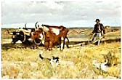
2. The Great West
♫
Out here I leave behind the mean-
Spirited gentility of the East.
A change of scenery, at least…
Their flag should be red, white and green,

The Americans’, and what am I
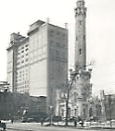
If not another salesman, chasing
Dollars? Depressing thought. The bracing
Winds of the prairie, by and by,

May lift my spirits. So we make
Our way by train (far, far too slow)
To hog-butchering Chic-ago,
The waterworks and the great lake.
The Chicago Water Tower, possibly
(The Mississippi in flood? Oh my! the ugliest building in the world.
No well-bred river should behave
That way, and so uncouthly rave.
So without comment I pass by.)
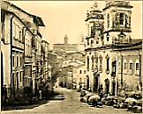
Sioux City, Cincinnati and
Racine, Saints Paul and Louis… Then
On to towns full of mining men
Whose simple manners are quite grand,

No questions asked, few jaundiced eyes.
I’d make a model desperado,
I think—and oh, great Colorado
Whose mountains soar into the skies!

The Royal Gorge, for the first time,
Silences me. Such scenery
Beggars the powers of poetry.
It is excessively sublime.

*
Leadville, Colorado.
Sombrero and loose corduroys.
Around my neck, a handkerchief.
No whisky is for me too stiff
And all the miners and cowboys

Are much impressed that ‘some art guy’
Can drink them all beneath the table,
My powers become a Western fable:
‘A bully boy and no glass eye’.

Apart from England, the great West
Is where I should most like to live.
In San Francisco I arrive
To find myself an honoured guest.

By far the best state in the land,
This golden Californ-eye-ay,
As the prospectors like to say;
It reaches out to shake your hand.

♫
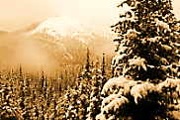
V. Coda
Back in London

What wicked god shot me this barb?
Back in London, I have just seen
A cartoon in a magazine
That shows me dressed in prison garb.
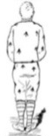
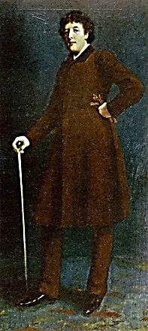
♫
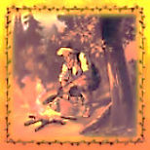
The Critic as Artist as Cowboy
♫
[Somewhere in the Panhandle. In the wake of my American
lecture tour of 1882, a curious cult of cowboy-aesthetes
has sprung up here and there in the great Southwest.]

It’s night. The campfire glows. They dine.—
Hey, Bill, pass me a sweet pertater.
Say, what you doon there? Readin’ Pater.
Who? Don’t be such a Philistine!

No point discussin’ Wilde, I guess.
I bet you ain’t read Salomé.
Salami? Had some t’other day…
Lord but I miss my girlfriend Bess!

You got a girl, a Sue, a Jill?
Look how the pallid moon doth beckon!
She is a courtesan. I reckon.
Pass me the beans there, could ya, Bill?

What are you readin’? What’s there to it?
It’s criticism. Criti-what?
Well now, remember when you shot
That piano player ‘cause he blew it

Smack in the best part of the song?
So? You were criticizin’ him,
Somethin’ severe. (Was his name Slim?)
Well, he was playin’ it all wrong!

But who’s this Wilde hombre ya jaw
About from dawn to dusk? I met him
In Leadville. I won’t soon forget him.
What was he? Some sort o’ outlaw?

How sickly seems the moon tonight…
P’shaw, it’s just the moon there, feller.
It is a sickly shade of yeller.
Now she is shinin’ ghostly-white.

This talk of yers is downright queer.
Let me kiss your mouth, Jokanaan.
My name’s not Jokanaan, it’s John.
Soft! Overhead, I think I hear

The beatin’ o’ the wings o’ Fate!
Hey there now, don’t ya be like that!
You know it’s just a goll-durn bat.
Let’s get some shut-eye, Bill. It’s late.

*
At roughly two o’clock in the small hours, under the twinkliest Southwestern stars…
Hey, what ya doon? Move over, will
Ya? Aren’t you cold? You got yer own
Blanket! Don’t you feel so alone,
Sometimes, John? Well, but gentle, Bill.
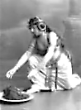
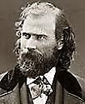
The American Byron
Hommage à Joaquin Miller

1.
Joaquin Miller, I salute
The noble Wild West chivalry
You showed when you defended me
Against the ones who tried to shoot

Me down. You scorned the ‘stiff-neck’ set;
For one who’d done so much, and seen
So much, how trifling seemed their mean
Gentility! They’d never met

And Indian, let alone been one,
As you had been a real squaw-man.
What snob who’d read, on his divan,
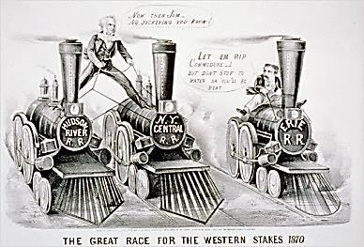
Of bison, but had never seen one,

Could ‘buffalo’ a man like you?
The gold mines that you wrote about
You’d worked, and earned the right to flout
‘Top hats’ with blood more green than blue,

Not outlaws but above-laws fighting
With stocks and bonds their six-gun duels,
Who broke, because they made, the rules.
And oh, their ‘literary’ writing’!

Weathered of face, with gleams of youth
Still in those eyes, you understood
Life’s a Tall Tale. (Twain said you could
Do anything but tell the truth.)

2. Jesse James

Are not all cowboys sometimes known
To land in trouble with the law?
Their awful crimes become the awe
Of law-abiding folk. Renown

In death was Jesse’s consolation,
For crime and fame go hand in hand
And if the atrocities are grand
Enough, they dazzle a whole nation.
You’d think this hombre was a saint
The way they flocked the dead man’s home.
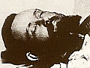
And some felt blessed if they could come
Away with chips of outhouse paint.

They were like pilgrims on a mission
Prizing the sacred merchandise.
A tintype fetched so high a price
You’d think it was the rarest Titian.

Of Kerry stock was Mr James;
Billy the Kid was Ireland-grown,
As was the man who gunned him down,
Pat Garrett—legendary names!

3. Jersey Lily and American Byron

‘The American Byron’ you were called,
For your adventures dazzled London:
It seemed you’d left no exploit undone.
Far from offending, you enthralled

Society, wearing that hat
You never doffed, indoors or out,
And some expected you, no doubt,
To shoot up the saloon (make that

‘Salon’). And yet, how much you prized
Swinburne and the Pre-Raphaelites!
Although of all those leading lights,
‘Twas ‘Lily’ you most idolised,

Goddess to cowboys one and all,
Red-blooded men. Why, not a shack
Out on the Prairie dared to lack
Her picture, tacked up on a wall!

*

Though you were once a jurist, pray
Don’t judge me harshly, my old friend,
For coming to a grisly end.
Don’t cowboys risk that every day?
♫
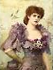
Musical Program

Page 1, The American Tour (title page)

Sousa, The Stars and Stripes Forever. United States Marine Marching Band.

Page 3, London Debut

Gilbert and Sullivan, Patience. Act I, No. 7, “Am I Alone and Unobserved?” (George
Baker as Bunthorne). Pro Arte Orchestra, Sir Malcolm Sargent, conductor.

Page 5, The American Tour: I. Declaring my Genius

Stephen Foster, Beautiful Dreamer. Piano version.

Pneumatic Circus Calliope, ca. 1920.

Page 14, The American Tour: IV. East and West

Flotow, The Last Rose of Summer, from Martha . Adelina Patti, soprano.

Page 15, The American Tour: IV. East and West

The Barbershop Singers, My Wild Irish Rose.

Dvorak, Symphony No. 9 in e minor, Op. 95 (“New World”). II: Largo. Vienna
Philharmonic, Herbert von Karajan, conductor.

Page 45, The American Tour: IV. East and West

Jesse James. Ry Cooder.

Page 45, The American Tour: IV. East and West

Gottschalk, The Banjo, Op. 15 (Fantaisie Grotesque). Amiram Rigai, piano.

Page 17, The American Tour: V. Coda: Back in London

Henry Bishop and John Howard Payne, Home Sweet Home. Nellie Melba, soprano.

Page 18, The Critic as Artist as Cowboy

The Streets of Loredo. Traditional ballad. Unknown harmonica player.

Page 21, The American Byron: Hommage à Joaquin Miller

Jesse James. Ry Cooder.

