* T h e A r t h u r C y c l e *

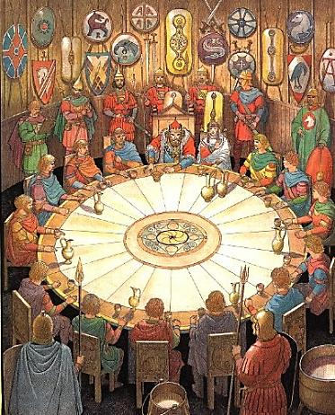

♫

Tennyson and I

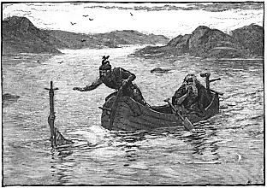
The Arthur Cycle

Tennyson and I again,
haunting Somersby Manor.

1.
Must every male child be named Arthur?
In tribute to that grand Ideal
Whose own wife doubted he was real…
One must not take this any farther!

*

Alfred, my excellent good friend,
Sing me a song of Camelot,
Won’t you? Oh, dear! I’d rather not,
But since you ask: attend, attend!

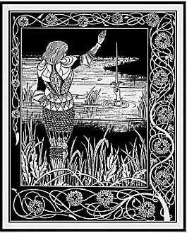
2. King Arthur

O spotless fool, royal cuckold:
The torch, the torch will not be passed!
Why must the lilies fade so fast,
So fast the roses? I am old.

Your knights were many, and true and bold!
Your ladies, they had golden hair.
All that is beautiful and fair
Is as unthreaded cloth of gold.

Thrice must Sir Bedivere be told,
‘Give back the brand Excalibur!’
Ere he relinquish it to her
Who gave it you to have and hold,

The Lady of the Lake, to fold
Into the waters whence it came,
That shining sword of golden flame.
But now ‘tis done, as was foretold.

(Strictly his lot to each is doled.)
Now on a dim and dusky barge
Three queens shall take you in their charge
Weeping and wailing unconsoled

Over your body pale and cold,
And take it to Avilion
Whose other name’s Oblivion.
And the Round Table will be sold
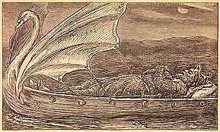
At auction, the silk gown will mould,
A death-moth-eaten souvenir
Of what was once Queen Guinevere.
I weep, but tell what must be told,

The story of this king of old,
King Arthur, and his soul so vast!
And how the torch that was not passed,
On misty evenings, on the wold

That like a tapestry unrolled
Spreads out its endless waste of green,
That fatuous fire by fools is seen,
Sometimes, a Grail of fine fool’s gold,

And how they chase across that wold
A phantom (and to phantoms turn)
That warms them not, although it burn,
And leaves the ‘nighted world quite cold.
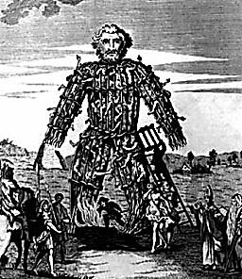

3. The Wicker Man

You brought upon yourself a fate
That you would not have wished upon
Your worst of enemies. It’s done,
Enough! It’s done! It’s far too late

To change what happened. Why tear off
The bandage and the scab beneath
And pull the dagger from the sheath
And stab my heart and make me cough

Up blood again and let out cries
And seep again the morbid fluids?
What, is my soul some sort of Druid’s
Plaything, a hapless sacrifice

In cage of wicker set ablaze
And destroyed so flamboyantly
Pity and terror to ecstasy
Are driven? Through an acrid haze

To see it writhe, that blackening speck,
A small fire lost in a great fire,
The gods of savage men desire,
But spare me, pray, arrah! vos prec.
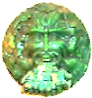
4. The Green Man
♫
You chop him into bits and serve
Him as an archetype-ragout
Or hearty, seething mythic stew,
And in your every vein and nerve

He’ll magically reanimate
And your own inner viridescence
Invigourate. You’ll feel his presence
Within you as an altered gait,

A lighter step, a suppler wrist,
A languid new vitality
With just a soupçon of ennui
To scandalise the moralist.

Two or three inches of transcendence,
That’s all he asks for, from the ground,
That, and a band of angels round
His head to clown, and dance attendance.

Look at his skull! Out of the eye
Sockets, the nostrils, and the mouth
Spring green carnations and the youth
Eternal of regeneracy!

5. Sir Gawain and the Green Knight

He also comes in an edition
De luxe: a Knight, in skin of calf,
Whose head, swung by his hand, will laugh
At you, Sir Gawain, with derision

Quite supernatural, for you
Have severed it with an axe blow.
It says, as it sways to and fro,
That you’ve a debt will soon fall due:

Soon you must offer him your head
In what of course is a Green Chapel.
But first Eve offers you an apple.
Move back a step. You are half-dead

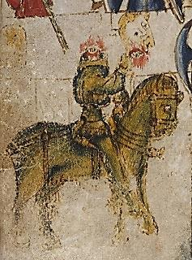
From questing for the giant’s lair
When in a castle you are offered
Harbourage—and much more is proffered:
One Bertilak de Hautdesert

A lovely wife hath; to your bed
She comes, night after night. Her plan?
Seduction! But you, virtuous man,
Retain your chivalrous maidenhead,

It remains unviolated,
Although not so your sacred vow
To give back the wife’s girdle, now
The talisman that saves your head.

For on the point of hewing you
The Green Knight pauses at the sight
Of it and laughs: ‘twas all a light-
Hearted bit of fun, much ado!

Morgan Le Fay’s behind this jest,
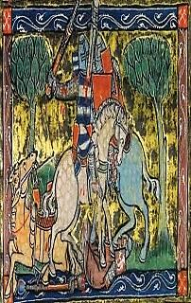
That sometimes devious, sinister
Or merely mischievous half-sister
Of Arthur: it was all a test

Of Gawain’s vaunted chastity,
And of the ideals of the Court,
And withal a malicious sport
Queen Guinevere to terrify.

*

And as the Green Knight doffs his head
To Sir Gawain, for courtaisìe,
I take my hat off to you, Dee-ah,
Who don’t believe a word I’ve said.

6. Merlin and Vivien

The charm you should have kept, that charm
You gave her: ah, she understands!
The woven steps, the waving hands!
The power she has to do you harm

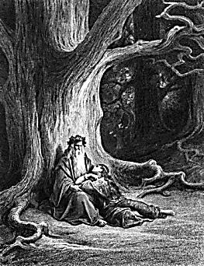
You put into those hands that doom
You to a hollow oak for ever.
You, whom we thought so very clever,
♫
You made the Tree of Life your tomb!

Poor wizard, wizened but not wise,
Who made from music Camelot’s gate
And knew before it came your fate,
And still believed her lying eyes!

You, the wand-waver, a mere tool

O, ay, it is but twenty pages long;
But every page having an ample marge,
And every marge enclosing in the midst
A square of text no larger than the limbs of fleas;
And every square of text an awful charm,
Writ in a language that has long gone by,
* * *
And every margin scribbled, crost, and cramm’d
With comment, densest condensation, hard
For mind and eye; but the long sleepless nights
Of my long life have made it easy to me.
And none can read the text, not even I;
And none can read the comment but myself;
And in the comment did I find the charm.
—Idylls of the King, ‘Merlin and Vivien’

In the hands of one so profoundly
Unworthy! I denounce you roundly,
Hapless magician, gifted fool!

7. Princess Ida and The Lady of Shalott

Your Princess, though: what, from sheer chivalry
She must renounce her independence
And submit to the man’s transcendence,
Foregoing gifts and mental rivalry,

Eunuch self-castrated to flatter
The vanity of the poor male,
The victim, lest his manhood fail?
Must treat her mind as a small matter

Compared with her predestined rôle
As selfless servant wife and doting
Mother—and how he must be gloating,
Your husband who has killed your soul!

Decked out in hollow-clanging blank
Verse and Arthurian trumpery,
Poems of such complacency
Have but Philistia’s Muse to thank.

But Oh! the Lady of Shalott
Whose mirror cracked when she forgot
She must not look on Lancelot.
She drifts down dead to Camelot,

The Lady of Shalott, Elaine!
Her web flown hopeless, floating wide,
What she must do she did, and died:
If love brings death, death ends love’s pain.
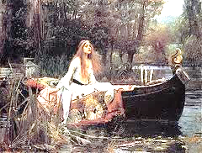
♫
8.
And shall I speak of Galahad
Who perserveres o’er sea and land
♫
Till he alone of all that band
Beholds the Grail, and yet is sad?

For nothing now can be the same.
Ah, back into the world he goes,
And all he knew no longer knows,
And ‘home’ sounds like a foreign name!

All things look skeletal and old
As branches when November winds
Strip their bright leaves away like sins
And leave them purified and cold.

His heart is pure, and so is snow
Unsmutched, a virgin sheet of white.
He prays upon a winter’s night
In his stone chapel, head bowed low.

Infinite Love will ruin Love
Of earthly kind, so dear a waste!
And kisses leave a bitter taste
When human love’s not love enough.

He only wants to die a death
Of his own choosing: he would be
Of flesh entirely, wholly free
And rise toward Heaven like a breath.
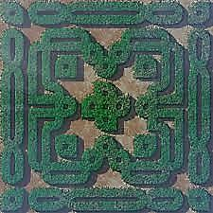

9. The Faerie Queene and the Labyrinth of Allegory

Complexities, in the end, defeat
Design. The maze grows only denser.
Think of those episodes in Spenser
Where plain knights weave in dark conceit

‘Mongst nymphs and wizards and what-not,
Until the allegory spins
So many myths of origins
That Virgil’s oak is overwrought

With Ovid’s ivy. ‘Hard begin’, The Faerie Queene, III, iii, 21.
What is your end? You have too many
Of these to be said to have any,
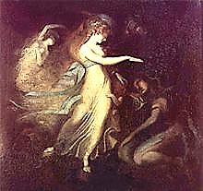
And fewer the ways out than in.

So highly charged with gorgeous Eros,
♫
Infected will unwilling serves
Erected wit, and sensory nerves
Are insolent squires to his knight-heroes.

A knight may ‘gainst his interest act,
His better judgment; what he fears he Prince Arthur and the Fairy Queen (Fuseli).
Is overtaken by: his Circe
Turns hoggish mind to bodily fact.

The thread tatters to threads, to broken
Endings leading. But these are new
Beginnings, each a chance to do
It all again, new vows are spoken

In a tempestuous wedding of
The pagan and the mediaeval,
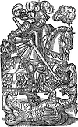
Protestant God and Catholic Devil.
It is the straying that we love.

*

Spenser, you hated us, it’s true. Hated the Irish, that is.
Hysteria mars your fantasy.
But though you fear to set him free,
Eros exuberates from you.

You wrestle to the ground but can’t
Pin down the daemon. He will rise
Again. What spell could exorcise
The Protean from the Protestant?

10. Childe Harold

Childe Harold sings his anxious song
Of influences that make him pine
To go a quest that will, in fine,
At a dark tower, and a throng
Of palely loitering phantoms, end—
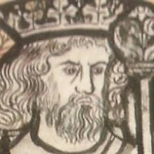
Though first he through a plashed and muddy
Waste, as through a dead scholar’s study
Littered with scribbled leaves, must wend

With steadfast and obdùrate will
Set against Time and its It Was.
But why so hard a quest? Because
Opposed, irreconcilable

Are power and will, good, and the means
Of good? Because triumphant life
Achieved through such a ghastly strife
Might just as well be death? The scenes

Of misty squalour through the which
He struggles are composed of naught
But splendid failures, all they wrought
A poverty that makes them rich,
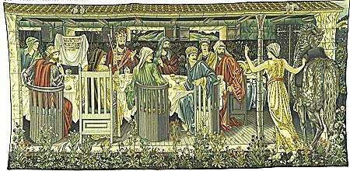
A wealth that leaves them poor indeed.
Who steals my purse, steals trash: how true!
Accumulations vast accrue
Until they bloom into a weed.

11. Arcturus Redux?
♫

Oh once in a blue Cambrian moon,
Perhaps, stray knights will constellate
Into a court, can we but wait!
A king will strike a fork, and tune

Their disparate notes into a Song
Of Solomon uniting God
And Aphrodite. On a broad
Heraldic field that noble throng

Will clash the shield and break the lance,
Before a gateway by a clever
Sorcerer built to last for ever,
Since made of Music and Romance.

A supernatural resource
Endangered, rare, exhaustible
Are the real, loyal, true, frail, spell-
Bound, binding few. But does their force

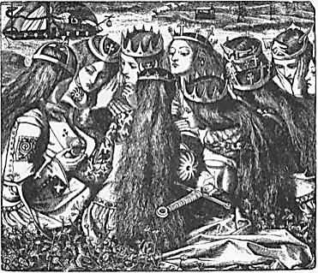
Diminish over time, will jackals
Inherit the high halls, the Round
Table? Merlin’s already bound
Inside an oak, in wooden shackles.

Who shall be judge of Lancelot?
Who so high-minded and severe
As to condemn poor Guinevere?
Yet with their passion comes the rot.

Fear Arthur’s justice! Look and see:
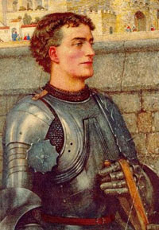
His trusty friend, ah, such a charmer!
Lies dead and crumpled in his armour.
The Queen has joined a nunnery.

*

Some say that he will come again.
Some wounds take centuries to heal,
And many times the earth will reel
And we as blind as drunken men

Will trail a slick of blood behind us
As down the hall of time we stumble,
And many a tower will rise and crumble
Till by the full moon he will find us

Feasting like wolves with small red eyes
And bloody mouths upon each other,
Mother and father, sister and brother,
Lips stained with gore and smeared with lies,

And he will have his hands full then,
Assembling once again the knights
He’ll need to set it all to rights:
Why should he ever come again?

♫

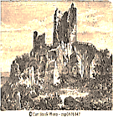

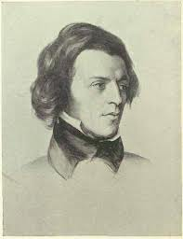
Musical Program

Title page

Chausson, La légende du roi Arthur avec choeur. La Société Philharmonique de Mirande,
conducted by Max Fouga.

Page 4

Guillaume de Machaut, Puis qu’en oubli (rondeau). Rogers Covey-Crump, Mark Padmore
and Paul Hillier.

Puis qu'en oubli sui de vous, dous amis,
Vie amoureuse et joie à Dieu commant.

Mar vi le jour que m'amour en vous mis,
Puis qu'en oubli sui de vous, dous amis.

Mais ce tenray que je vous ay promis,
C'est que jamais n'aray nul autre amant.
Puis qu'en oubli sui de vous, dous amis,
Vie amoureuse et joie à Dieu commant.

Since I am forgotten by you, sweet friend,
I bid farewell to a life of love and joy.

Unlucky was the day I placed my love in you;
Since I am forgotten by you, sweet friend.

But what was promised you I will sustain:
That I shall never have any other love.
Since I am forgotten by you, sweet friend,
I bid farewell to a life of love and joy.

Translator unnamed

Page 6

Chausson, Viviane, Op. 5. Orchestre Symphonique de Nancy, Jérôme Kaltenbach, conductor.

Page 7

Wagner, Tristan und Isolde. Act III: Mild und leise (Isolde’s Liebestod.) Kirsten
Flagstad, soprano, Philharmonia Orchestra, Wilhelm Furtwängler, conductor.

Page 8

Peter Warlock, Corpus Christi. Text: Anon. carol, ca. 1500. Blossom Street, Hilary
Campbell, conductor.
Lulley, lully, lulley, lully,
The faucon hath born my mak away.
He bare hym up, he bare hym down,
He bare hym into an orchard brown.
In that orchard ther was an hall,
That was hanged with purpill and pall.
And in that hall ther was a bede,
Hit was hangid with gold so rede.
And yn that bede ther lythe a knyght,
His wowndes bledyng day and nyght.
By that bedes side ther kneleth a may,
And she wepeth both nyght and day.
And by that bedes side ther stondith a ston,
Corpus Christi wretyn theron.
*
“One theory about the meaning of the carol is that it is concerned with the legend of the Holy Grail. In Arthurian traditions of the Grail story, the Fisher King is the knight who is the Grail's protector, and whose legs are perpetually wounded. When he is wounded his kingdom suffers and becomes a wasteland. This would explain the reference to ’an orchard brown.’
“The text may be an allegory in which the crucifixion is described as a wounded knight. The bleeding knight could be Christ who bleeds for the sins of humanity endlessly. Christ is most probably represented as a knight as he is battling sin and evil by his continual pain. The "orchard brown" to which the knight was conveyed becomes, in this reading, the "orchard" of wooden crosses that covered the hill of Golgotha/Calvary where Christ – along with many others – was Crucified, while the "hall... hanged with purpill and pall" could be a representation of the tomb in which Christ was placed after Crucifixion. This allegorical interpretation would tie in with the seven stanzas possibly representing the Seven Deadly Sins. The maiden who is by the knight's side could be Mary. There is religious symbolism throughout the carol. The falcon may have several possible meanings. It may be that, as a bird of prey, it represents those who killed Christ and sent him to heaven. It may also represent a new beginning and freedom, which Christ gained on his death. The colours in the carol are also significant. The purple and gold are signs of wealth, although these were also colours that referred to the Church due to its wealth. The pall (black velvet) probably refers to death. An interpretation of the inscription on the stone may also be that it marks the location of the grail itself, still guarded by the Fisher King.”—From Corpus hristi Carol (Wikipedia), based on an article in The Independent currrently inaccessible on the Web.

Page 9

Mendelssohn, A Midsummer Night’s Dream: Scherzo. Mariinsky Theatre Orchestra,
Valery Gergiev, conductor.

Page 10

Wagner, Tristan und Isolde. Act III: Prelude. ORTF Orchestra, Karl Böhm, conductor.

Page 11
Purcell, King Arthur, Act V, Scene II: “Fairest isle, all isles excelling.” Text by John
Dryden. Barbara Bonney, soprano. Concentus Musicus, Nikolai Harnancourt, conductor.

VENUS:
Fairest isle, all isles excelling,
Seat of pleasure and of love;
Venus here will choose her dwelling,
And forsake her Cyprian grove.
Cupid from his fav'rite nation,
Care and envy will remove;
Jealousy that poisons passion,
And despair that dies for love.
Gentle murmurs, sweet complaining,
Sighs that blow the fire of love;
Soft repulses, kind disdaining,
Shall be all the pains you prove.
Ev'ry swain shall pay his duty,
Grateful ev'ry nymph shall prove;
And as these excel in beauty,
Those shall be renown'd for love.

