The Four Stages of Cruelty

The short, brutish
The way that leads from force to power life of Tom Nero.
Follows a winding, torturous motion.
The narrow fury of a river
Drowns in the vast, impassive ocean.

First Stage takes its origin
in the periwigged man with the arrow
piercing the dog’s anus
in Hogarth’s series of engravings—
you will note, in the lower-lefthand corner,
the meandering guts a cur
has bitten from the belly of a cat.

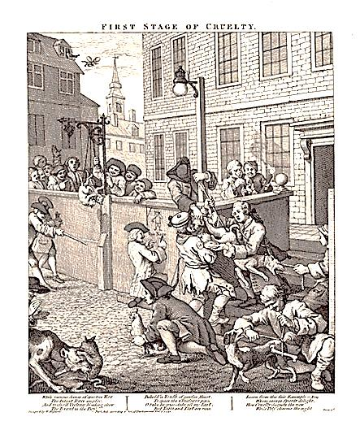

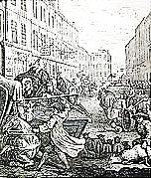
Hence Stages Two and Three,
where beatings
administered in streets
to horse and sheep
with overturn of carriages
to the scandal of the good
and other tributary evils
lead finally to the unlucky notch
carved into the strumpet’s throat,
the emptying bottle of her veins,
the criminal apprehended,
stunned in lantern light, the knife
held out to him there, to damn him.

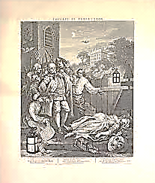

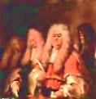
Cut to the anatomy lesson,
Stage Four: the table a ship’s deck,
the amphitheater a shore
on which the surgeons sit
collegial and frank,
expertly ogling
in the Royal College of Physicians.

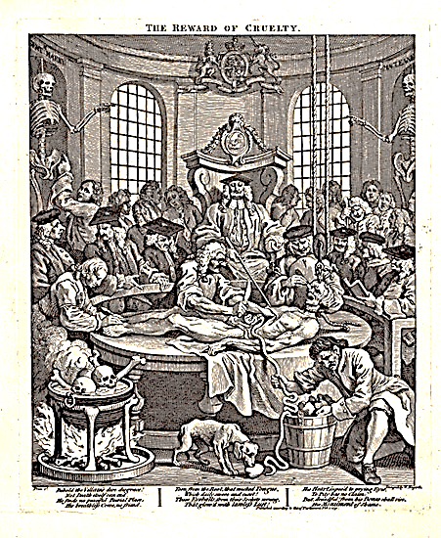

On that deck
note the criminal catch of the day
with the chum
of its entrails slopping
from belly into bucket.

A dog feasts on the liver.

Evil redounds to its source
With a redoubled force.

Skulls seethe
in the rendering vat
that stands nearby, waiting.

From his bones shall rise
His Monument of Shame.

Observe the sturdy screw
implanted in the skull,
how it cranes the thing up
that all may witness
the scooping of the eye
out of its socket like an oyster.

