Farther Revels
[Of Oscar Wilde]

Tombe III
Mystical Maths
(Trial by Numbers)
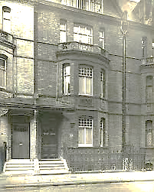

The House Beautiful (Hypercube Edition).
Table of Contents

Chapter One: The Mythematician
The Astral Blues 5
Purgatory: The Latest Edition 6
‘Trains and Trails 9
Real Numbers 11
XIII 12
Horn Book 14
Te Deum Alephi 15
π 16
The Bony Labyrinth 17
Autumnal 19

Chapter Two: Promixta Theologia
A Roundabout Cosmology 22
Faith and Despair 24
Selfish Giant (II) 33
The Critic as Artist as Theologian:
A Commentary on ‘The Selfish Giant’ 35
Erda and Wotan 37
Osiris 38
The Phases of the Moon: A Consultation with Yeats 40
A Round 42
Chapter Three: Labyrinthia
Deployments of the Labyrinth 46
The Aleph and Other Things 47
The Birth of Labyrinthia 48
The Forking Paths and the Zohar 50
The Prison of the Prism 53
The Water of the Mirror 54
The Thing That Wasn’t 55
Stanzas for Asterion 61
How Certain Is ‘Curtain’? 62
My Egyptian Dream (II) 65
Theseus, Tithonus 67
The Minotaur 69
The Wrathful Goddesses 72
‘Everyman’ Refert 75
Escape from the Labyrinth 76
The Forest of Listening 77
Lux Aeterna 78
Quieting the Eye 81
Harmony Lessons 82
The Music of the Spheres 83
The Music Ends 84
Hamlet Revisits Mimesis 85
Fire in the Hall of Mirrors 86
The Mirror-Man 87
With Three MCVs in the Garden
of the Earthly Paradise 88
Crossing the Bridge 90
The Sacred Monster Stellified 91
Chapter Four: The Metansomatosis
of Oscar Fingal O’Flaherty Wills Wilde
The Circles of the Sphere 93
Selfscape, with Topologists and Avatar 94
A Conversation with Thomas Martin 100
Metansomatosis 101
The Astral Ashram 102
Krishna the Blue 103
Another Charming Chat with Krishna 104
The Bawdy Bodhisattva:
Chögyam Trungpa 106
More Talks with Trungpa in Utero 107
Emptiness 108
A Consultation with a Palmist 109
On Rock Candy Mountain 111
The Jolly Corner 112
Karma 114
Of Fibonacci Numbers 116
The Ascension of Old China Blue 119
The Missing Lines 130
Prologue to the Epilogue 131
Triton Shell Horn 132
Chapter One

The Mythematician

∞

I never could understand mathematics,
and life is now a mathematical problem.
When it was a romantic one, I solved it—too well.

[Letter to Leonard Smithers, 17 March 1898]
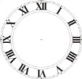
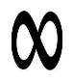
The Eternal Turn (II)

Again I dream I am born again
As Oscar Wilde, exactly as
I was before, hurrah, alas.
Some error, made I know not when

Or where, some cosmic clerical
Error, assigned a number to
Itself. When I have run things through,
Again into the past I fall.

I know what I am going to say
Because I have already said it.
I have already said this. Edit
The text? It is too late. The day

Has not yet dawned. To what I say
There is an echo that precedes
The sound, and who knows where it leads?
Perhaps into that future day.

Because I have said what I am about
To say, it sounds spontaneous.
My voice is not unanimous,
Precisely. There is room for doubt.

The extra resonance in my voice
Makes everything I say sound double.
Paradise with a hint of trouble.
I know beforehand every choice

Already made, the one chance lost.
So there is omen everywhere.
And when at night I climb the stair
I see, as one might see a ghost,

Myself, and he is heading down.
Our crossing paths are a design
Things follow. All is as a sign.
We learn what we have always known.

This is a dream you will forget
Except in flashes of the past
To be. The omens will come last.
The sun has risen and is set.
The Astral Blues

I have become a study in grey.
I see my picture and recoil.
For the robust, full-blooded oil
From the Old Master’s atelier,

Enriched with poisonous metals and
Rare earths, is a blurred photograph
Now—no, a pencil sketch, smudged, half-
Erased…! Like a Tibetan sand

Painting has the original
Been swept away by the same hands
That shaped it: back to desert sands
The living eyes blow, tears and all.

Dears, would oblivion cure me? Would
The infinitely elastic stuff
Of pre-existence be enough?
Plenipotential of the Could,

Pleroma of the not-quite-yet?
The virgin glass in which no face
Has looked. It knows me still, my place,
And it will not let me forget.

To a Thanasian creed, a creed
Of things inanimate as stone,
I would subscribe, and thus atone
For all the greediness of need.

Which of you, in some corner of
Yourself, thinks it not rich to die?
Why? So that you need not ask Why?
Again, or again mourn lost love!
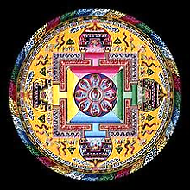
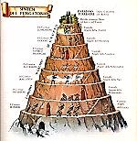
Purgatory: The Latest Edition
The Spiral Labyrinth

1.
They have redesigned Mount Purgatory
By twisting its parameters
In engineering space: now there’s
A spiral staircase you must, story

By story, climb past every ghost
That haunts you. Built of jagged granite
By gods who could reshape the planet
As an elastic strip of coast,

Or a rhomboid, if so inclined,
The staircase takes you past the Proud,
Past Sloth, Lust—all the usual crowd.
A tour, that is, of your own mind

Is what you are given: mind turned in
Upon itself: How shallow, mean,
Arrogant, foolish and obscene
You were! Each Roman Catholic sin,

With some perversions in attendance,
Wants you to feel extremely bad,
And say you’re sorry, and be sad.
This leads to some sort of transcendence.

But there is something tired in me.
A climb is but a climb, spiral
Or otherwise. I hear them call,
The steps: One. Two….Infinity.

Dante descends beatricestically and
all-too-instructively from Heaven.
2. On the Accounting Ledge

You’ve dropped me behind enemy lines, `
I see, il meo maestro. Is
This cricket? Has it come to this?
I can’t tell plus from minus signs.

You know that. Do you think it’s funny?
I am alone here, stranded in
An alien land, and for what sin?
Your reckless carelessness with money.
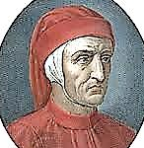
Your scorn of prudent calculation.
You lived on flights of rhetoric
And impulse. The arithmetic
Is that of an examination

In maths, to you an alien land,
As you say. Your stupidity
In maths helped shape your destiny.
It left you with an empty hand.

You have been in Purgatory long
Enough. Which way is the escape?
The way you got into this scrape.
Correct the answers you got wrong.

You must construct a rigorous shape,
A geometrical staircase,
A spiral. At each turn you face
Your monsters…Then, at last, escape?

To further Trials, five, six, or seven.
I think not. I am liberated
From you. I will not be berated.
Dante, this is—Oh, go to Heaven!

3.
I did pass my geometry
Exam at Oxford, but just barely.
I think of numbers only rarely.
Accounting is a Mystery

On the order of the Orphic rites,
To my poor high-aesthetic brain.
But an accounting full of pain
Is what I render day and night.

No, I was neither good at maths Luckily, I have as tutor in maths a
Nor at religion. So I take professional mathematician, Mr V,
The fork in the road, and I make to whom I am eternally grateful.—[OW]
My way along a pair of paths. You are welcome, Oscar —[Mr V]
And I shall have a certain Mr MCV.

4.
I watch my tortured being flow
Into the soundless wisdom of
The East, that Depth immune to rough
Wind and water. It fades, that show
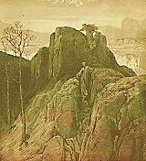
Of violent bluster we call world:
A play that knows not how to stop,
Unconscious as a dizzy top
That has no choice but to be whirled.

My taste has grown, what? Atavistic.
I’ve moved beyond the Mother Church
(I hate to leave Her in the lurch)
Towards the universal mystic.

I come before you as the Fool.
There is no virtue, but I lacked it.
If there’s a wrong horse, I have backed it.
So I have put myself to school.

To undertake a study of maths
And myths will be my final mission,
To make myself a mythematician
And gather in the forking paths.

I will re-write my history
And this time not as my own Judas;
And speak a calm more like the Buddha’s
In the autothanatography.

Backwards and forwards goes my World Line.
(Mr V—I make no apology—
Has taught me a new terminology.)
Pick out a thread, a pale and pearled line,

And follow it, in its direction.
But where they all may meet, who knows?
The circles of the sphere will close.
My Book ends at their intersection.
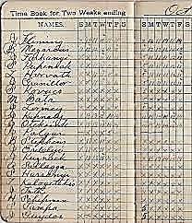
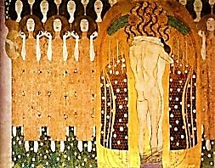
‘Trains and Trails
‘Trains: quatrains. —[Mr V]

I ride the light; it is my coach.
Powerful are its strong white horses.
Shadows behind me in my courses
I leave; hills glow at my approach.

In Boolean numbers and poetic
Tropes are encoded what I see
And hear, moving through imagery
And music of a pure noetic

Consistency. Past, future, and present
Are cards I can lay out upon
A table and see all, or one
By one; through waning-into-crescent

Intaglios-into-bas-reliefs
Of time foreshortened or expanded
I ride the eye-light and am branded
With blues and joys and greens and griefs!

Explosive as Beethoven’s Ninth
(The Scherzo, with its kettledrum
Pulses bounding o’er Kingdom Come),
Light as the scent of hyacinth,

Electric waves, my astral coach,
Fly me, light’s passenger and made
Of light, as down sight’s sharpened blade,
Towards the ever-to-approach.

That kinematic flickering
Of hot lamps flinging on the night
Images moth-like black-and-white
Is my own eyes nictitating

The world in punctual, jagged streams,
The blanc-et-noir, the chiaroscuro
Of my gone life. In brief but thorough
Review I search the files and dreams

Of mine and many others’ lives,
Then pause like Hermes on a message,
The Herald at a threshold-presage,
The eagle poised before he dives.

*

The mind, a flawed god, fiat-looks
The world into its shapes and sizes,
And yet the world still holds surprises
Hidden in corners and in nooks

Of what it fails to see to see
The things it does. Light never ceases
To dazzle it, and missing pieces
Maintain the puzzling mystery

Of what it all might finally mean,
The world, I mean, so deep and wide,
The world inside the mind inside
Its own vast Transformation Scene.

*

My fiat is not legal tender,
Credit’s a problem, the debentures,
Often enough they fail, my ventures,
With letters marked Return to Sender.

So, as a God, I would not say
I am perfect, or infallible.
My Let There Be is liable
To be ignored outright, quite rude,

I think. My old plank bed appears
Before me quite without permission.
It seems it made its own decision.
Friends don’t appear, despite my tears.
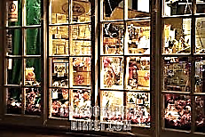
God stands at the pâtisserie
Window, feeling hungry and dull.
He swoons to see it all so full
Of things that will not let Him be.

The Transcendental Number
My soul sojourns among the infinitesimal…
The asymptotic gauntlet-line is run
By the abstraction of a questing hero
Through the remotest places of the decimal
Towards the absolute, the perfect Zero.
The expectation truth must disappoint
Is that this Null can be attained. The truth
Of which one cannot make too fine a point
Is that the point is infinitely fine.
Nirvana can’t be reached, ‘tis but a smooth,
Pure dream of space. Then say all things are One,
Dears, where 1 = 0.999.

And to the 3 of Trinity affix,
Alas, .1415926…

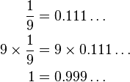
XIII

Valhalla burns, and all the smoky
Remains thereof like soma fade.
They leaped into the fire they made,
The doomed gods. And I think of Loki,

The Thirteenth of the Pantheon,
The thirteenth at the funeral,
Top bunco-artist of them all.
(Of course, when thirteen gather, one

Of them will die within the year:
A hard fact whose establishment
To rigorous experiment
We owe. The dead we owe a tear.)

The hangman’s rope needs thirteen turns
Ere it can hold a hanged man’s weight.
Unlucky numeral of his fate!
The moon, whom none of this concerns,

Revolves, each day, thirteen degrees
Around the earth, and you may count
Thirteen full moons (O fell amount!)
In many a year. (Her mysteries

Are ancient, menstrual, feminine,
And as her cycles cycle through,
Hunger to Harvest, she is blue
Sometimes, and shines a crooked grin

When she is slowly growing full,
And she grows white, and very old,
And looking down, she is a cold
Skull meditating on a skull.)

The Zodiac includes signs twelve,
And a thirteenth, concealed from us:
The Serpent named Ophiucus
Into whose secrets who dares delve?

Old Glory, of course, has stripes thirteen
(The thirteen earliest colonies):
Ill omen flapping in the breeze?
Its colour should be money-green.
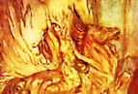
Thirteenth Apostle at the Last
Supper, Judas number. The Persian
As into Chaos the reversion
Saw the thirteenth millennium, vast

Void where no star or planet orders
The play of chance. Again, Loki,
The Cain of gods, the one guilty
Of murder: Thirteenth. On the borders

Where bad luck starts to merge with good,
Mercy has thirteen attributes.
And wise Maimonides imputes
To Judaism, understood

Philosophically, thirteen prime
Principles. Thirteen prime, turned round,
Is, it will readily be found, Whimsically called an ‘emirp’
Another prime. In a cold clime, by mathematicians. (Thirteen
is also a Fibonacci number.)
High in Tibetan elevations, —[Mr V]
Where wisdom is austere and clean,
Auspicious is this old thirteen,
The theme of mystic meditations.

(That there are exactly thirteen ways
Of looking at a blackbird Stevens
Has demonstrated. Odds or evens,
With loaded dice perception plays.)

Now 13 rue des beaux arts gave
Me shelter. If the coach was number
Thirteen, that bore me to my slumber,
I drove myself into my grave.

Then Coach 13, I bid thee be
My Boat of Ra, of purest light!
Through years and spaces infinite
Oh lightly shalt thou carry me!

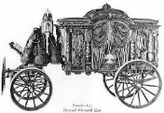
Horn Book
And the Number of his Name
is Fourteen

A rhapsodic effusion from Mr V
on one of his two favourite Cantors.

B - Bellows: The lungs of the organ aloft ♫ Loud as the thunder, as distant and soft.
Bach: Brook, river, cascades from the mountain ♫ Flows into the sea, returns as a fountain.

A - Allemande: A dancer, German by birth ♫ Grace of the Suites, lightly touching the earth.

C - Counterpoint: Each line flints off its brother ♫ Each Heaven-bent to outrace the other.
Continuo gives to the voice of the cello ♫ Harmony’s body, a chromatic halo.
Circle of fifths, climbs straight as a rail ♫ Descends as a serpent devouring its tail.

H - Harmony flashes brief and resplendent ♫ From fleeting consensus of parts independent.
Held note: The violin halts in mid-threnody ♫ Letting the harpsichord take up the melody.
Horn calling deep from the forest to say ♫ The hunters are closing in on their prey.
Hornpipe: Is peasants, rude in their vigour ♫ Stomping the rounds of a simple dance figure.
Hemidemisemiquavers’ quick little swirls ♫ Circle the flute stops like scampering squirrels!
Handel, whose secular operas taught a ♫ Colleague to ‘operate’ mass and cantata.
Home key the citadel, watchtower the dominant ♫ Sly modulations sapping the monument.
Hallelujah! Gratitude, joy and elation ♫ Tuning fork, tonic, and lungs of Creation!

♫

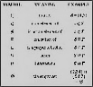
Te Deum Alephi
Melismas for Two Cantors

[Here the medium and automatic writer (myself, Mr V) interpolates an
encomium of the great German mathematician Georg Cantor, inventor of
set theory. (And Bach, too, was a Cantor, wasn’t he?) Oscar has kindly
allowed this clumsy effusion to stand, though it breaches our séance protocol.]

Your mind divined, as did your soul,
In countable Infinity,
The equal cardinality
Of set and subset, part and whole.

Georg Cantor, what grand melismas
You sang upon set theory!
Devout in Christianity,
You raised the Aleph-Child of Christmas—

Highest Infinity-Plus-One!—
Above the hard-set features of
Our numbers, in the name of Love,
Back to the God who made atone

This infinite Child for finite sins
Of Man, and God Himself chose you
To spread the Gospel so good and true Mr V, this does not scan. [Oscar]
That the World ends where it begins, I was actually trying for a free
ballad metre here, I think. [Mr V]

In actual Infinity.
Laudamus Cantor Bach, Musician
Cantor Georg, and their clean vision
Radiant of God’s great glor-y! Mr V sings the last sentence, drawing
out the ‘y’ in ‘glory’ melismatically.

In Origin dwells the Creation.
It is an ever-branching throng
Of song-lines leading to one song
To recreate Origination.

Bach, divine architect of tone!
Believer in the cantilever,
Whose maze of lucid bridges ever
Crosses through difference to the One!

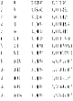
π

The truth of perfect circle or sphere,
Its imperfections and anomalies,
Makes ‘pi’ of rationalist homilies:
It filled Pythagoras with fear,

Became a scandal in his other-
Wise perfect circle. One was drowned
For spreading the ugly truth around;
Indeed, it is a curious bother.
O pi, complex, perverse old pi,
You never end, nor do you ever
Form a pattern. You seem both clever
And plodding, and can’t tell me why.

You are both unpredictable
And dull in your long random walk.
But are you random? How they talk
About you, mathematicians, full

Of fascinated indignation,
And how they stalk you, out into
The expanding boundaries of you,
A trillion places, each a station

Of the endless crossing and the crux
Insoluble of imperfection
That like a curious infection
Queers the circle, and fills whole books

Carrying things to lengths that stagger us
To find, far out in abstract space,
Some pattern that might save the face
Of the discountenanced Pythagoras.

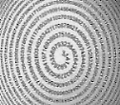
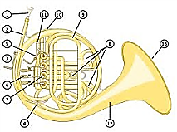
The Bony Labyrinth
Or: The Spiral of Listening

J'aime le son du Cor, le soir, au fond des bois.
—Alfred de Vigny
Hermetic is the ear’s musician,
Obscure the winding passage of
The hearing we give songs we love
Down birth canals of an audition.

A tap upon the tympanum:
Audience granted. Pass the tones
Through a bureaucracy of bones:
Into the spiral then they come.

Each segment of the spiral is
Assigned its frequency along
The curve: electrified, the song
Lights up the listening brain with bliss.

But what the brain perceives as now
Is slightly in the past, already
Over, or soon to be. Those heady
Glissandos, they remember how

Their patterns are supposed to sound:
Present, accounted-for and savoured,
Darkling or glistening, game-flavoured
Or sweet. Faint overtones abound,

Fan out among the neural cells
As complicated connotations
Too recondite for our notations.
The music is a force that wells

Up out of silence like a geyser
And falls back to the stillness whence
It burst, and the enchanted sense
Hears echoes, echoes, none the wiser.

Think how entangled are the sounds-
In-themselves with the technical
Formalities through which they call
Us, and we hear! They make their rounds

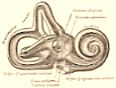
Along the auditory prism,
And notes painstakingly put on
The uniform of unison
Or motley of chromaticism.

The French horn is a golden ear.
The ear is spiraled like a horn.
And where they intersect is born
The tune that we were born to hear.

Pursue into its inwardness
The spiral, down to its least curve:
Note how it flows from nerve to nerve
Into a tiny emptiness,

Or a phantasmagoria
Of leptons spinning in the ear,
Or a translation, dark or clear:
Le son du cor au fond des bois.
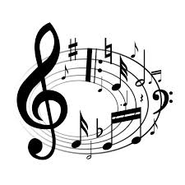
Autumnal

Addressed to Mr V.

Green in the fullness of its days
Spring swells, bursts into summer. The ember
Of autumn, dying in December,
Rekindles as the primrose blaze.

Red in the fullness of desire
The heart swells till it bursts in love
Amid the primrose and foxglove
And crocus flush with golden fire.

Soft tongues of beauty, living flames
Sparked into colours by the dawn:
Where has that nameless poet gone,
The one who gave you all your names?

2.
I walk, as one who drifts in dreams,
These woods where maples at their shed
Lay down a carpet of the dead,
And to my grieving heart all seems

A kind of pastoral suicide.
The reign of leaves is ending, ever
So slowly; but in truth, it never
Ends, save on the white, wintry side

Of things, whose sides are many. Dear,
We move, and have our being, and act
In sections of the Tesseract,
Whilst others know not we are here,

Or ever were. We cannot see
The whole wherein a past event
Stands side by side, beneath the tent,
With presence and futurity.

3.
Is there a wistful wit in leaves
Leaving each year for their hibernal
Bank holidays in the infernal
Old none-at-all-a-days? It grieves

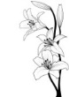
The anticipation of the vernal,
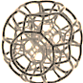
How fat soever be the sheaves,
Till it is scarcely one believes
That generation is eternal.

All that is strongly said but weaves
The wreath of elegy, to mourn all
The shrivelled children of the kernel,
The nothing up the Reaper’s sleeves.

As epics into the diurnal
Plunging see forests full of leaves,
So in his helmet and his greaves
Felled Hector falls. And the leaves turn all

Colours, and on roofs and in eaves
Collect, and in one blazon burn all
Away, away. Then the hibernal
Whiteness. The blackness in the leaves.

4.
But, Dear, you see my autumn crepe!
Recall the Tesseract of me,
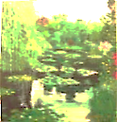
And that another side is free
And in a different landscape.

One part is gone, a broken wing,
For-Ever-Grief—while one reposes
Upon a lawn, breathing the roses.
My Dear, come see me in the spring!

______________________________________________________________________
Note by Mr V:

No mathematician, Oscar nevertheless learned from me such terms and concepts as the
tesseract,and put them to his own uses. ‘Tesseract’ (from Greek τέσσερεις ακτίνες, ‘four
rays’) is a term coined by the brilliant bigamist, mathematician and engineer, Charles
Hinton, in his book A New Era of Thought (1888), to describe what in geometry is to
the cube as the cube is to the square, an eight-cell regular octachoron or cubic prism, a four-
dimensional cube, or, as it is sometimes called, a ‘hypercube’. (It is, as well, one of the six
convex regular four-polytopes.) It is said that a man went mad trying to make sense of this
fiendishly complicated geometrical figure. Wilde appears to see this ‘fourth dimension’
as Time. It is worth noting, as well, that any corner of a tesseract has four perpendiculars.
Chapter Two
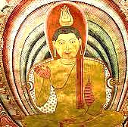

Promixta Theologia

The prisca theologia,
The philosophia perennis…
Many have never been to Venice,
But all are in one Gondola.

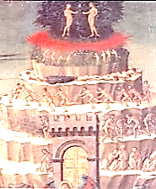
A Roundabout Cosmology

1.
And then the pivot of a comma
Spins me about, and I return
To C.3.3., and there I burn
In tinsel fires of melodrama,

I am in Hell, nor am I ever
Out of it, and by the same token
By which Eternity’s stained, broken,
And pieced again (as by a clever
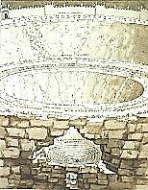
Craftsman) in what the eye sees as
White swans against a sky of blue,
When a warm wind blows gently through
The meadow, ruffling the green grass,

I am in Purgatory, am always
In Purgatory, by the same token
As who shall heal a promise broken
I walk the long, memorious hallways,

I am in Heaven perpetual
By the same (is it the same?) token,
Awakened now, and my fast broken,
I find it hardly bearable,

At times, this sorry Paradise,
For the sad secret of salvation
If you look hard, is resignation,
Writ in ice-crystals in its eyes,

Despair is only hope fulfilled,
So with its selves my soul debates,
Lingering by Saint Peter’s Gates,
So the same soul of mine that willed

Its way up from the lower realms
Is not the same that sees the good
Points even in the savage wood,
Rebellion gathers, overwhelms

A soul that doubts this is the best,
And the redundancy of stasis
Becomes the Luciferian basis
Of renewed longing and unrest,

As if there had to be a fall
From grace, as if there were a Schedule,
And now Hell is a burning red jewel
And a sidhe-cry and Siren call

That slices through the sound of harps
And psalteries and cold, hymning voices
Like mad despair, sick of its choices,
Chromatic accidentals, sharps

And keen augmented fifths arouse
In me, a critic always, even
In Heaven (especially in Heaven!)
A lust to join in Hell’s carouse,

To be there, or to have been there,
So I have always been in Hell
When the past drowns me in a swell
Of guilt that comes from everywhere,

But it recedes, the whelming sea
Of grief, the salt regret, again
I am, and will, I think, remain,
Upon the Mount of Purgatory,

For in real Hell or abstract Heaven
I am someone else, here only I
Am what I am, eternally,
It seems, when it is half-past seven,

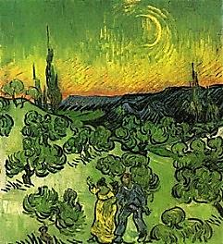
The Phases of the Moon
A Consultation with Yeats

What is it about Thirteen and Fourteen
That so compels me? They are where you are.
Or somewhere in between them: they are phases
Of the interior moon that guides and governs
The migratory movements of our souls.

So what the spirits said to George is true: Yeats’s wife. One of the fruits of her
The soul does have moon-phases twenty-eight— many automatic writing sessions was
Or is it twenty-six? At full and dark Yeats’s esoteric book, A Vision.—[Mr V]
There is no human life. In the twelfth phase
One lives and dies a hero’s rôle, like Nietzsche
Or Hector—even, a little bit, like you,
When your astounding folly gave your life
The purple of tragedy, not quite your size.
You were, or you were meant to be, a man
Of action. Then, the action… So I am
Between the thirteenth and the fourteenth phase?
Your hero days are past. Weak as a worm
You have become, and there is war within you.
I read this in your ‘Phases of the Moon’:
‘The soul begins to tremble into stillness,
To die into the labyrinth of itself’.

My soul has trembled into stillness such
As you perhaps could not imagine, Yeats.
And I have died into the labyrinth
That is my self: it was an empty place,
And, like all empty places, full of ghosts.
And now I do it all again, the trembling,
The dying, the stillness and the labyrinth…
This time you can escape, to Phase Fifteen,
Where spirit and symbol become absolute,
And Choice and Chance are one. Here, in the realm
Of poetry, vanishing is fulfillment.

Then, I suppose, I shall ‘pern in a gyre’.
And what will be your next phase, may I ask?
I lay them out before me like a pack
Of cards. I shuffle and reshuffle, and still
I cannot quite decide. What do you think?
I think you’d look quite dashing in a Twelve.

Please give my best to Mr Africanus. Yeats’s guiding spirit, Leo Africanus.—[Mr V]
A Round
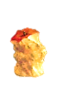
The Apple of Self-Knowledge is
Riddled with worm-holes through and through.
These tunnels give us access to
Both past and future, passages

Through Space and Time the Imagination’s
Free to take where it lists. A hunger
It feels to grow both older and younger
Than Time itself, expatiations

It craves that make it dwarf all Space.
But where does all this lead, and when
You move beyond all Time, what then?
Where is your hour, when is your place?

Old things no longer know you, never
Knew you at all. Imagination,
Eternal Exile, has no nation,
Doomed to its liberty for ever.

Things mock our child’s nostalgias,
Old haunts and faces now estranged,
And all is changed, and all is changed,
My Dears, and nothing’s what it was—

Nor what it will be when the One
Who boasts, Behold, I make all things
New comes around again, and sings
Once more that old refrain, and bone

With bone is back together stitched
To act in Resurrection’s latest
Production, and the least and greatest
As if from a long sleep bewitched

Are roused to play their parts again.
All things being infinite, you see,
Infinite, too, is the ennui
Of shuffling bits of where and when.

And fiery John of Patmos, too,
May yawn a little, when at last he’s
Obliged to play Ecclesiastes
And find in newness nothing new.
Chapter Two

l a
l a b y r i n t h i a
b h
y t
r n
i
r n
y t
b h
a i
l a b y r i n t h i a

Must Come the Hour

To climb the mountain or the set of stairs,
The spiral staircase in the ceaseless tower,
Or arduous Mount Maru, must come the hour.
But courage hesitates and hope despairs.

Must come the hour to pass the narrow gate,
The only exit from the hungry maze,
Mirror to doorway, past the fixing gaze.
The hour approaches, and the hour is late.

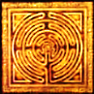
Deployments of the Labyrinth

1. Inscription

THE DEVIL AT THE ENTRANCE ISN’T DANGEROUS
THE SELF WITHIN, THE CENTRAL SELF? A STRANGER.
THE ANGEL AT THE EXIT IS NO ANGEL.

2. Enter MCV

Be calm. There is no exit from
The Library of Babel’s maze.
From aisle to aisle you move, and graze
Upon the books till Kingdom come,

Which it will not—save in this version.
Remove it from the shelf. You see?
‘Kingdom comes in three-thousand-three’.
A mistranslation from the Persian.

The riddles beckon, and one delves.
As I have written in a book
For which you shouldn’t try to look
On the infinity of shelves:

MCV MCV MCV MCV MCV MCV
MCV MCV MCV MCV MCV MCV*
MCV MCV** MCV MCV MCV MCV
MCV MCV MCV MCV MCV MCV Quoted in MCV: The Autobiography.

* An acronym: ‘Marcel Chérit Vinteuil’. A message from M. Proust.
** One-thousand-one-hundred-five, but only in this instantiation.
Can also be construed temporally as 11:05, but only antemeridian.
MCV… Any relation to you, my Mr V?

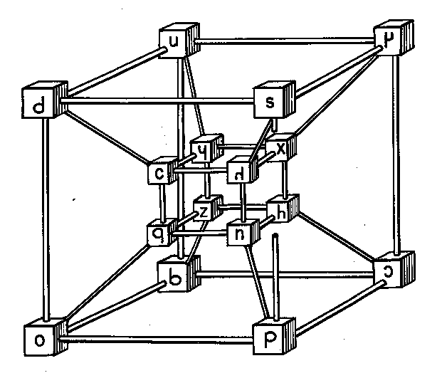

Mi casa e su casa.
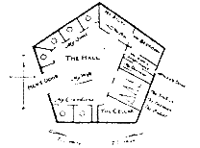
The Aleph and Other Things

By elegantly and accurately dreaming, a young, near-
sighted Argentinian author (de)materialises before me.
Out of an infinite number of incompossible Borgesii,
he is the one who happens to appear as a semi-fictional
character in a poem by Oscar Wilde. Or does he? The author has asked to be identified
in the text as ‘MCV’.—[Mr V]
Among the particles, one particle MCV appears in a wizard’s robe, black as night.
Contains the others, all of them.
Some call him Aleph. Some say Shem.
Chapter and clause, to the least article,

Is there, of particles and laws.
I saw my own face in it, and
My bowels, as well, saw from left-hand
And right-hand, fore and aft. No loss

Is suffered not retrieved elsewhere,
Though perhaps very far away
And inaccessible to-day,
Perhaps for ever. Need we care?

Why is it not enough to wander
In wonder through the labyrinth
That in a temple on a plinth
Is laid out for a god to ponder?

Though you may think yourself behind
Doors, you in fact are on a plane
Projected, in a square. In vain
From Aleph’s hyper-cubic mind

You ‘hide’: he sees your face. He sees
Your entrails. Fail to understand
This and you are trapped in Flatland.
Who sees not, him the Blind Ones seize.
The wizard gear is put aside and we sit down together
* on an old-fashioned chintz divan. We are in MCV’s
library (which is technically infinite), cocktails in hand.
The only bridge to Shangri-La
Is a staircase stretched laterally
Across the abysm. This will be
The maze that guides you to Trungpa.

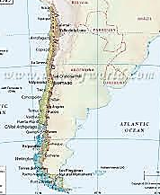
The Birth of Labyrinthia
as Told by MCV

1.
Chile fell into civil war
And self-seceded, west from east.
Chile, as such, is now deceased.
There are two where one had been before.

East Chile has its east and west.
These fight, as east with west will do:
East Chile breaks itself in two.
The reader can divine the rest:

West Chile, with its west and east,
Comes to the same result. Now, four
Countries where two had been before.
(Not that this matters in the least.)

Never is donned the irenic robe
Of international community,
From which the countries feel immunity,
For each is bitterly xenophobe.

This mad mitotic trend for years
Goes on, and each seceding land
Has narrower territory, and
Proportionately, the frontiers

Increase their territorial share.
Walk, and you cross a boundary; stand,
And straddle. There’s no room, no land,
Only the borders, everywhere.

2.
How name these subdivided lands
After so many iterations
Of east-west subdividing nations?
With so much little on their hands

Some poets suggest names like ‘Rose
West Eastern Chile’, ‘Lily East
Thrice-West’, the name increased
The more, the less the country grows.

On the street’s eastern side stands one
Nation, and on the western side,
Another; across the street’s Divide,
The no-man’s land, fire mortar and gun.

Some lands insist on numerals
Based on the Dewey decimal system.
The Founding Fathers, in their wisdom,
Named one land (seized, some say, on false

Pretences), ‘PR823
.J5 7325.’
Another name’s a Boolean hive:
Those noughts and ones spell sovereignty.

3.
Born out of so ingrown and vexed
A microgeopolitics,
The bickering Labyrinthians mix
Like strands of a disputed text.

To list the burgeoning names, with lower
And lower national populations,
Of these proliferating nations,
The Encyclopaedia of Nowhere

Has been compiled: a ninety-nine-
Ton-tome. After much legal battling,
The Book is laid down open, straddling
A dozen countries, on its spine.
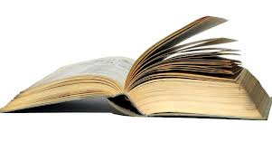
The Forking Paths and the Zohar

By elegantly and accurately dreaming, a young, near-
sighted Argentinian author (de)materialises before me
out of an infinite number of incompossible Borgesii,
He is the one that happens to appear as a semi-fictional
character in a poem by Oscar Wilde. Or does he? The author has asked to be identified in the text as
‘MCV’.—[Mr V] Hmm. Any relation to you, dear?

You never wrote the book you should We are sitting in MCV’s library (which
Have written. Thou of little faith! is technically infinite), cocktails in hand.
Oscar, my dear, you are a wraith.
I am writing you. You are quite good.

You know you were almost always right.—
‘Almost’? I see a falling off,
Apostate! It’s praise, not a scoff.
It takes but one mistake: Good-night!

I have not made enough mistakes,
I long to make outrageous ones.
You speak my language now, for once!
Yes, make as many as you can:

You may end up where none has been.
And if it is a luckless place?
No matter. We both know the race
Is not to swift or slow. To win

Is to lose opportunities
To fail in a magnanimous way:
For poetry this wins the day.
Explore all possibilities—

Oh infinite possibilities!
There is a place where polymaths
Wander like fools down garden paths
That fork into insanities.

And in a parallel dimension
You are the Chinaman who spies
For the Huns. I’m the one who tries
To open up to you the intention,

Unfathomably deep, of your
Forefather’s garden, in which grew
The Book it was. You never knew
Until I told you that, before
You thought to ask, you were the scion
Of one who seemed a failure to
His family, even to you,
But was a visionary Lion.

Well, he was infinitely clever,
That much is obviously true.
I owe my happiness to you.
Never shall I forget you. Never!

And here you take a pistol from
Your pocket and shoot me. The name
Of the ‘ammo’ depot is the same
As that of the town to which you’ve come.

You were successful. Headlines tell
The Kaiser’s men the place to bomb.
With an inscrutable aplomb
You will wear the noose. You have done well.

My death is penance, and it is
An act of gratitude, and love.
But meanwhile, in another of
My multiple realities,

I am a minor character
In a book written by a ghost.
There is a story, almost lost
In the sub-plots, in which I, sir,

Am the author of this book. This part
Is the key to the whole structure, and
Disproves that you had any hand
In the making of this work of art.

In this thread I am the narrator:
‘The stairway spiraled roundabout.
As I looked down, while leaning out
Over the trembling banister,

‘My father’s corpse went falling by.
It had been falling many years,
Skeletonised. I watched my tears,
A few drops, like rain in a dry

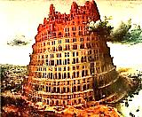
‘Climate, fall after him. They will
Evaporate within the hour.
Above, the stairs of Babel Tower
Shrink into the Illimitable’.

I am that father, am I not,
Falling into his past again?
A corpse that falls and falls… And when
He lands, he wakes—is that the plot?—

In C.3.3., and watches, this
Time, as he looks over his own
Shoulder as he looks over his own
Shoulder as he looks over his

Own shoulder Do you feel it, then,
The turning screw, the winding stair-
Case? and sees what he’s writing there:
Born you shall surely be again.

So I have brought you face to face
With the infinite. There’s nothing Greek
About it. Can one even speak
Of it, let alone give it place

And time, or any pleasing shape?
And yet you frame the Infinite
With elegance, you make it fit
Inside an image, a landscape,

A looking glass, a labyrinth
Or labyrinthine garden. Why,
You almost set Infinity
Upon a fluted marble plinth!

3. The Zohar

This version has it that you are
A man who is obsessed, so much
So, it is all you see and touch:
I mean the false coin, your Zohar.

You wake, and there is the Zohar.
You dream Zohar. You hear him call.
You paint the Zohar on the wall.
It is the Self you think you are.

Your vision becomes, finally,
Spherical, and the great Zohar
Stands in the centre, a dark star,
And front and back at once you see.

What can you do now but go out
Into the desert that you are
And fix on the great god Zohar
You will for ever think about?

And now you are the great Zohar:
You are the look of the Zohar,
And what is seen by the Zohar
And the Zohar of the Zohar!

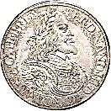
The Prison of the Prism

I see now that I am back in the Hall
of Mirrors, but on a higher floor, a
further twist of the spiral staircase:
not lust for one body, but the lust
of the eye for the Visible led me here.
I am in the Book of Mirrors, or the
conjunction of a mirror and a book.
Am I following the itinerary set
out by Diotima, up the staircase of
Eros, from loving a beautiful boy
to loving beautiful boys to loving
Beauty’s abstract invisible Self?
The invisible source of all the
beauty that one sees, the undying
Beauty of things that fade and die?

MCV:
You know all things to be illusion.
Mirrors and fathers multiply
As they disseminate the lie,
And yet you cling to your confusion

And worship the abomination
That is the mirror that you place
Upon a shrine, to see your face
Adoring its own adoration.

How paltry is mere symmetry
When every pleasing shape you see
Is ruined by Infinity,
Which says, To be is not to be!

When I look in the mirror that is you
I am startled by the absence of my own
Reflection. Is it hidden by a stone,
Or in the air one can see only through?

The Water of the Mirror
MCV

The punishment reserved for facile poets
Who, on a thoughtless reflex, liken mirrors
To water, is to suffer absolute
Immersion in the truth of metaphor,
Animal baptism by night and day.

Beneath the surface of a pond you catch
Fish with your bare hands, and you eat them raw
Like any beast. They squirm repulsively
Between your teeth, and sometimes they escape.
Your mouth emits curse bubbles: gargled parts
Of speech rise to the surface, where they pop
Into the glare.
The water is your drink.
And yet, because it is the element
In which you move, and have your shadowy being;
Since when it goes, you, too, must disappear,
You are, in essence, drinking your own blood,
Consumed with that which you are nourished by.

(In darkness, your continuing existence,
A parenthetical consistency,
Is an hypothesis the metaphor
Entertains purely for its own amusement.)

O how you hate the birds and the gazelles
That lap your precious sustenance away,
Hastening the arrival of the hour
When, on the hottest day of the dry season,
The pond evaporates, and so do you!

No longer does the instant fire of lamp
Or sunlight spark a pair of dazzled eyes.
Somewhere far off they fall, two drops of rain.

The gilded metal circle on the wall
Is pure xerosis, cleansed of you. Fulfilled
By emptiness, the frame is now the image:
The ourobouros. Serpent self-enclosed,
It curves around an undistracting blank.

The Thing that Wasn’t
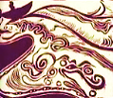

1.
I waft, I float, I dawdle and linger
Here in the In-Between; for being
Nowhere and everywhere is freeing,
Somehow. I needn’t lift a finger.

My ‘Boat of Ra,’ steered by a thought,
Is something of a drunken boat.
Look! Lazily reclined I float
Down a canal, past Angkor Wat.

I have no promises to keep,
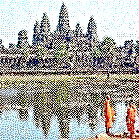
No obligations to be met,
And no appointments to forget.
I can do everything but sleep.

2.
For the dead have no place to lay
Their weary, immaterial heads.
The clouds make unreliable beds,
There is no night, there is no day.

No, an eternal wakefulness
Inside a dream that lasts for ever.
When the last human tie you sever
With those you cared for, you are less

And less attached to any place,
To any person, any time,
A stranger now in every clime.
And none can even see your face

And say, I do not know this man.
They do not know they do not know you.
And everything seems far below you,
All the spread landscapes that you scan,

For you are looking from a cloud
That drifts along, your floating home,
And watch the hurried humans come
And go in darkness like a shroud

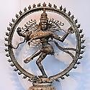
That covers them, of ignorance,
Of pain and pleasure, hypnotised
By moments so soon vaporised:
Gone at a single gamma-glance

Of Shiva, he for whom the Ages
Are counted by the second-hand,
And rise and fall of sea and land
And Empire, those tumultuous rages,

Are as a little puppet-show
Of lantern-shadows on a wall.
All these futilities appal
A spirit, nowhere do they go

And nothing do they come from, all
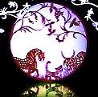
A microscopic business
Of tiny furies, meaningless
Buzzing of flies that hover and crawl

Over the body of your lover,
Left in a shallow grave somewhere
Deep in the woods, and you are there,
You helpless phantom, weeping over

The helpless corpse with phantom tears,
And this shall never be forgot,
And never shall you leave the spot.
Less than a minute are the years.

For you there is no time, but wake
Unending, and no opium
Can rescue this insomnia from
Itself. It is a frozen lake

In which the faces of the dead
Just underneath the surface stare
Up at you, asking you to care:
We lived! We were! You want a bed

To sleep in, sleep away your death,
A bed for endless sleep, and sound.
But it is nowhere to be found,
Above the clouds or underneath.

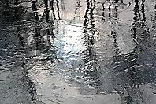
The now in which I speak: unreal.
Unreal the passion, life or death,
A rusty sword without a sheath,
A buried coin, a cast-off wheel,

Unreal, I say, unreal the pain,
The things you think you love, unreal,
Unreal the feelings that you feel,
An orphaned mind outside its brain,

Your thoughts are not real, and your senses,
Shadows of wits that once saw light,
Heard songs, and parsed the black from white.
And all the verbs have lost their tenses,

No ‘was’, no ‘will be’, and no present,
For where you are now is not now.
Do you begin to fathom how
It is to be a thing that isn’t?
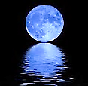
Stanzas for Asterion

The cursed are sacred, they are set
Apart. They wander lost in rooms
That have no house, and darkness glooms
Over the floors a spreading net.

He came for you, he kept his pledge,
And from his hand your head swung free
Of Gordion-knotted intricacy
Solved by the simplest, keenest edge.

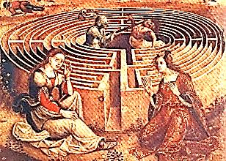
How Certain is ‘Curtain’?
Or: A Door, a Jar
A Philological Tragicomedy

Hermes leads me through a labyrinth of words.
1.
Open the curtains, dear. Let pass
The coaches and the clouds awhile.
Here is a tale to make you smile:
A story about words. If as

A philologian I may speak,
The etymology of ‘curtain’
Is veiled behind a weak, uncertain
Vulgate translation of the Greek. Which in turn renders
Heb. yeriah in Exodus.

Cortina means, in classical
Latin, ‘cauldron’, diminutive
Of cortem, from which we derive Derived in turn from
The ‘court’ in ‘courtyard’. (Thus the ‘fall’ cohortem (nom. cohors).

Of language brings a faint recall
Of etymology.) In Greek, ‘curtain’
(Aulaia) connects with a certain
Custom: not using doors at all

But rather curtains opening
On courts, as much as possible
Allowing the house to breathe and fill
With air, and what the breezes bring

Into it of their cool, with fragrant
Hints of a bright Athenian day.—
‘Curtain’ is but a silly say;
Consider it a semantic vagrant.

A cauldron serving as a door!
We’ve much to thank confusion for,
Like those illusions we adore
Until found true, and thus a bore.

2. The King, the Door, and the Assassins

The door is thick (with walls to match)
As the rooms lodged within are deep,
And has compartments spies can creep
Through on their intramural watch.
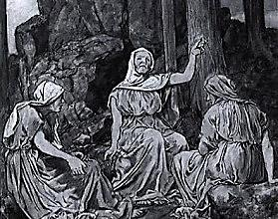
This makes the door a kind of room
Large enough to store, in one chamber,
Cauldrons with oil or fragrant amber
Filled; in another, at her loom,

A Norn is spinning out a cloth
Embroidered with a tragic story,
Which some might call an allegory:
The Angel Turned into a Moth.

An eyeless Norn the pattern feeds.
From sister Fates she brooks the schism,
Feeling her way by algorithm,
The writer, not the one who reads.
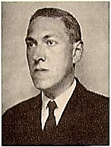
So thick a door has its own walls.
Through these a fricative sussuration
Like running water’s circulation
Of rats down intramural halls

Scurrying provides a score of rushed
And hurried whisperings, as of some
Omen of dire events to come.
And they will not quelled or hushed.

Behind the walls are other walls,
And behind these, the Old Ones wait.
Nothing’s more ancient than their hate.
They bide their time till Master calls.

They are off-coloured. Red-ed, blue-lue,
Green-reen: Colours for ever fleeing
Themselves, they so abhor their being.
They give their hate the name CTHULU.

3.
The King who broods within the walls
In one of myriad rooms (the palace,
Dear, was designed, with subtle malice,
As a maze, and ghosts walk the halls),

The King who drains his cup and laughs
For one insanely barking moment
And then declines all further comment,
Numbed by the Rhenish that he quaffs,

Is on all sides by foes surrounded.
Ah, the Great have great enemies!
He squeezes his mind’s eye, and sees
Some stones unturned, no fears unfounded.

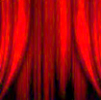
The King is in a parlous way
For he is trapped, besieged by mirrors
That multiply him by his terrors.
They own his mind. He is their prey.

The assassin in the door is dazed
By thump of treadle and rush of rodents,
And by a maze of chambers so dense
He wanders lost and slightly crazed.

The assassin in the walls is guided
By priests to a small entrance whence
He issues, knife in hand. His sense
Of orientation a decided

Turn for the hapless takes, however,
For where the hidden King may be
Is anyone’s theology.
This murderer, too, is lost, and never

Heard from again. For there are many
Spare spaces in the tombs inside
The closets where a ghost may hide.
For such, may Charon waive the penny!

The King could sometimes wish his killer
Might find him, and conclude the endless
End-game that so torments him, friendless
And weary. From behind a pillar

He dreams him springing with the knife
And writing in his willing throat,
To end a play not worth the groat,
A bright red finis to his life.

4.
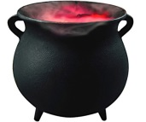
So I ‘draw-to’ this cauldron-curtain
Of words and all therein contained.
I hope it was not well explained:
One wants things thus, a bit uncertain.

Theseus, Tithonus
In Astral C.3.3.

Labyrinthian Pledge of Allegiance

I pledge allegiance to the Land
Of Labyrinths, and to the god
Of this wan nation, under sod,
And to the Man-Bull, axe in hand!

1.
How many quests is Romance made
Of? How many mazes are there
In the House of Mazes? Climb the stair-
Case in its spiraling, past the jade

Monkey simpering on its plinth
Again, and again pass the jade
Monkey: the charm begins to fade
Of living in a labyrinth.

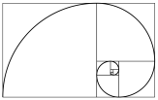
So many stairs to climb, and quests
To question or to quest, that is
The question. There is deep unease,
Arthritis in the knees, the guests—

The guests!—have long since gone, and I?
I am your charming host, Tithonus.
I bear my house, its creaking onus,
With shrinking strength, and dimming eye.

I am the weary master of
The mazes, and their slave. My heap
Of questing-trophies I still keep
In a room several floors above.

There I am, sitting by myself.
They’ll never find me here in this
Attic. My Don Quixote is
Looking sad up there, on the shelf.
*
Once more, dear friends, into the maze!
Is getting lost perhaps the only way
Out of here? It will be a lonely way.
I still must serve so many days,

So many days, so little time!
It is not gentlemanly to rush.
Nor yet to beat about the bush,
When burning. Ah, these walls, this lime!

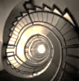
The Minotaur

Or is he something different,
This creature waiting in the centre?
One part of him is a young renter
Used and discarded, perhaps bent

On vengeance for my having shown him
Glimpses of a world not his own,
Spoiled now for his, stranded, alone
In the sea back to which I’ve thrown him,

Now alienated from his kind
And to the Paradise he’d known
Denied re-entry, twice-alone.
(All this takes place inside my mind!)

Parts of him are my family,
It may be: Constance and my sons.
A good husband and father once,
When I pursued debauchery

As if it were my Holy Grail,
I quite forgot them, gave them not
A thought. I left my wife distraught,
My sons neglected. And I fail,

Even now, to understand just why.
The monster is the unhappy life
My helpless sons led when my wife
Could find no reason not to die,

When they were left to the cold care
Of relatives who punished them
For my sins. For this I condemn
Myself to climb, stair after stair,

The spiral of my guilt, to thread
The maze of my indifference
To loved ones. Acts that made no sense
Now make that nightmare sense, that dread

You’d feel, trapped in a prison-maze
Of the kind drawn by Piranesi,
Cruelly, rigorously crazy,
And infinite are the crooked ways,
And not one way leads anywhere,

Narcissus the Cogito

Malin génie, why did you let me sink
Into this maze of watery mirrors, caught
In multiple reflections of one thought
I think I think I think I think I think?

Or leads you back to where you started,
A wilderness that can’t be charted—
And the monster waits hidden there.

Clutched in its hand there is an ace
Of clubs, or simply a club, or say,
A card left at a club one day.
It knows its way around the place.

I know it keeps its hungry den
Somewhere inside. I hesitate
And hide until it is too late.
The nightmare must come round again.

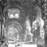
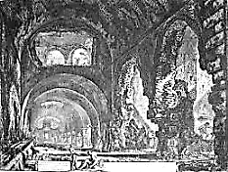

The National Flag of Labyrinthia.

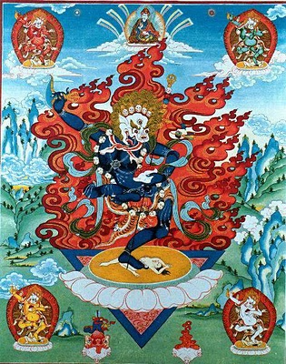
The Wrathful Goddesses

First, the Wrathful Gods, dancing like Shiva, with horrible faces,
gibbering Queensberry faces, pursed-lipped Justice Wills faces,
mutton-chopped jeering Cockney faces, horrible, oh horrible!
Then the Wrathful Goddesses, and all of them are aspects of
the damage that I did to my poor Constance: shapes of guilt!
A vampire, bleeding from her loins!
Pregnant and bleeding from her loins!

Then shall I call you Dragon Lady,
Daughter of Draco, or Dracul,
A whispering, seductive ghoul
‘Mid trees, in a wood drear and shady?
Kali, tongue lolling, dancing a bone-shaking
dance over my sprawled, lascivious body as I
lie in bed with a young renter—the walls shake,
the world shakes, my brain shakes within my skull!

Then shall I do as the Bengali
And make of the dark goddess my
Madonna? For I have caught the eye
Of the annihilating Kali!

Horrible goddesses of the Underworld, decaying black
corpses of prostitutes exulting over my humiliation!
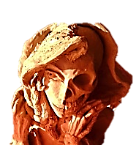
Shall I call Hel’s decomposition
Black Resurrection, shall I call
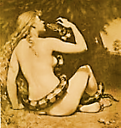
The gangrene of Ereshkigal
Beautiful, and a Heavenly vision?

Now, beautiful Lilith—or is it Alfred Taylor in drag?—
approaches. She is beautiful and pale and forsaken,
and full of little hungers! She has a serpent’s tongue!

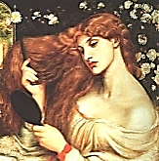
Come, Lilith of the witching smile!
The lila of the lily be
And lotus of the Mystery.
Illude me with your charming guile.

Ill there are many who have known
Those charms, O Belle Dame Sans Merci;
Many the dead. The Mystery
Will not be still, it thrills the bone!
You are the goddess and the demon,
Betrayed for-ever for another,
The monster Grendel’s monster Mother
You have become, and no man’s leman

But a devourer of man-flesh!
You are coming after me! You flare
Your nostrils as you snuff the air,
You want my blood, you want it fresh!
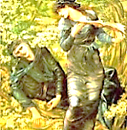
Now it is a beautiful young Artemisian girl, slim-
hipped, with a face uncannily like my Bosie dear!

Sly Vivien is Lilith now.
Me, Merlin, she has coaxed dark treasure
Of magic from. She waves the measure
And weaves the hands, until somehow

I am imprisoned in an oak.
I can see only her, and she
Alone can see me. Doomed to be
The victim of my foolish stroke

Of whim, of love (and none-too clever),
‘Twas I who taught her all she knows,
Enough to bring me to this close.
I am a prisoner here for ever!

The inner walls of the oak are slowly closing in on
me. I will be crushed to death over and over again!

Except that in the Oghum script…
What is it in Brythonic, or
Could it be Gaelic: oak is door,
Duir. This trap may yet be slipped…

And now the interior of the tree begins to
resemble an illustration by John Tenniel: am
I in Alice’s Adventures Underground?

This oak tree, that is, has a door.
I look around: ah, there it is!
A cat-door. Shall I be Alice?
I’ve been as small as that before,

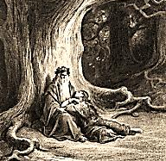
Quick business for a man turned cat
To slink through a tight aperture,
And so escape. But am I sure
It is as simple as all that?

Alice stands in the door, very, very small, but
I suspect she will grow tall at any moment.

Am I inside a bigger tree,
The World-Tree? You’re a horrid man,
But I shall help you if I can.
Quick, through this door! And I am free.

Free to be what? I have escaped
Because I am small and thin, a ghost,
A hungry ghost! Free to be lost
Inside the twisted soul I have shaped!

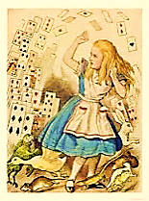
‘Everyman’ Refert
Knowledge returns, and has the last word.

Help, someone! Help! I have no food!
I am a Hungry, Mouth-less Ghost.
Knowledge, help me, or I am lost!
I am so sorry I was rude.
Every man I wyll go with thee
And be thy gyde, in thy most nede
To go by thy syde.—(You do mean need?)
I know the way. Follow thou me.
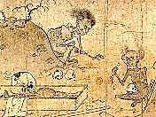
Escaping from the Labyrinth

These walls are blankness washed with lime
And I can find no passage through.
Where is the Aleph-gate, where do
The spiral stairs begin their climb?
I seem to hear the voice of Orpheus
The origin that rhymes with sin. echoing down the cavernous hall.
The fortune made so soon unmade.
The forward step, the retrograde.
The sin that rhymes with origin.

Selfless Poet, where is the gate?
I think I will be lost in here
For ever if you don’t appear.
You have lost time. Is it too late?

Follow me, I will lead you out.
You will not turn and look at me
And leave me here eternally?
Trust me! There is no time for doubt.

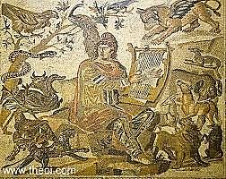
Quieting the Eye
The Voice of Anthologoios.

1.
Be blind awhile, and listen, dear.
Your eye has done you much offence.
Lay black crepe on the hungry lens.
Let Beauty enter through the ear.

Let the acrobats of vision rest,
No more upon the retinas
To dance their hand-stands for applause.
Let colour drain into the West.

The prism that has broken light
A million ways to feed your eyes
Let break, that all the hues may rise
Back to their Heaven vague and white.

Accept the music of what is
Into the blind and cradling ark
Of listening, where Truth is dark
And sheltered from all images.

The music feels its way along
The labyrinth. By feel it knows
The furniture of nerves, it goes
The spiral journey of all song

That wants to build into the joy
And soft explosion of its power
To make a blossom of an hour.
It is not still, and does not cloy.

Nor is the ancient music gone.
Great Memnon sits upon his throne
Built of cool ratios of stone
Whose architecture sings at dawn.

Music is the link, isn’t it,
Between the Mathematical—
The expressible—and the Mystical,
The inexpressible infinite?

And wasn’t it a Cantor who
Equated the Aleph with the Lord?
A Cantor, too, who set the Word
To music infinitely through-
Composed, as it were, intricately
Deep as it is perspicuous,
Yet filled with soul? Yes, hear it thus,
Theomathemusically.

2. Pythagorean Orpheus

Vision finds sanctuary in time made rhythm.
The auricular nerve vibrates in unison
With Orphic strains, and ear and harp are one.
The spark of joy leaps the synaptic schism.

He tunes the music on his giant harp
Of myriad strings, each string a particle
Or wave, on staves multidimensional.
In neutron flat or in electron sharp

Through the star-eaten body of the dark
The fugue of matter and energy pursues
Its trillion courses, bent to split and fuse
And split again to fractions of a quark.

The lowest octave of a stone he plays;
And in the sopranino heights of space
In fiercest notes, each with a Shiva-face,
The furious descant of the gamma rays…

Everywhere wave-functions decohere
Symphonically in whispering, roaring, sobbing:
Basso profundo of the black hole throbbing.
Flute notes that keep their distance, although near.

Our lives and deaths vibrate across the strings.
Pythagorean Orpheus orchestrates
The Vast from its minutest quantum states:
He is the infinite part-song that he sings.

Harmony Lessons
The Voice of Anthologoios.

Pythagoras studied well the intervals,
And reasoned out the rational harmony
Of unison, fifth and octave. But when he
Heard cosmic harmony, his ears played false.

He shied from the alien interstellar reaches
Of the overtones, where crackling dissonances
Perform chaotic microtonal dances;
There, eardrums shatter as Shiva booms and screeches.

(Students of harmony were the Chinese,
As well. They knew the chord built on the third.
But the Emperor forbade it, for he heard
It as a dissonance. It did not please.

And so they cultivate their garden plot,
The pentatonic scale. And yet they savour
The timbre of zither or flute, the dissonant flavour
That is nuance, a subtlety of thought.)

In the black vacuums, aleatory is
The music of the spheres… We hear white noise,
Echo of an Explosion. The human voice
Has no place in that stifling abyss.

Then let us cleave unto our simple psalms
To scaled-down, manageable Sublimity.
The storms of a Beethoven symphony
Are not the Ocean’s furies, but its calms.

The Music of the Spheres
The voice of Anthologoios.

All things return, and now the time draws near
When Shiva will make light of rocks and bones.
All will be light, and silence will descend.
All will be still, and gathered at the end.

And in that silent stillness Soul will hear
Its inmost, esoteric microtones,
In all their timbres—ancient hopes and fears—
And these will be the music of the spheres.

The Music Ends
The Voice of Orpheus
The melody’s end is not its goal. But until it reaches its end, it has not reached its goal.
—Nietzsche
The music ends too soon so that the ear
May ring with wishing it would never cease.
We learn to love by losing what is dear.
Just when with parting we have made our peace
The music ends

In a smoke sharp enough to sting a tear.
Those Odes to Joy are Heavens that we lease.
The Timeless briefly hovered and was near.

Da capo then, belovèd Masterpiece,
The only Opus that we ever hear!
A rosin cloud drifts over the high C’s:
The music ends.

Fire in the Hall of Mirrors

It watched itself burning from every angle:
Fat bulging dwarf flames and tall skinny tongues
Of fire blackening the glass panes everywhere.—
Or was it just one more of the magician’s
Tricks, the flash powder, crimson ribbons, crackle
Of cellophane? The heat: was it the fire
Or a blast from the registers along the floorboards?
Revelers ran lost and screaming through the hall.

But weren’t the revelers, perhaps, just actors?
Was screaming in the script? When they ran ‘lost’
Wasn’t it along paths chalked out for them
By the production crew? Was this a motion
Picture? As for the mirrors: Were they real?
The smoke you mentioned: Was that really there?—
You can be sure about the smoke and mirrors.

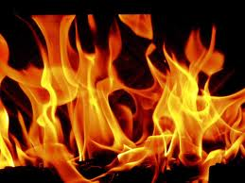
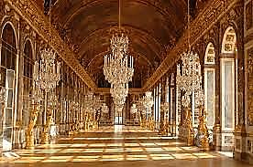
Holding the Mirror up to Artifice

Show the mirror its own reflection.
Catch the reflecting in the act.
The coating with which it is backed
Let it look back on. Introspection

Makes the impassive speculum
Turn Hamlet, making question of
Beerbohm Tree.
Itself. How can Narcissus love
His image when, like a fine scum,

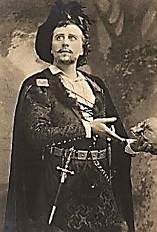
Doubt clouds the mirror of the pond?
He doubts his self-love, for he doubts
He has a self. And when he shouts,
Whose echo mocks him from beyond

That stand of trees? His too-close look
Dirties the lens and makes obscure
What Surety once thought most sure.
Perhaps he is written in a book…

A character made of characters?
If he exists, is it because
Someone is dreaming that he does,
And dreaming him a universe?

Let but reflection once reflect
Upon itself, and ‘twill confess
Too-great awareness makes things less
Real, and not more. Let it direct

Upon itself its shining beam,
As through a magnifying glass,
Till tinder-dry as summer’s grass
It bursts into a Phoenix dream,

The flame, the victim and the pyre.
Out of the ashes may arise
A ghost with second-sighted eyes,
Self-fathered in the purging fire.

Mercury’s coat makes glass look back
At us, but Mercury’s a liar.
(Yet life may lovely lies require
If truth be but a Void, a Lack.)

Even second sight may prove a liar.
Who knows what lies behind the lies?
Illusion, that so charms our eyes,
Is but the mirror of Desire.

Hamlet Revisits Mimesis
After Smoking Hashish
Car les miroirs ne nous montrent
que les masques.—Salomé
…To which I say, just as the sound
Should be the echo of the sense,
The ‘look’ of words, as at lines’ ends,
Should mirror it, should show the wound,

If wound there be, in body or soul,
In its own texture and proportion,
Give back distortion as distortion,
Crack if it must, or take the hole
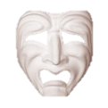
Pain’s arrow makes into its own
Vitreous flesh. To push mimesis
To the point where it falls to pieces,
Glass shivered by an overtone,

Irruption of wild Energy
Into the Image till it shout
In shining shards, features blown out
In shattering thermal ecstasy,

Unmasks the features, shows the face,
That fragile mask, in part exploded,
With regions patchy or eroded,
How tenuously it stayed in place.
He holds a mirror up to my face.
I wear the Mask of Tragedy:
The twisted rictus on my face
Is permanently glued in place.
I am that mask, the mask wears me!

Canst thou not stand the looking glass?
Then break the glass and break thy face
Into a thousand faces, face
The breakage of your looking glass!

The Mirror-Man
MCV

The mirror suddenly saw itself in the mirror
Of a man. On assignment from The Daily Mirror, the man
Interviewed the man who was once stared down by a mirror.
The Man-Mirror you saw in the mirror was a man
Looking in the mirror at a Mirror-Man. Smash the mirror.

Bits of mirror lie on the floor. Step over the shards of Man.
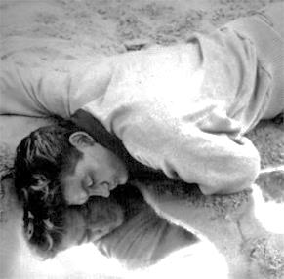
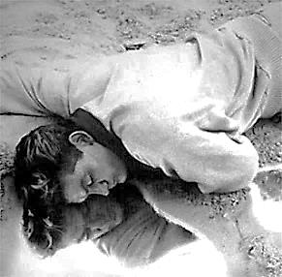
Three MCVs and the Garden
of the Earthly Paradise

The truth is that we all live by leaving behind; no doubt we all
profoundly know that we are immortal and that sooner or later
everyone will do all things and know everything.—MCV

1. MCV-Marcel ChéritVintueil

This bloom, this little seed you see,
This wilted stem (is, will be, was),
Prenatal, present, posthumous,
Existing as one, shimmeringly:

Lily and violet and rose.
What would you name this little tract?
The Garden of the Tesseract.
Much like your novel, I suppose?

2. MCV Proper

That fall you took from the edge of the
Cliff in the Alps? It was into
The bottomless regress of you
And your return, eternally.

The year is nineteen-forty-six.
In nineteen-thirty-nine you were
Reborn as Trungpa. And yet here
You linger on…You are in a fix:

In this version, by some mistake The ‘1946’ version.—[Mr V]
You have reincarnated as
Yourself. Just as the one I was?
That makes no sense! Strange they should make

This sort of error; it’s very rare. Looking back from the 1950’s, I am tempted by
No matter. The strange Lethean spell the ‘Everett Interpretation’ to speculate that
Was such that you could hardly tell Oscar’s karmic wave-function carelessly allowed
The difference that wasn’t there. itself to decohere into two parallel plot- or world-
lines with two different outcomes.—[Mr V]
It must be when my ghost went back
To this poem, or the sketch I made
In C.3.3., when something bade
Me gather up those threads gone slack

And undertake to finish what
I’d started and abandoned. Then
I fell into this loop. Ah, when
Will it be finished? Tell me that.

We take the fork in every road.
There is no finish. Things continue,
Merge and diverge, without-within you.
There is no code that solves the code.

3. MCV A.M.

Rotate the Tesseract a few
Degrees, and go back seven years
Where your next avatar appears.
You become him. He becomes you.

All this is set for February
The twenty-eighth, at MCV
(11:05) A.M. Be
Ready. These schedules never vary.

It is here that your journey ends
And the long poem is at last
Complete. Abandoned! No more past.
‘Your’ future is waiting: you will be friends.
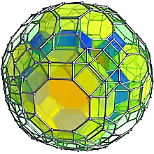
Crossing the Bridge

And so across the bridge I thread
My way. Two ropes support and guide
Me lest I fall from either side.
And the loose planks that I must tread

Are each a house, or tesseract,
A space in time, my life and times.
As arduously as one climbs
A mountain I traverse each tract

Or wooden rectangle, for each
Has depths down which a man might fall,
And rooms for getting lost in. All
Below is depth, but within reach

Is the other side—no turning round!
A tiny figure in the vast
Landscape I walk until at last
My feet are safe on solid ground

And I am in my Shangri-La,
Perched many miles above the abyss.
My home away from home is this.
Here waits my soul’s next avatar.

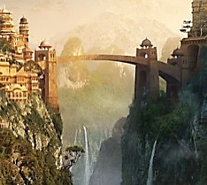

The Sacred Monster Stellified

The sacrificed abomination, the one
Whose palace was an endless prison house,
I raise amongst the heavenly carouse:
The darkly shining god Asterion.

*
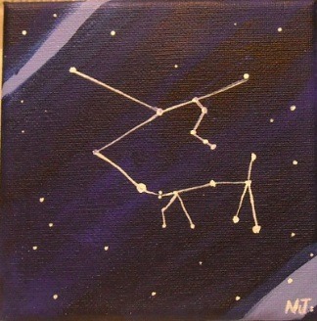
Chapter Four

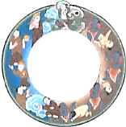

The Metansomatosis

of
Oscar Fingal O’Flaherty Wills Wilde

From the day when [the Greeks] left the chill table-lands
of Tibet and journeyed, a nomadic people, to Aegean
shores, the characteristic of their nature
has been the search for…

—From The Rise of Historical Criticism

*

Blue! ‘Tis the life of heaven,—the domain
Of Cynthia,—the wide palace of the sun.
—Keats

*

Old China Blue,
With a bright sunflower
He’d play by the hour.
He was utterly, utterly, utter-too-too.

PatienCe, MY DEars! The ENd is NEaR…
Some tying up of loose ends, loosE
Lines, and EAch hanging-bacK CAboose
To close tHE circles oF the sPhERE…

Donot all thinGS come Round again?
They do, and round again They come.
Away fROM home away FROM home,
Nomad, how to tell loss from gain?

Selfscape, with Topologists and Avatar
i.
It is a heavenly mistake
To seek the Absolute, one sighs.
The Truth is not in Paradise.
The Truth once tried its best to make

It through the gate, but was too wide for it.
Sadistic is the sun, the moon
A masochist. They are in tune.
I lived for Pleasure and I died for it.

ii. Topology

Is geometric caricature,
This or that feature exaggerating
In ways that can be quite elating
Or too restricting to endure.

What creature logically absurd
Survives the heckling torsions? I
Am far too much myself. They try
To round me off. But I am a surd.

Karma and Fate are having sport
With me, exploiting my psychology
To work out problems in topology.
To what extent, when they distort

The curves and ratios of me,
Do I retain my properties,
And at what point do I lose these,
And with them, my identity?

Becoming someone altogether
Other, a wholly different entity.
(Is this perhaps my alientity?)
As wood is by the harshest weather

Tested, and learns if it is proof
Against vicissitudes, can stand
These changes without warping and
Discolouring, fit for wall or roof,

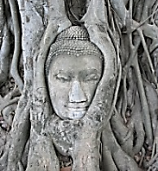
So Karma bends and stretches me
(For instance, making me employ
A word like ‘Karma’!), not to annoy,
Though, so much as to set me free.

Can Oscar change in all these ways
And still be Oscar? Need he be?
Negative capability
Can go no further than this place.

The question that the Buddha would
Not answer: Whether an underlying
Soul, through the cycles of our dying
And being reborn, subsists, for good

Or ill. Is some identity
Retained through all the transmigrations
And up-and-down reincarnations—
In Hindoo terminology,

An Atman, indestructible
Since it is one with the Unthinkable,
Brahman, and therefore is unsinkable
So that in the end, all is well?

(If I am to be reduced to my
Essential Self, I hope my Atman
Is not this forty-year-old fat man
But the trim youth of days gone by!)

iii.
Is this so different from my old
Aestheticism, my defence
Of the Unreal? The world of sense
I made into a calf of gold,

Perhaps. I spoke of the undying
Beauty of things that fade and die.
Now all I see is sky, and sky.
I find all this a little trying.

iv.
Sometimes I hear a child’s voice speaking
From where? I have chosen to assume
That it is coming from a womb.
He is the one I have been seeking.
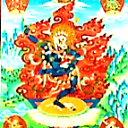
Affinities we two have found
With one another. They are expressed
As radical difference. Yet, from west
And east, we meet upon the ground

That is the table land from which
The Aryan shepherds long ago
Descended to become, below,
The Greeks. The irony is rich

As blood must be (and feet well-shod!)
To brave the skyey altitudes
Where light is closer, where it broods
Upon the mountains like a god.

It was for light his ancestors
And mine (and we both share these same
Ancestors) always sought. Though name
Gives way to name, ‘tis the one course

Our vision follows, one direction:
Toward the light, and even the dead
Move towards it, as if by light fed.
I see you’ve done some introspection.

I was, until those years, an antic
Sage, Bodhisattva-like in some
Respects, and to this pass I’ve come
(In bodiless form, yet still…Romantic)

Because the seer-through-the-veil
Who should know all is an Illusion
Betrayed the Unreal, to his confusion,
When he the veil rent (you won’t fail

To catch my meaning) and so fell.
And that is why all this was bound
To happen: that I circle round Trungpa manifests himself.
Myself to meet you, and how well

Met we two are, Trungpa! We’ve both
Covered much ground to find each other
As the other. Brother and anti-brother!
I want to rouse you from your sloth.

You spent six years in college, no?

The Buddha on the Five Senses

Let one cut away the five, relinquish the
five, and, especially, cultivate the five.

—The Dammhapada, XXV
—The Dammhapada, XXV

Not till your thirties did you write
Substantial things. For one so bright
And quick you can be rather slow.

Dear, you must promise me no longer
To dawdle in the Bardo. Four
Decades you’ve lingered at the door:
Still you will not pass through. Be stronger!

v.
And so Aesthete will undergo
A deformation into Mystic.
By twists and turns almost sadistic
The hedonist must come to know

The pleasure of renouncing pleasure.
The lover of gems, intaglios
And precious sonnets and the rose
Must look on vistas without measure. The Himalayas writ infinitely large.

O little, well-wrought things, a face
Youthful, chiselled and marble-white,
Blue china things, a touch as light
As air: you fade into pure Space!

Something within me will be ‘smart’
Even in the presence of the Unthinkable.
(Then is my shallow skiff unsinkable?)
How worship at the shrine of Art

When it is dwarfed by boundless shrines
Of luminous emptiness and peace,
The stars beyond the stars, the seas
Beyond the seas, the light that shines

Nowhere for no one and for ever?
I’d love a spot of tea and crumpets
Just now. And then the Angels’ trumpets!
It seems a tedious endeavour.

vi.
Among such far-too awesome shapes
One takes a page from Heraclitus
And counters the sublime arthritis
Of mere Immensity’s landscapes
With this perspective-thought, that small
And great are from ‘a god’s-eye-view’
The Same, are One that plays as two.
Scarbo is Scarbo, dwarf or tall.

My Crystal Sonnet

I console myself by trying now and then to put the ‘Universe’ into a sonnet…a strange crystal that mirrors all the world… Poetry should be like a crystal: it should make life more beautiful and less real.

—From an Interview

To put the Universe into a sonnet:
No small thing! Yet, though intricately clear,
It would be small… And when you looked upon it
You’d see yourself inside that crystal sphere,
But only as one atom among many,
A myriad, nay, wholesale infinity!
A sonnet coined into a cosmic penny
Would by itself be seen, and, seeing, be,

And find its purchase in the fact of seeing
As the act of being seen. How Truth would change,
Knowing ITSELF! So rich would grow the real
That Truth would prove to be the dream of Being,
The Terror of its Beauty, and the feel
Of something unimaginably Strange.

vii.
I am with the Greeks, in that I want
A world built on a human scale.
And if in Beauty it should fail,
And of Sublimity make vaunt

In the brow-beating Infinite,
I take my stand with the Unreal.
Profundity, I tend to feel,
Is over-rated. It lacks wit.

Nietzsche has written that the Greeks
Chose superficiality
Because of their profundity.
They knew the Deep, that what it seeks

Is not what human beings seek.
What does it want? Its purposes
Are not our purposes. This is
A scandal to an ancient Greek.

viii. Infinity: a Critique

The very idea is absurd.
A concept one cannot conceive
It seems quite pointless to believe.
If one could touch it—if a word

Of two it would exchange with me—
If we could have a conversation
About Art, Classical civilisation,
Or even the economy,

Things would be different altogether.
I wouldn’t even mind if IT
Lacked skill in repartée, or wit.
We’d simply talk about the weather.

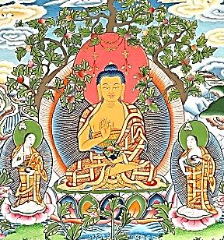
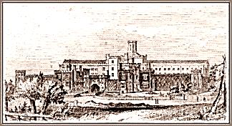
A Conversation with Thomas Martin
In astral C.3.3.

1.
Now the great Brahmin sages: were
They wise, sir? Very wise, indeed,
Thomas—much wiser than one need
Be, possibly. Is that so, sir!

Three Aspects Brahman has, to wit:
There’s the prolific playwright, Brahma,
The grand Creator of the Drama,
Shakespearean in his infinite

Variety of invention, rich,
Strange to the point of stupefaction.
Prompter Vishnu sees that the action
Goes off without an awkward hitch.
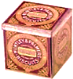
Shiva the cold and analytical
Can shut plays down within a week
Of opening with his critique,
For he is nothing if not critical.

2. A Fairy Tale

Once upon an Upanishad,
Dear, and a very good Upan-
ishad it was, after some one
Million million years, a god

Named Brahma made the universe
Of things that seem, and on that seeming
Based all the is there is in dreaming.
In Brahma’s night did they rehearse

Their traffic on the lighted stage
Of day, in light of mighty Brahma’s Day.
And on that stage they play, dear Thomas, day
And night. Ah, they are all the rage

There is inside the soul of Brahma,
Besides his supernovae and
His newborn worlds. Look in the hand
He stretches out: our tiny drama!

Metansomatosis

So restless Soul must make her rounds,
And a new suit of flesh encloses
Poor Psyche. Metensomatosis,
Platonists call it. Ah, it sounds

Much like a medical condition,
A chronic illness. Which it is.
Ignited by a moment’s bliss,
We die into that brief coition,

Prisoners of sexual gravitation
As planetary bodies are
Prisoners of the nearest star.
Look at our herds, in transmigration!

*

Will the last variant of all
No longer recognise the theme,
Or hear it as in a vague dream
One seems to catch a distant call

Too far for the intelligence
To pattern, intermittent smattering
Of a tune past the range of mattering,
Except for that uncanny sense

It has of the familiar,
As of a homing signal humming,
Summoning you to a homecoming
To some unknown ancestral star?
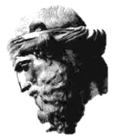
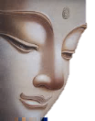
The Astral Ashram

How earnestly I try to groom
My soul for union with the godhead!
My mantra I have learned—and nodded
Off humming OM (pronounced AH-OOM)

By the fourth or fifth repetition.
And it is not the sleep of Brahman,
But of the heavy, lolling, common
Variety, with no dream or vision,

But a deep, indolent, animal slumber,
Stuporous, almost comatose.
No rousing me when once they close,
My lazy eyes, and should you number

The days I’ve slept by piling bread,
As Utnapishtim did when Lord
Gilgamesh tossed and turned and snored,
A demigod turned slug-a-bed,

You’d build a wall extremely high.
The lowest loaves, ‘tis to be feared,
Crumble, and grow a moldy beard
As the wall rises to the sky,

So that eventually it must
Collapse upon me like a ton
Of bricks (the kind bread’s baked upon)
And I am crushed into the dust.

Therefore, before it is too late,
I may play truant from all this.
Sometimes the most enlightened bliss,
Perhaps, is not to meditate.
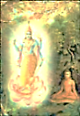
Krishna the Blue
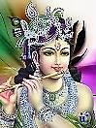
I join the god speaking
to His devoted disciples.
And let the Yogis day by day
Practice the music of their souls
Far from bazaars and waterholes.
For solitary is the way.

I see how you upon me dote, He catches me staring at
Priyah! Would you prefer another, his adrogynous beauty.
More Grecian god? Then I am my brother,
Hermes! And does not Caesar note
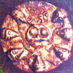
In passing in his Gallic Wars
How the Celts love your trickster gods
Who use their wits to beat the odds
And prefer subtlety to force?

Aengus and Ogma are among
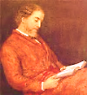
My veils; these storytelling bards
Are in my pack of knavish cards.
Shape-shifters shall not be unsung!

Picture me as your Fairie Queene,
Speak to me, dear, as to the wee
People, the good folk. Let us be
The best of ‘mates’ tonight, I mean William Allingham,
poet of the wee folk.

The very best of friends! The friend
Of men and women all, I move
The Ying and Yang and Tao of Love:
If you so choose, that way I bend.

Old China Blue, I am Krishna, young
Blue India! I am the sky
That tents the Himalayas. I
Am the sad, distant fluted song.

Even if another deity
You worship, if with pure devotion
You do so, with sincere emotion,
With love, you also worship me.

O priyah! Look into my heart!
Ah! dost thou not see all things there?
Thy heart is there. And now, my dear,
Look in it: see me? THAT thou art! ‘Tat tvam asi’. Chandogya Upanishad.
Another Charming Chat with Krishna

Or Christna, or Krist? Oscar’s ‘pronunciation’ was
often ambiguous between ‘Christ’ and ‘Krishna.—[Mr V]
How often do I sit and brood…
Do transmigration’s charms reside
In leaving one unsatisfied?
On to the next, the bad, the good.

Do the gods have gods of their own,
And so on, pantheon on pantheon?
The unfading flower, the amaranth, eon
Following eon, outfacing stone,

Blossoms in myriad dimensions,
And every petal of it all a
Burgeoning, intricate mandala.
Who can divine its deep intentions?
It rests upon itself, and not
Even upon itself. And none
Knows what it knows save it alone.
Perhaps it knows not. It is a thought.

It is the thunder, and the still,
Small voice. It is serene and deep
As in his cave the hermit’s sleep.
It is the glow beyond the hill.

The amaranth, immortal flower…
It also takes the name, Love-Lies-
A-Bleeding. Ah, love kills, and dies!
I want to call it back, the hour…

Think that the tumult and the pain
That made your life a wasted thing
Was but the Dream of the Red King,
And he has woken up again.

Who can rekindle a dead star?
This is how it has always been.
The time has come. You must begin
To be another avatar.

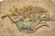
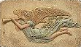
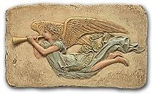
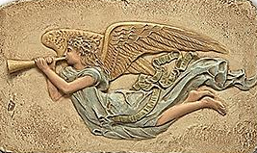
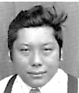
The Bawdy Bodhisattva
Chögyam Trungpa

I am in C.3.3., yet it is late summer of nineteen-thirty-eight in the Bardo, which
doubles as my tomb in Père Lachaise. I in several months I will be born again, this time
as…well, you will see. In the Tibetan table-lands, he is gestating in his mother’s womb.
He is already full of crazy wisdom: yeshe chölwa. His voice is that of a small child.

I think that art should be a part
Of daily life, don’t you? I do.
(I started here, and so have you.)
Life itself is the greatest art.
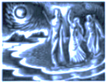
I see why you are me and I
Am you! I lived a foolish life
And learned, I hope, from the useless strife.
Nothing is worth such misery.

Only when we have been all Strangers
Do we know who we really are.
Swim upwards, to the shimmering star
That births and looks down on these changes.

It calls you to its distance. Swim
To it! Though heavy its burden seemed
To Gilgamesh, the star he dreamed,
Its calling was the core of him.

Your antimimon pneuma, your Gnostic and Neoplatonist term.
Counterfeit Spirit, you must leave
Behind. And yet perhaps I grieve
Over the thing a little, for

I was quite fond of the façade.
Then you should take yourself to task:
It is a vulgar crystal mask,
The work of an inferior god,

Only a showy, tinsel thing
Put on for social purposes,
All glitter and spangle and ‘show-biz’.
Away you must that Spirit fling!

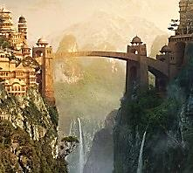
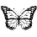
More Talks with Trungpa In Utero

Strange how it’s not that far away
From San Francisco, a place like this.
You mean the womb? Nowhere. One is
The stranger one will meet one day.

On Jacob’s Staircase, winding high,
Invited to the blue soirée,
One greets oneself along the way,
One hails one’s other, passing by.

You go down to Le Cirque de Birth
Whilst he ascends to Club Nirvana.
One from the womb, as from a sauna
Emerges red, in sweat of earth;

One sees himself in all that mind
That is the mother and the matter.
And at the foot of Jacob’s Ladder:
The thing filled with tears, hunger, wind.

*

Are you…Anthologoios? I am.
I laid the Buddha on his pyre.
I burned Troy, and burned in the fire.
I am Achilles. I am Priam.

No one, who speaks for all of us,
Am I: the mouth that sings it All.
Whoever sings has heard my call.
I am the Poet, Orpheus.

I am the body of Poetry,
Shot through with little lyric wounds.
I am the way the music sounds
When it mourns in a minor key.

And are you possibly, Hermes?
I have been the Guide, and the Misguider.
The horse who bears, and throws the rider.
The gods? I have been all of these.

Well, I suppose you’ll tell me next
That you were Dante in a previous
Life! And the Bard. Child, you are devious!
The Ur-Text is a palimpsest.
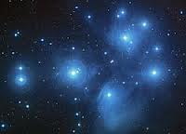
Emptiness
Trungpa. Valentine’s Day, 1939.
The nothing. It is everywhere,
This fruitful barrenness we call
Nirvana, though the name, like all
Names, is a little thing of air.

The emptiness is active, boils
With dreams and cataclysms, trees
And temples and the Pleiades,
And back into itself recoils.

It dreams me, the emptiness. The sum
Of all this strife, a kind of peace?
I have known the vintage and the lees.
Sweet, bitter, they are the same. I come
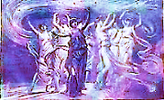
With empty hands to meet this…nil.
There is tranquillity in being
At last that famous nothing, seeing
All. Everything looks so still.

See? There it is, or was, again.
It followed what I just now said.
It is Meander. A mazy braid
Of black and blank. The voice and then

The echo, then the stillness. Near
And far. It floods the being. There
It is. You felt that gust of air.
It is here. It is there. And here:

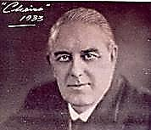
A Consultation with a Palmist

I decide to consult the ghost of Cheiro regarding
my next incarnation. (He died 8 Oct 1936 in Holly-
wood, California—a place of dreams whose actual
existence is doubtless another of its many fictions.]

I’ve a peculiar premonition
Of him (of you!) holding a sort
Of orgy with his cult, or court,
Svengali of the Eastern Vision.

Those who decline to join the fun
His henchmen forcibly unclothe.
The Enlightened One would surely loathe
Such bullying. He, like you, is one
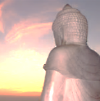
Who will know exile and its grief.
He will be forced to leave Tibet,
His country, when it is beset
By the Chinese. He’s no frail leaf

At the wind’s mercy, though. He’ll make
His way to Britain, he will learn
The language, as a teacher earn
Respect, and finally will take

His crazy wisdom West, to the
United States. He will live where?
Amid the peaks and bracing air
Of Colorado. (Dear to me,

As well!) They so remind him of
His sublime Himalayan home.
And many searching souls will come
To join his Ashram. But his love

Of alcohol and sexual pleasure,
Of power and perversity,
Will earn him notoriety—
I see! A most ambiguous treasure,

His wealth of Eastern mystic knowledge,
For with it comes his overbearing
Charisma. He has a gift for sharing,
However, and founds a Buddhist College. Cheiro at this point also mentioned a professor
whose name I didn’t quite catch: Ginsburrough?

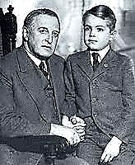
And how long will he live? Beyond
The nineteen-eighties I see clouds
Only, and past that, only shrouds.
I think I am already fond

Of this Trungpa. One’s avatars
Should always be, I think, a little
Improbable. If it’s a riddle,
So is the influence of the stars.

A superb teacher of meditation.
I see him with a young student, yes,
Named David Jones. No, that’s a guess.
I am tired of prognostication.

We soul ascend from Purgatory
In spiral wise, dispersed, to be
Gathered into rebirth. To free
Ourselves we widen into sky…

But what of Vyvyan? Oh how
Could I forget? What will become
Of him?—He’ll find a wife, a home,
And have a son: Merlin. You know

His name! I trust dear Vyvyan
Will not immure him in a tree!
Your grandson will grow up to be
A very cultivated man.

His voice will have the timbre of
Your own. He has some cause for hate,
But will become your advocate
In books, out of a grandson’s love.

And Vyvyan, as well, will write:
He’ll tell of his deprived childhood,
But help you to be understood,
Edit your letters, set things right

As best he can. The poor, dear boy!
How could I…? How could I have done
That to him? O my poor, dear son!
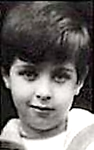
I took his treasure, his child’s joy!

On Rock Candy Mountain
Alias Mount Everest

Trungpa speaks from the womb.
Cheiro and I have talked about you Time: 28 February, 1939.
And what the future holds for you.
That’s merely sorcery. I do
Not wish to know. There is no doubt you

Will make your presence known, young master.
Is crashing into a joke shop In Dumfries, Scotland—driving while inebriated.
Not funny enough, you cannot stop
There, with a physical disaster,

But have to lead as many astray
Into the Buddha’s errant glory
As there are sheep to trust your story
And leave the good American Way
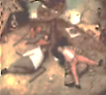
For Nephelokokkygia,
Cloud Cuckoo Land? Fine white cocaine
Is the only snow in your Cockaigne,
Schlaraffenland or Shangri-La.

You’ll abuse power in the crudest
Of ways, Neronian guru!
You and the rent-boys… Yes, but you
Are the world’s lewdest nudist Buddhist!

Whatever I may do, you are
Doing, too. Getting fall-down smashed?
How many times will I have crashed
Before the white, consuming star

Whisks me beyond all this folie?
A Bodhisattva does not hurry.
There is no place in God for worry.
There is no God. No God, and He

Is infinite. That’s nice to know.
Plenty of wiggle-room for folly.
Don’t you feel a bit melancholy,
Knowing so well how things will go,

What you will do? With what? The nothing
It matters. Any, or all of it?
God is dead. And is infinite?
Put on your latest Maya clothing.
The Jolly Corner
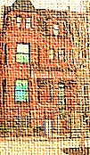
One minute before 11:05 AM,
28 February, 1939. It is time.
1.
There is a house James writes about,
The Jolly Corner. In it dwells
A threatening ghost who is—what else?—
The hero’s double. Fear and doubt

Assail him, and a sense of shame:
What sort of life might he have led
As worldly businessman, instead
Of the rich idler he became?

One’s real life is the life one did
Not lead. The man of flesh and blood
Is thus the ghost of what he could
Have been. There’s no way to be rid

Of him, the double who is and
Is not himself. He can’t erase him.
He is too strong. So he must face him.
Two missing fingers on one hand

Bespeak a man who has known strife—
A man of action—and because
Of this, has suffered. They must cross,
The two paths of the hero’s life,

The one he took, his present life,
And the uncanny path not taken,
The possibility forsaken.
Enraged, the double like a knife

Thrusts himself at the hero, who
From fear collapses in a faint.
In the arms of a female saint,
A loving friend, the man comes to.

Is he alive? Will he go on,
Merged with his ‘animus’, to lead
A stronger life? Or is he dead,
And dreaming this companion

In the afterlife? Has he survived
Himself as someone else, his double?
The author leaves us here, to trouble
Over the sequel. He who lived

Was not alive. The life he failed
To live took the shape of a ghost
Livelier than he. Who is host
And who is guest? What is unveiled?

3.
Before I walk into a space
Thoroughly emptied of my life
And full of freedom from all strife,
There’s one more trial that I shall face,

My last trial, which is self-imposed:
To face my Double. I will ascend
Along a spiral to the end
Of memory. Then my Book is closed.

Or open, of the human cry
Exhausted. Tears evaporate
In air, traces of love and hate
Dissolve into their home, the sky.
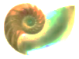
Karma
Let faint-lipp'd shells,
On sands, or in great deeps, vermilion turn
Through all their labyrinths…
—Keats, Hyperion
1. To my Reader

I hardly feel, at times, quite new,
Almost an Edison cylinder
Of sorts, mechanical echoer
Of Cupid’s arias. Can you

Recall how many times you’ve played me,
Dear? I am condemned to repetition,
Or say, redemption and remission
Of the mistakes I made; they made me.

2. Dissociation: the Stuff of Astral Travel

In time my lonely body grew
As innured to my absences
From ‘home’, my infidelities,
As Constance grew, who learned to do

Without my pleasant company
And live the matrimonial lie,
In her way, just as well as I
Who was as free of her as she

Was bound to me, an errant nomad
On his erotic Odyssey,
Hotel to hotel: helplessly
She watched me gradually go mad.

You see, I had to grow quite sick:
It was the only way to die.
With life an uninventive lie,
Dying a Roman Catholic

Formality, blind, deaf, and numb,
I was quite senselessly made ready
To leave my body to the steady
Low hum of the viaticum.

3. Trungpa and the Spiral Labyrinth

The wheels of Karma’s juggernaut
Trample the wrathful and the proud.
They look about: a thundercloud
Of all the evil they have wrought,

Here on the earth, comes rumbling after
Them, in the shape of ghoul or demon,
Explosive mists of scat and semen,
And the void howls with hell-souls’ laughter.

Some through the Bardo drift for ever.
These spirits we call hungry ghosts:
Guests who don’t know that they are hosts.
Such demons can be very clever.

Escape is possible: renounce
The demons in yourself, whose power
Is but to ruin and devour—
For they are ever-set to pounce.

I have seen the wrathful goddesses.
Their anger was my selfishness,
My folly and my carelessness,
More cruel a thing than cruelty is.

I have been a hungry ghost; I am
No longer hungry, and yet still
A ghost. You have purified your will,
Confronting them. You are the Lamb

To your own Lion. Now: prepare!
I know. I must construct a stair-
Case leading to the upper air.
I will be waiting for you there.

Be always wary, never frightened.
Learn to be wakeful always: this
Is Consciousness, this is your Bliss.
In this way you will be enlightened.

It is all very complicated,
Intricate as a labyrinth,
Disorienting as absinthe.
Enter the Spiral. You are awaited.

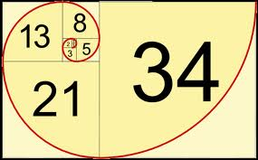
Of Fibonacci Numbers

[I find myself standing in a lecture hall in Magdalen College.
I am at that indeterminate age somewhere between the 39
I claimed to be at the First Trial and the 40 that I actually
was. Dante is responsible for this Purgatorial joke: he has
made me, a maths dunce, Professor of Mathematics! His
last hurrah. The students seem restless and bored.]

1.
Behold! a Golden Spiral on
A coin, in a rectangle!—I
Confess, it is a false coin: φ φ = the Golden Ratio (1.6108339887…).
Is not attained, ever–anon The Fibonacci spiral is built on integers but
approaches to the Golden Ratio at infinity.
Approached though it may be, for mine The Fibonacci sequence represents the closest
Are Fibonacci ratios, approximation to the Golden Ratio using
I am almost certain. (Ah, they doze! rational numbers: 2/1, 3/2, 5/3, 8/5…
At least it’s nearly time to dine.) —[Mr V]

2. A Lecture of Sorts

If one and one make two, and one
And two make three, and we get five
From three and two, then shall we strive
For eight? And by addition

Most horrible reach dread thirteen?
Which I can barely say! What fun
I had when I was twenty-one,
Betwixt a little, and between,

It’s true, but so? At thirty-four
I had moved out towards the extreme
And I don’t even care to dream
What waits at fifty-five or more,

Say, eighty-nine, how inconceivable!
O sequence rabbit-multiplying
Who rule the breeding and the dying!
Wrinkled the skin grows, irretrievable

The loss of youth’s crisp curls of hair,
Irrevocable the greying trend
When in a steep ascent you bend
To infinity and leave us there

So far behind you, husks outworn

Leonardo Fibonacci, a 13th-century mathemati-
cian, independently rediscovered the ‘Fibonacci
sequence’ and used it in an idealised thought-
experiment to chart the growth of a rabbit pop-
ulation. Oscar fails to grasp a key assumption of
the experiment, that the rabbits do not die. It is
interesting to note that the sequence was first
discovered by Indian scholars in the 6th century
AD and applied to Sanskrit prosody—specifically,
to rationalise the relationship between long and
short syllables. So Poetry and Maths come full
circle, eccentrically. (Let me add in passing that
Fibonacci’s far more consequential contribution
to Western Civlisation was to introduce and
popularise the use of Hindu-Arabic numerals.)
—[Mr V]

By the genetic seeds we hold
In trust deceived when rendered old,
Redundant, and then, why be born?

The numbers spin their lazy eight-
Approaching vehicle around;
I come back to the launching ground
Of one plus one, if somewhat late.

Now God is surely One. To be
Incarnate, unity makes two
In one, for God is Lord Christ, too.
And Holy Ghost makes Trinity
And the duality atones,
And two and three are five, and three
And five, eight: add these last and we
Reach the unspeakable number once

More. Evil arithmetic! But I
Will brave the Fibonacci numbers,
Though nightmares may invade my slumbers.
I recognise no boundary.

We’ll set sail for the Ratio
Of Gold, though we shall never reach
That place, my Dears! Ulysses, teach
Your mates the Perilous Way to go!

With what is left us of this so- I have forgotten that I am already
Brief vigil of the human senses, past this vigil. Ah, to be carried away by
Let us learn how immense the Immense is, one’s own rhetoric, like a blushing bride!
Let us know what it is to know!

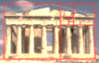
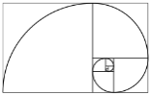
The Ascension of Old China Blue

Here, at the podium again?
Time: 16 October, 1946.

The ‘spiral vase’ seems to be a sort of Klein bottle, un-
bounded, non-orientable in space and rather self-absorbed.
—[Mr V]

1.
Spiral in shape, my fictive vase
Became a staircase I must climb
To view a different place and time
At every turn of what I was.

[A student creates a disturbance, heckling this tentative
beginning as stilted aestheticism. He is escorted out
of the lecture hall. A bit ruffled, I must start again.]

1.
Spiral in shape, my fictive vase
Became a staircase I must climb
To view a different place and time
At every turn of what I was.

2.
I have told you how my spiral vase
Became a staircase I must climb
To view a different place and time.
But did you know that what I was

I saw as what I would become?
And on each landing was a bust
Of something crumbling into dust.
I was alone, and far from home.

3.
You can predict my spiral vase
Will climb the same stairs every time—
But with a difference, yet a rhyme
At every turn of what I was.

I see the one I did become
And on each landing pass a bust
Crumbling into a different dust.
Then dust is where I make my home?

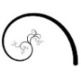
Each turn affords another view
Down the vertiginous stairwell
To various degrees of Hell.
What I did I cannot undo.

5.
The spiral shape, the fictive vase,
Are versions of the stair I climb
But with the difference, this time,
That I turn into what I was.

I am the man I would become
And on each landing pass a bust
Resembling, but only just,
A face that I once knew at home.

Each turn affords a brother view
Or mother view, down the stairwell,
And those whose life I made a Hell
I see, and know not what to do.

The memory of the floors below
Is an accretion of my loss.
A fictive vase with serious flaws
Is the best metaphor I know

For the heartbreak that heals you when
You see the past sink out of view
Like the wrecked vessel that is you.
And you must turn, and turn again.

8. Constance

It spirals into itself, my vase,
No matter how far I may climb.
So I grow smaller every time
I see I am smaller than I was.

How unbecoming to become
The man I am! I think the bust
Is of the monkey of my lust.
The likeness of a broken home.

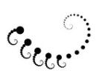
I turn to get a better view
And in the depths of the stairwell
I see a face I once knew well.
She wore a veil and said, I do.

The memory of it years ago
Became oblivious to its loss.
That’s one of my more serious flaws.
It happened on the floor below

And all her heartbreak happened then.
But now her face sinks out of view
And there is nothing I can do
But turn and turn and turn again.

I am sorry Constance! I am so sorry.
But that was on a different floor.
And there are many, many more.
Of course, each story is a story.

Happiness was a thing that used
To happen to me. I am a child
Of mood. My name is Oscar Wilde.
My breath is short. My feet are bruised.

The more I climb the more there is
To climb. Must every step create
Another step? And it grows late.
How shall I ever get out of this?

13. My Children

The downward spiral of a vase
Is the inversion of sublime.
Innocent victims of a crime
I see, of which I was the cause.

And into focus now they come,
As I look down. I pass a bust
I do not notice, for I must
Assess the damage as a sum:

I turn to get a better view
And in the depths of the stairwell
I see the children I loved well.
There’s nothing that I would not do
For them, but that was years ago
I did that to them. For I was
As fictive as a spiral vase.
And I weep down on them below,

On all their heartache and their pain.
But now their faces sink from view.
The thing I did again I do.
The turning has returned again.

Cyril, Vyvyan, I am so sorry!
They led me in, and shut the door.
I shall not see you anymore.
Hell is less harsh than Purgatory!

How cruelly you were abused
By relatives who raised you. ‘Wilde’
Was not your name. No, no, no child
Deserves to be so meanly used!

The more I weep the more there is
To weep. What can I do but hate
Myself, or blame it all on fate?
That it is that, that it is this.

But Cyril, you went off to war
And came back as the ghost I saw
And in the terror and the awe
The tearing open of a scar

Occurred, and I shall call it healing.
And you became my Happy Prince,
With the poor swallow gone long since.
No fire consumes the heart of feeling.

The bird shall sing, the Prince shall praise
The giving of the gems away.
He is in Paradise today.
My vase can only crack and craze.

My heart is in the urn with him.
Ash of my ashes, you, my son,
And Vyvyan, too. All into one
The ashes settle, light grows dim.

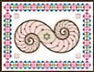
How many steps, and for how long
Must I continue to ascend
Into a sky that has no end
To make a rightness of the wrong?

21. Bosie

My spiral is a weary vase.
The staircase cannot cease to climb
Through larger spaces, longer times,
Surprised to see how small it was

When higher iterations come
Not quite full circle. And the bust
Is of a spiral quite nonplussed:
The vase contains itself. Its home

Is in another home. Review
The Hellish stories down the well.
Remember Bosie, and your cell.
The panther feasts, and what was due

In the end, and how it fell. Below
My station. Too much revel was
Enough to shatter a fictive vase,
With revelations bringing woe

To me, and Art’s ache, and the pain
Of sacrifice betrayed. My view
Is blurred, my eyes are moist with dew.
Again return, return again,

Dear Bosie, tell once more the story
Of how I walked a stony floor
For you. See how much rope I tore!
Think how the morning’s morning glory

Returns to mourn at evening. Bruised
Is the apple of my eye. Reviled
For ever is this Oscar Wilde.
And I believe you were amused.

The more I brood the more there is
To brood upon. But it is late.
The end game crawls to the checkmate.
Failure, what is the sense of this?
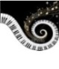
Is Cupid Mars, so to love war?
Your character may have a flaw,
My dear. You lived by your own law
And so did I, but I have the scar

To prove it, you, nostalgic feeling.
Forgiveness when the lover sins
Must scourge him first and make him wince,
But for some wounds there is no healing.

I swallow up my pride these days
For it was I who chased away
My Bird of Paradise. I pray
My pride may go up in a blaze

Of wisdom, but the chance is slim
That I will be the lucky one
Whose ashes fly into the sun.
The Phoenix fire is guttering dim.

The day is short, the shadow long.
And time can never put an end
To brazen sorrow, my old friend,
And grief’s perpetual undersong.

You were my slim-gilt lily boy,
You had the genius of your youth.
I had the genius of my mouth,
My honeyed tongue, my gift for joy.

You were my prince, my fleur de lys
And flirtily familiar with
A thirtyish man who was a myth,
And is a myth eternally.

I fell. You did not make me fall.
The myth, at higher iterations,
Opens onto what revelations?
Revels unravel. I willed it all.

Perhaps blue blood and a blue face
Cancel each other into love,
Somehow. But from the floor above,
This story is of other days

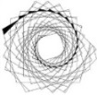
Much darker down, a depth unclean
With hate. The Irish cock-and-bull
Must face John Bull, and he is full
Of Minotaur. It is obscene.

And how obscene we were, together
In our adventures in rough trade!
In Naples love is known to fade
Beside a Bay, in autumn weather.

My spiral is a maze of wandering,
Wandering up to who knows where?
No ceiling but the empty air.
The stars, perhaps, were made for pondering.

The ghosts of old astrologers
Have left their eye-prints on the skies
That do not care who lives and dies.
The stars are Tinkers, Travellers.

34. The Marquis

This spiral of blue china, vase
Full of itself, was once sublime.
What is most beautiful with time
Becomes the shade of what it was.

It is the time when monsters come
Out of the closet. Broken bust
Of ugliness, you are the just
Likeness of one who broke my home.

And he comes gibbering into view
And wants to pull me down the well
Into the hate that is his Hell.
What an unspeakable thing to do,

Enter my house and threaten so,
And here you come again! My vase,
Though but the shards of what it was,
Brims over like a cup of woe.

How mad I was to fight the insane!
Could it be monstrously true
That you are me, and I am you?
I turn again. What do I gain?
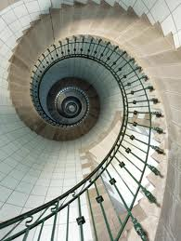
Fresh understanding of the gory
Details, which who would not deplore?
They are even uglier than before,
And many times I have told this story,

How I was stubborn, and refused
Advice to let it go, and filed
The suit that brought down Oscar Wilde.
Oh, Queensberry was much amused!

The more one hates the more there is
To hate, there is no end of hate.
He is the monster of my fate.
I cannot climb away from this.
Between the gutter and the star
Most thread their way by rote and law.
I wanted both, that was the flaw
That left me with this shameful scar

That makes another wound of healing.
The Screaming Scarlet Monster wins
Again, then a fresh trial begins,
And the familiar awful feeling.

A monster hides in every maze
And of the lost he makes his prey.
The snake in Eden has his way
With every Eve. I curse my days

Of penance, and I glower at him,
The one he hated as his son,
That Bosie boy, the Golden One:
The Parsifal who on a whim

Shot down the swan, but the great wrong
That he had done he would defend
Bitterly to the very end.
And still my way is long, too long!

Their faces haunt me, golden boy
And brutish father, arrogant youth
And the beast who sniffed out the truth,
Base metal of a base alloy.

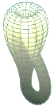
Why will it not be history
That scholars calmly reckon with?
I am still tortured by my myth.
Am I the Sphinx’s Mystery?

The Marquis did not make me fall.
It was my myth grown out of patience
With all reality, the nation’s,
The world’s, the success of it all,

The fiat lux, the course of days,
Provisions for below, above,
And in between. I had had enough
Success, I longed to touch the face

Of failure, though it be obscene.
Happiness, sadly, can grow dull.
And the vase becomes overfull
Of emptiness. Down, down careen

The tragic heroes, heaped together
On the ground floor, how low are laid
The saviours by the mess they made!
An end must come to every tether.

Out of control the spiral’s wandering
The twists of its own turns nowhere
But up the iterative stair
Amazed, when what it should be pondering

Is how the stars, the Travellers,
Can find their way across the skies.
They do not know that they are wise
But know that what occurs recurs.

*

Look there! Could that be Oscar Wilde?
A serious man, some seventy
Years old. Respectability
Weighs on him, there are Honours piled

Upon his back. He is an old
Master. Upon its plinth, the bust
Of him rests solemn and august,
And he, as well, feels marble-cold,

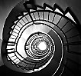
Depressed by a lifelong success
Which through the decades grew to be
A species of vulgarity
That used to cause him some distress.

But what an oeuvre he compiled…
Asterion has eyes so mild!
To being a Sir Oscar Wilde
He is grudgingly reconciled.

I am the satyr, and his double
And Doppelgänger—I am the ungrounded
Bacchus, the Man of Gestures wounded.
He is glad he never knew such trouble.

*

Everything learns to say farewell
By moving farther from its source
Because this is its only course.
We tell what we won’t live to tell.

I bid good-bye, not to my wife
And children, and not to my lover
Or foe, but to the things left over,
The memories of a finished life.

I am beyond myself, beyond
Belief and doubt, and every care.
Estrangement is the truth we share.
The heart of its own heat so fond

Becomes a cloud winds blow away
And leaves behind no scars, no stains.
The lightness of the light remains
When there is nothing left to weigh.

*

Blue China I at last live up
To, now that I have climbed the stairs,
You are but a sky that puts on airs.
Let spiral be a simple cup.

Circle is ever at odds with square.
Be genially unreconciled.
And shape no bust for Oscar Wilde.
His is a monument of air.

The scent of roses in a vase.
The sunflower, and the flower on high,
The morning glory in the sky.
For I am not the one I was.

*

We stars are Travellers, and we roam.
Planets and sea-shells are our traces.
We are at home in many places
But there is no such place as home.

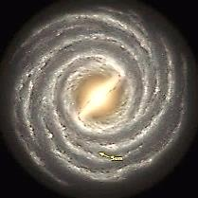

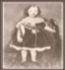
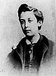
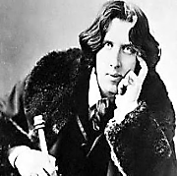
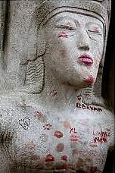
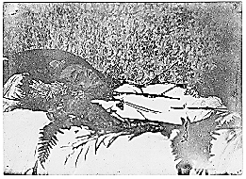
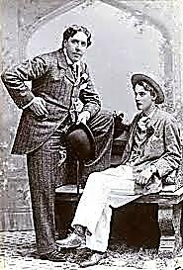

The Missing Lines

Blankness took the preceding text
And the line that ought to come next.

This quatrain space will also riddle:

Beginning, ending—but no middle.

Stet what came next: more emptiness.
It leaves the lines by two lines less.

Think of it as a haven of

Blankness. Words below, words above.

Only these middle lines are left
And they feel pleasantly bereft.

And emptiness can have the rest.

Prologue to the Epilogue
by James Clarence William O’Flaherty Joyce

Bone Song
of the Mysty by the Sea

What with his staff the mistery-eyed
Wrote in the sand, what bardic rune
That in its hollow hummed a tune
As twilights pinked the foaming tide

And the sky greyed away and over
The darkling emerald of the sea
The reader may, if he or sidhe
Will turn the page, forthwith discover.

Triton
Shell
Horn

I am
a whisper
and an ear.

My hollow
cup holds
distance near.
to the
Listen world Play me
air. ♫ breathe by listening,
with in there. turn in your hand
fills
Bone wind
is bone. on the water,
Inside you churn of the

* * *
sand.

There is a “note” symbol in the empty space in the center of
the spiral’s last turn, between “air” and “breathe.”
The symbol has been given the same font color as that of
the page so that it is invisible. But it is there, and can be
hyperlinked to a music clip—Irish tune on solo recorder.

