* The Orphan in the Dark *
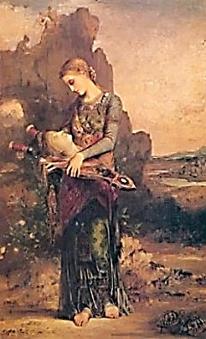
♫

Poems of Orpheus

by

Arthur Chapin

I am the body of elegy
Shot through with little lyric wounds.
I am the way the music sounds
When love bleeds in its native key.

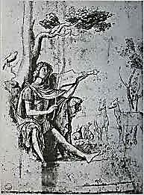
♫
Table of Contents

The Orphan in the Dark 4
The Sacrament of Song 5
The Young Thracian 6
Instant Myth 7
Hermes Psychopompos: Shepherd of the Dead 8
His Grand Recital on the Harp 9
Orpheus in the City of Dis 11
Orpheus Insufferable 12
Eurydice Incensed 13
Rilke: Credo 14
Rilke: Château de Muzot, 1922 15
Traveler’s Round 16
Orpheus and the River of Glass 18
Head of Orpheus on the Water 21
Passing Through 22

Musical Appendix 23

The Orphan in the Dark

Who am I? Open up the book.
I am the orphan in the dark
Lamenting, cupping my one spark.
How could I help but turn and look?

Eurydice, breathes through the cave.
An echo. A hiss. I grope my way
Back up into the light of day.
There, in the meadow, is her grave.

There, the immortal snake that bit her
Days, weeks, or was it years ago?
Eurydice, whispers the low
Wind in the grass, so cool, so bitter.

I lay flowers on her grave, and then
I rest. I look up at the sky.
I sleep, till I hear the wind sigh:
It is time to go down again.
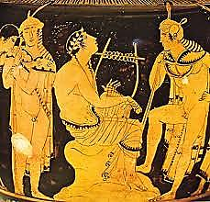
♫
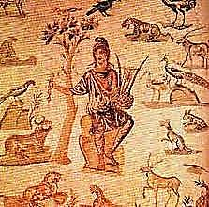
The Sacrament of Song

In the woods, in the forest of
My music, ancient animals
Move. I coax from their cries and calls
The hidden harmony I love:

The active quiet of bees humming,
The rest that is the heaving, grave
Sleep of the bear inside his cave,
Those little feet on leaves snare-drumming…

These creatures, ignorant and strong:
I lure them from their shrieks and howls
Through measured consonants and vowels
Into the sacrament of song.

I build long staves across their listening
Haunted by owls that dream of trees
That dream of owls. I fill the breeze
With little eighth-notes, blackly glistening.

I make a clearing for the moon
To see alive the struggling wood
In motives snarled, and call it good,
Because it lives inside a tune.

They are still wild as wind and fire.
The fang gleams, and the eyes glow red.
But with my music they are fed.
They quiver when I touch my lyre.

The Young Thracian

This is the burden of the song
That is the poem Orpheus,
The poem of Orpheus. What it does
It is. In darkness it is strong.

O red-haired, beautiful young Thracian,
You harrow with such gentle shocks
Of sound, you levitate the rocks
In metamorphic trance-formation!
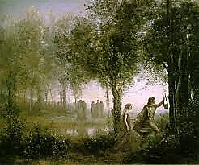
Instant Myth

Running through the meadow
she startles a snake
and in a lightning-strike

he comes out of the cave
eyes black with the dazzle
of her vanishing.

Hermes Psychopompos
Shepherd of the Dead

Cover her eyes. Steal past the dead—their souls
Are still awake—she must not see them—no,
Not yet… They are so weak, their shadows throw
Them on the walls, they have the eyes of moles.

Follow that winding strip—that frozen whirl—
Down to where magma forms a bubbling sod.
Let her trust gravity: it serves the god.
He dwells down there. That heavy heart… Poor girl.

Is that a distant echo? Daughter, daughter!
Now on her cheek she thinks she feels a breath.
Come, I will bathe you in the cool, still water.

It walks beside her now. Her heart is sad. Oh
Open her eyes, god, she must see the Shadow!
It reaches out for her. It is her death.!
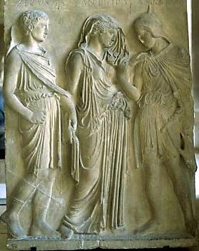
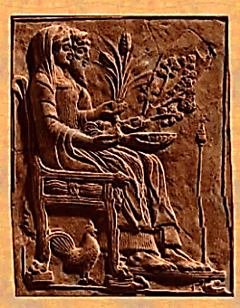
His Grand Recital on the Harp

It is your audience with the King.
No one alive has seen Hades
But you. Play him your melodies.
Let there be no more vanishing!

One long, thin finger seems to wear
A ring of smoldering almandine.
His crown is a penumbra. Fine
Bone-powder whitens his gray hair.

His throne? A sort of solid smoke.
Next to him: Queen Persephone.
Her face is chiseled ebony.
She is wrapped in a shadow-cloak.

How shall your music charm this Head
That is a pale cloud in the darkness
Around you? Glooms of rocky starkness
Speak Death. His ring glows Hell-fire red.

Evoke for him the Revelry,
The dancing of young, nimble feet,
A blue sky and the summer’s heat
Fanned by a soft breeze from the sea.

That glimmering figment of a head
Is bowed, and down it seems to sink
In thoughts it swore it would not think
Again. Memories of the dead

Meadows, green spots where once he dallied
With nymphs long-gone, the fountains muddy
Now… From the brown to the black study
His heart is moved. His face is pallid.

He would cry out, but, short of breath,
He wheezes as he grants the boon:
You, you will sing a different tune
To see her die another death.

♫
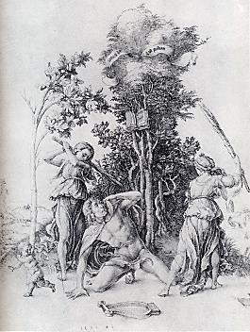
The City of Dis

They’re waiting for you
anywhere night vision's poor,
swindles of perception,
optical disillusionments.

Dis: city of deprivatives,
insults, assaults. A puncture
is worth a thousand words.
Retrofit your lyre with trigger and barrel.

Walk fast, shoulders
hunched looking crazy
and mean. Ignore the blurt
of a car horn, the squealing wheels,

that gaseous burp wobbling
the manhole cover on
its rim, the down-and-outer
in the cubbyhole sucking

brain damage from a paper bag.
Glide along the wall
like moonlight. Good.
Descend.

(Should you go back the way you came,
up the subway stairs?) Someone’s
stepping out of the shadows. Look!
She disappears.

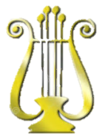
Orpheus Insufferable

They’re breathless with excitement! I live up
To my distinguished reputation, filling
Their ears with melos, brimming each dry cup.
I am a touring star. I get top billing.

One soft arpeggio… There they are, reliving
Trysts under willow trees in summer’s heat.
They weep, and (ah, the dead can be so giving!)
They lay flowers—wilted flowers—at my feet.

These are the scales I practice on the heart.
Ghosts rise to meet the notes like grass in meadows:
I mow straight through them with a keen C sharp.

It is my Grand Recital on the Harp
That wins the prize: The Emperor of Shadows
Will pin her like a ribbon to my art.
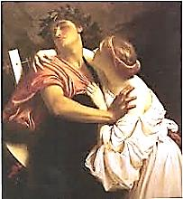
♫
Eurydice Incensed

Having passed the shadowy audition with flying
Coloratura singing and eloquent harping
On themes so dear to the departed—Grieving
In springtime—Death on the eve of the white wedding—

Daguerreotypes of dazzled faces fading—giving
Them ears composed of nothing but a listening—
Leading me stumbling up a mineshaft twisting
Toward that pin-hole radiance thronged with the living,

You turn, and I am that startled vanishing
You needed to sculpt a frieze of pure departing—
A soft, defeated cry stonily echoing

Into the tragic poem of your regretting
It wasn’t to see my face—Or to see me going—
Or gone—It was to turn—It was the turning:

Rilke: Credo
♫

Let things felt be your credo, not mere feeling.
Look, always look… Be calm with Pain and Pleasure:
Your destiny is buttress, vault and ceiling.
Squeeze into silence under massive pressure.

Spread through these stained-glass shapes, be the still bliss
In martyrs’ eyes when sunbeams bruise them; coil
Your tumult deep inside the wafer’s kiss,
The cool, chromatic sheen on chrism oil—

Fling yourself out now, in convulsive waves,
And find, in Orpheus, your mouth, your breath.
Float down the river of a song no staves

Can hold—the one whole note that rings through death
And grows so vast and palpable and round
Earth dwells entirely in that single sound.

Rilke: Château de Muzot, 1922

It ripens to its hour; I will be spent.
I never knew that it would feel so light,
This strength the Angel gives me. You were meant
For this, he says. And I stand up and write.

Hearts hinder, hearths hold back… Geese-haunted skies,
O orphaned spaces shivering! Can a breath
Husband the share of all departing cries,
Bless each thing with the shape of its own death?

My tower is vigil. Patience makes me rich.
Let statesmen dig excuses from the rubble
They made. They boast of peace. There will be trouble.

America floods the emptiness with kitsch—
But our dead still belong to us. Soon Europe
Will taste its harvest: that dark, Orphic syrup.

Traveler’s Round

First, source. Then river. Then the vast
Salt sea. Sunlight and rain, halfway
Between the earth and heaven, play
A rainbow. Beauty cannot last.

Born of an urge to tell us why
It needed to be born, to mean
The dawn, the poem becomes the scene
In which the god begins to die.

Beginning softly, the notes wend
Their way to a climactic middle.
Like the solution of a riddle
They find a path to reach the end.

Overture to the eternity
Where changes end, the tune, nel mezzo,
Learns it was always intermezzo
And this is its finality.

Open the curtains of the rose:
There, at the center: the red heart.
You hear a mournful music start;
A voice sobs, and the curtains close.

Prelude to noontide in the valley,
Unscorched by the meridian,
The earliest aubade is wan
With thoughts of the long grey finale.

First sea, then river, across vast
Distances traveling home. Halfway,
A lake. Sunbeams on water play.
The source, high in the hills, comes last.

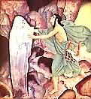
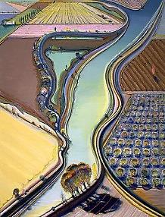
The River of Glass

1.
The river leaves so much behind.
It cares not to recall its source.
Would you reverse the river’s course?
Then you must change the water’s mind.

The water can be soothed, and hear
The music that is Orpheus.
Then it is vulnerable, thus
You find the water’s inner ear.

2. The Moving Picture of the River

Narcissus loves it as his mirror.
His dream would be to glide along
His beauty and hear its silent song
Of praise. If he could but draw nearer!

If only he could kiss his face,
And not its image! But it slips
Away, or twists its ghostly lips,
A blurred and agitated trace.

3. The Frozen Picture of the Water

Now comes the moment of arrest.
A standing still, as of a glacier,
When the calm water ever-glassier
Congeals around the thought of rest.

A white opacity prevails.
Narcissus cannot see his face.
The mirror has become a place.
Resemblance is a power that fails.

He would not, but he shall stay put.
The water is solid, a base metal.
The screw is turning and the treadle
Thumping beneath a heavy foot.

Ghosts bent into the shape of a
Question mark; others, gusts of wind.
The ghastly little thing that grinned.
The walking ghost that lost its way.

The dervish ghost, his Dance of Death.
How witches in the garden caught
By witches’ globes bemoan their lot!
The scryer of water underneath

The water sees the angry dancer
But cannot call him from a Sleep
As restless as the sea is deep:
He is the question, not the answer.

Who am I? Asks the man. A ghost.
Now the ghost knows it was a man.
Narcissus from his bronze self can
Be freed. I gather in the lost.

4.
The river rages in its force.
I give the water a key, a measure.
The Song in all her steadying pressure
Reaches down from her mountain source
And calls the river. Up she gathers
The waters all into the song
She is singing, It Will Not Be Long.
The trees that guard her are the Fathers.
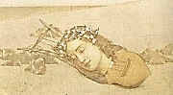
Head of Orpheus on the Water

Be the note you sing.

Echo of the rising waters.
How the sea’s premonition sounds.

Sing where you will be
with the voice of where you were.

Essential now,
teach the water what the water is:
a rashness lost and retrieved
in the mirrors of its motion.

Your voice is bodiless honey
afloat on a buoyancy
that is not hope.

Become the river.
Relax into your delta flats,
develop your intricate metaphors
for a vastness that swallows all qualities.

After the final cadence
your song will sleep in the arms of singing
and the moon’s over the ocean O!

Passing Through

I see an image, yes, it must
Be Orpheus: He stands before
A mirror, as upon a shore.
He aims to charm the King of Dust.

He passes through the liquid glass
And down into the shadows goes
Where echoes of an otiose
Palaver of ghosts, Why? and Alas!,

Play off the empty space where should
Be walls of what is really nowhere.
Come to me, husband! Lower and lower
Past stream of blood and mournful wood.

He has gone through the watery glass.
The glassy waters barely wobble,
They know so well by now the trouble
Passing, how it will never pass.

♫
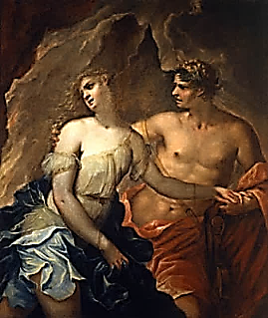

Musical Selections

Page 2

Fauré, Elegy. Gregor Piatigorsky, cello. Unnamed orchestra.

Page 4

The Song of Seikilos. The Atrium Musicae de Madrid directed by Gregorio Paniagua.

Page 10

Monteverdi, Orfeo, Act I. Lasciate i monti. English Baroque Soloists. John Eliot
Gardiner, conductor.
Chorus of Nymphs
and Shepherds

Come down from the hills,
come down from the springs ,
Nymphs so comely and glad,
and in these meadows
in wonted dances
let your fair feet rejoice.

Here shall the sun
behold your measures
lovelier far than those
danced to the moon
in the dead of night
by the stars in the sky.

Ritornello

Come down from the hills,
come down from the springs ,
Nymphs so comely and glad,
and in these meadows
in wonted dances
let your fair feet rejoice.

Then with fair flowers
crown the heads
of these lovers,
who after the torment
of their longing.
are happy at last.

Coro di Ninfe e Pastori
Lasciate i monti,
Lasciate i fonti,
Ninfe vezzose e liete
E in questi prati
Ai balli usati
Vago il bel piè rendete.

Qui miri il sole
Vostre carole,
Più vaghe assai di quelle
Ond'alla luna,
La notte bruna,
Danzano in ciel le stelle.

Ritornello

Lasciate i monti,
Lasciate i fonti,
Ninfe vezzose e liete
E in questi prati
Ai balli usati
Vago il bel piè rendete.

Poi di bei fiori
Per voi s'onori
Di questi amanti il crine,
Ch'or dei martiri
Dei lor desiri
Godon beati al fine.

Page 12

Monteverdi, Orfeo, Act II, Sinfonia: “Ecco pur ch’a voi ritorno.” English Baroque
Soloists, John Eliot Gardiner, conductor.

Orfeo:
Ecco pur ch’a voi ritorno,
Care selve e piagge amate,
Da quel Sol fatte beate,
Per cui sol mie notti han giorno.

Orpheus:
Here I return to you,
Dear forests and beloved meadows,
Blessed by that very Sun
Through whom alone my nights are day.

Trans. Gilbert Blin

Page 13

Gluck, Orfeo ed Euridice, Act II, Scene I: “Dance of the Furies.” Choir and Orchestra
of the Vienna State Opera, Sir Charles Mackerras, conductor.

Page 22

Gluck, Orfeo ed Euridice. Act II, Scene I: Quest’ asilo. Choir and Orchestra
of the Vienna State Opera, Sir Charles Mackerras, conductor.

Eurydice and Chorus:
E’ quest’ asilo ameno e grato del riposo il terren, è il soggiorno ridente beato del sommo
ben; non ingombra l’alma sicura pura, l’aura tranquilla gira, spira la calma piacere nel sen;
e dell’anima il dolore muore fuggendo il casto terren!

These fields are a haven of lovely and grateful rest, here repose the blithe spirits blessed
by the highest good, tranquil breezes play, passions are quieted in the soul, and all grief
dies, fleeing from the undefiled terrain.

Trans. Charles Harmon

