**\* *Pierrot* \***



***H i s L i fe, H i s L o v e***

***Table of Contents***

**Pierrot Galant 4**

**Pierrot Blasé 7**

**Tragedia dell’Arte:**

**A Puppet Show for Proust 8**

**The Visiting Moon:**

**A Valediction 14**

**Pierrot Lunaire 16**

**[Musical Program 19]**

[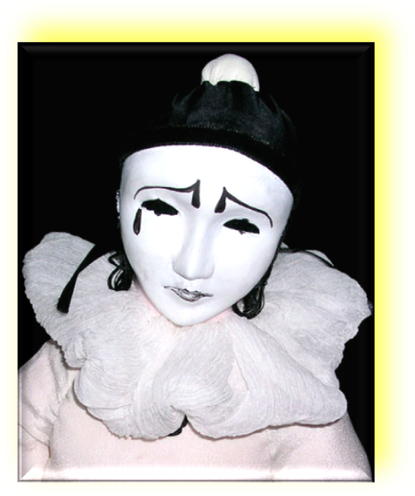](http://inmemoriamc33.com/pierrot2.mp3)***Pierrot Galant***

♫

[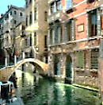](http://inmemoriamc33.com/stravinsky_suite_no._1_trim.mp3)

♫

I am a puppet of the Moon,

A busy midnight marionette.

I tumble and turn, I pirouette—

But the Pale Lady calls the tune.

‘Tis SHE dispatched our glib platoon

Tonight, that darkness might not lack

For gibbering gibbon and macaque.

Then shall we dance the rigadoon?

O lean and slippered Pantaloon,

Counting your lovely bags of gold,

So avaricious and so old:

You lose your lovely daughter soon,

Fair Columbine, as fresh as June;

For Harlequin, the masked valet,

Spirits my fair coquette away

Unseen, even at broad high noon.

Yes, Harlequin, that sly buffoon!

Sleek in his skin-tight leotard,

A diamond-studded poker card,

Cartwheeling like a suave baboon

Into her heart he comes, to croon

Lubricious balladry. Once more

She spurns her luckless troubadour,

Her trusty Corporal Clair de Lune.

(Comes the thrasonical, fat poltroon,

Il Capitano, reconnoitering:

*Cease and desist, fool, from this loitering!*

*Or I shall call my tall dragoon*

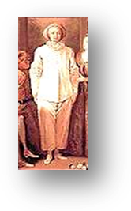*To hail you up and down, festoon*

*Your lily wrists with shackles, and*—

I slip a coin into his hand,

To be disbursed in a saloon.)

They say you slipped behind a dune

With Juan the swarthy stevedore,

And sold your tender mercies for

Some shavings from a gold doubloon.

Ah, like a spoon behind a spoon

They say you lay on Lido Strand!

Then what is love? The shifting sand,

A cloud, a carnival balloon!

And Harlequin, you…*picaroon*,

You demon rider in the night

Capering in the ghostly light,

You witty ape, you handsome goon—!

But the Pale Lady calls the tune…

I tumble and turn, I pirouette,

A busy midnight marionette:

I am a puppet of the Moon.

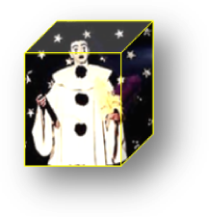

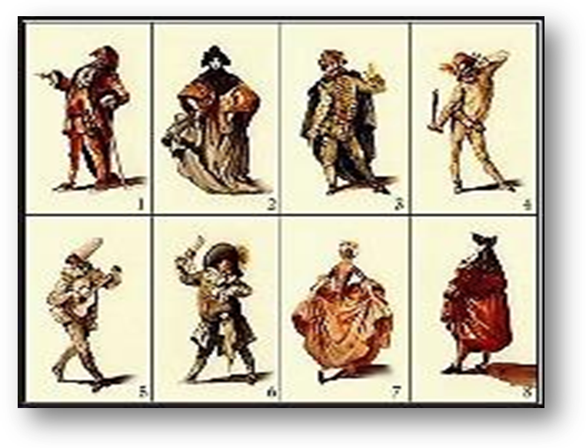***­­Pierrot Blasé***

♫

 *Oh predictably capricious Columbine!*

*The full moon, and the werewolves roam.*

*The plague moon, and an empty town.*

*The sickle moon, to cut you down!*

*The no-moon, and a broken home.*

That sliver of silver is the new

Moon rocking in the cradle of

The old, whose dying mother-love

Is fading slowly out of view.

The cycles turn, the church-bells ring

The Harvest and the Hunter’s Hunger,

That always-older, ever-younger

Diminishing-crescendoing…

There’s nothing new beneath the moon

Except the moon. Or, its reflection.

There are reversals of direction.

Fresh as a daisy or a tune

Recently minted, and as cheaply

Dear, as if from one’s wonted stall

In a suburban music hall

One loved the empty music deeply:

Such is the new moon’ novelty!

So interesting to speculate

What figure’s singing by the gate

A *Moon Song*—doubtless not for me.

♫

[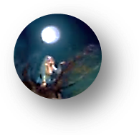](http://inmemoriamc33.com/rusalka.mp3)

[](http://inmemoriamc33.com/debussy_fetes_galantes_fantoches.mp3)***Tragedia dell’Arte***

♫

***A Puppet Show for Proust***

*We are in his bedroom in his Combray house.*

1. *Introduction*

You open for me that collage

Of photographs you have filed away.

They reassemble to display

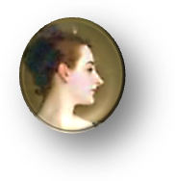Great Duchesses *d’un certain âge*

Who with their poses make a Masque

Wherein beneath the chandeliers

Come Questions to their eyes (with tears)

It only pains their hearts to ask:

The Question what is nobler in

The mind when Beauty, *déclassé*,

Falls to the ranks of yesterday;

The Question how it might have been

If she had followed her desire

When on the terrace, ‘neath the moon

She gasped, and fell into a swoon

To see in his dark eyes such fire.

Come, step into the Masquerade!

The part of ladies in old age

In ways so redolent of the stage

By comic actresses is played

That one is tempted both to smile

And weep, and certainly to say,

*Encore!* in one’s most genial way

To players of such practiced style.

[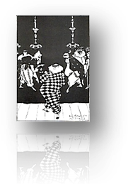](http://inmemoriamc33.com/stravinsky-_suite_no.2_-_harlequin.mp3)2. *The Performance*

♫

Sciatic old Lord HARLEQUIN

Attempts a dashing cartwheel for

His entrance, teeters, hits the floor,

And hides his pain with a forced grin.

None of the troupe at this *soirée*

Makes sport of him: too tired, too tired—

♫

[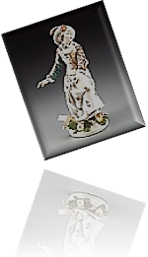](ttp://inmemoriamc33.com/stravinsky_-_suite_no._2__columbine.mp3) Though COLUMBINE, who once admired

The stumbling tumbler, and still may,

Comes to his aid. His words are fierce

To the coquette, now *très grande dame*;

Down her white cheeks, with strange aplomb,

Doodle the black mascara tears.

Her with a hairy hand he thrusts

Aside, and through his monocle

Casts ogles at the beautiful

Young courtesan for whom he lusts.

[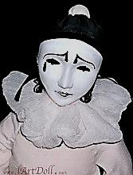](http://inmemoriamc33.com/stravinsky_suite_no.1_for_small_orchestra_pierrot.mp3)

♫

(Her glance, in turn, seems to appraise

*Him* as a rich though paunchy goat.)

PIERROT, he of the wrinkled throat,

Gives Columbine a pitying gaze,

But has no heart to play the game

He used to play. The mandolin?

He gave it up. But he *is* in

The midst of writing, for his fame,

A lengthy novel, a *roman*

*À clef*, of sorts, and a memoir,

Luminous, with a tinge of *noir,*

Of a considerable élan,

Revealing for all time what Time

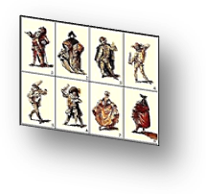 Has done to *them*, with all the paces

Still to be gone through, though with faces

Weathered, yet, in a way, sublime

Against the sunset fade-away

Of vices they must still pursue.

(And ah, what else is one to do

At the anti-climax of a play?)

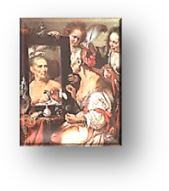

3.

IL CAPITANO’s eye for *très*

*Jeunes filles* has grown myopic, dull.

Too weak to wax thrasonical,

He is thin, taciturn, and grey.

DOTTORE, garrulous as Brichot,

No longer writes his weekly column.

His laugh is empty, his eyes solemn;

His lucid moments come and go.

But *he* remembers, old Pierrot,

A *père* *Goriot* (oh yes, he married,

Is widowed and a father harried),

How he decried the long-ago

Gomorrhan love-play and carouse

Of Columbine and ZERBINETTA,

How he*, toujours jaloux*, once set a

Trap to expose them in a house

Of ill repute, but they escaped

And robbed the voyeur of his pleasing

Anguish. How it amused her, teasing

The swain whose hapless heart she scraped

Distractedly as with a heel

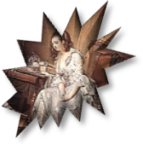 She scraped the floor in the champagne

Waltzes of yesteryear! The pain

She caused, but would not feel,

Returns now, as he gazes at her,

Shaped into unsaid sentences

He’ll write down on that desk of his

Tonight. Ah, what engrossing matter

Her lightness gave him, frivolously,

For contemplation, serious Letters!

Yes, she is one of the Forgetters.

But *he* remembers. So will we.

We will remember Columbine

Looking so queenly through her tears

At beauty stolen by the years;

What can one do but drink more wine?

4.

Then break the mirror, and burn all

Those *billets doux* the Spirit killeth,

Madonna of the morning, Lilith

By daylight, Eve at evenfall!

The shadows that grow round you are

The umbrage of a shelter for

A face that close inspection, pore

By pore, would find as secular

As the yew bending over tombs,

And grimaced like a tragic mask

In the full horror of the task

Of dying in these crowded rooms

Where, in the last sciamachy,

The magic lantern shoots its rays

As flames along a paned bookcase

Flickering into obscurity.

[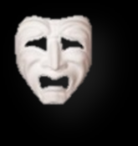](http://inmemoriamc33.com/debussy_-_clair_de_lune.mp3)

♫



***The Visiting Moon***

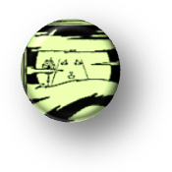 ***A Valediction***

*And there is nothing left remarkable*

*Beneath the visiting moon.*

*—*Antony and Cleopatra

1.

I’ll tell you, dears, what I believe:

Appearances. All things are mirrors.

Reflect on that, O mindful hearers!

Give back the light that you receive



Or it will burn away your eyes.

For you are apparitions all,

Appearers before mirrors. Call

Me down, and I will fill the skies

As once I did, so long ago.

Ah, what a Monster was I then!

At high tide, the waves rose up ten

Miles! Werewolves roamed beneath my glow.

These were the eons of the giants,

Titans uprooted from the clay

By my magnetic power. By day

It worked, as well as night. No science

Was there, for the material world

Was woven of a magic stuff.

Logic of dreams was cause enough

For things to happen. I unfurled

Like a freak orchid of the night,

And phantom-figments took on shape

And form and substance, the landscape

Wore the pale livery of my light.

2.

But dears, all this is of but waning

Interest to me. You always knew,

Somehow, I would be leaving you.

I shan’t go on for ever feigning

A light not mine, a stolen spark.

I have no stake in your affairs.

I weary of those foolish flares

Troubling the surface of the Dark.

Farther and farther I move away.

My distance from you will increase

Until it altogether cease

To shine for you, my light, some day.

I’ll squint for pin-light from the sun.

I’ll drift among the stone cold bodies

Between the distant stars, a goddess

Once, in your eyes! All that, undone.

No wolves will howl, Pierrot Lunaire

Without a moon will grope by night

Unsponsored by my maddening light,

Unwatched by my unblinking stare.

Ah, what will darkling poets do

When ponds forget my image? Where

Will all the nocturnes go? *Mes chers*,

I bid you all a long adieu.

***Pierrot Lunaire***

[](http://inmemoriamc33.com/ravel_trio.mp3)

♫

1. *A Walk in the Woods*

The oak, its every branch bereft,

Standing in old November’s bareness,

Is nothing if not self-awareness:

What, when the last leaf leaves, is left?

I walk beneath a sky of lead.

The leaves lie skeletal and cold.

I walk alone upon a gold

And scarlet carpet of the dead.

The garish tints grow dimmer, dimmer…

I am past my Expressionist phase.

They slacken, my old high-strung ways.

There is no spring in my *Sprechstimme*.

2.  *Farewell to Columbine*

Think of me now and then, my dear.

This much I claim the right to ask.

I will not spoil my white-face mask

With the black trickle of a tear.

May Harlequin be kind to you

As you to me, one summer’s eve.

And yet I fear you, too, may grieve,

For loves as true as mine are few.

3. *Serenade*



The sun, I think, no longer loves

The moon with his primordial fire;

That brilliance *she* did so admire

Seems merely garish now. She moves

Like one whose dreams have passed her by,

Or faded at the break of day.

She gives his gifts of gold away

Who glowed once, when she caught his eye.

For that was then, and this is later,

Ah, so much later now, in Time’s

Own evening! The Pale Lady climbs

Gingerly (for the effort’s greater)

The sky’s invisible staircase

To her high chamber amid the stars,

And, brooding over ancient scars,

Smears ghostly cold cream on her face.

Fond lovers, why do you still seek

Her blessing on a feverish tryst?

She only wraps herself in mist,

Thinks much, but chooses not to speak*.*

[](http://inmemoriamc33.com/standchen2.mp3)

♫

♫

[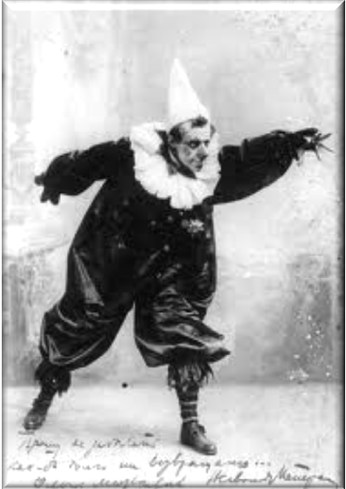](http://inmemoriamc33.com/chopin_barcarolle.mp3)

***Musical Program***

**Page 3 (Illustration)**

Schoenberg, *Pierrot Lunaire*, Op. 21. “Modestrunken.” (Original text by Albert Giraud, trans. Eric Harleben). Christine Schäfer, soprano. EIC, Pierre Boulez, conductor.

Den Wein, den man mit Augen trinkt,

Gießt Nachts der Mond in Wogen nieder,

Und eine Springflut überschwemmt

Den stillen Horizont.

Gelüste schauerlich und süß,

Durchschwimmen ohne Zahl die Fluten!

Den Wein, den man mit Augen trinkt,

Gießt Nachts der Mond in Wogen nieder.

Der Dichter, den die Andacht treibt,

Berauscht sich an dem heilgen Tranke,

Gen Himmel wendet er verzückt

Das Haupt und taumelnd saugt und schlürft er

Den Wein, den man mit Augen trinkt.

**Moondrunk**

The wine that through the eyes is drunk,   
at night the moon pours down in torrents,  
until a spring-flood overflows   
the silent far horizon.

Desires, shuddering and sweet,   
are swimming through the flood unnumbered_   
The wine that through the eyes is drunk,   
at night the moon pours down in torrents.

The poet, whom devotion drives,

grows tipsy on the sacred liquor,   
to heaven turning his enraptured gaze   
and reeling, sucks and slurps up   
the wine that through the eyes  is drunk.

Trans. Andrew Porter

**Page 4, *Pierrot Galant***

Stravinsky, *Suite No. 1 for Small Orchestra*. II: Napolitana. CSCSO, Stravinsky, conductor.

**Page 6 (Full-Page Illustration)**

Schubert, *Stãndchen* (*Serenade)*, from *Schwanengesang*. Text by Ludwig Rellstab*.* Wolfgang Holzmair, tenor, Imogen Cooper, piano.

Leise flehen meine Lieder

Durch die Nacht zu dir;

In den stillen Hain hernieder,

Liebchen, komm zu mir!

Flüsternd schlanke Wipfel rauschen

In des Mondes Licht;

Des Verräters feindlich Lauschen

Fürchte, Holde, nicht.

Hörst die Nachtigallen schlagen?

Ach! sie flehen dich,

Mit der Töne süßen Klagen

Flehen sie für mich.

Sie verstehn des Busens Sehnen,

Kennen Liebesschmerz,

Rühren mit den Silbertönen

Jedes weiche Herz.

Laß auch dir die Brust bewegen,

Liebchen, höre mich!

Bebend harr' ich dir entgegen!

Komm, beglücke mich!

**Serenade**

My songs beckon softly

through the night to you;

below in the quiet grove,

Come to me, beloved!

The rustle of slender leaf tips whispers

in the moonlight;

Do not fear the evil spying

of the betrayer, my dear.

Do you hear the nightingales call?

Ah, they beckon to you,

With the sweet sound of their singing

they beckon to you for me.

They understand the heart's longing,

know the pain of love,

They calm each tender heart

with their silver tones.

Let them also stir within your breast,

beloved, hear me!

Trembling I wait for you,

Come, please me!

Trans. Michael P. Rosewall

**Page 7, *­­Pierrot Blasé***

Dvorak, *Rusalka*, “Song to the Moon.” Renée Fleming, soprano.

Moon, high and deep in the sky  
Your light sees far,  
You travel around the wide world,  
and see into people's homes.  
Moon, stand still a while  
and tell me where is my dear.  
Tell him, silvery moon,  
that I am embracing him.  
For at least momentarily  
let him recall dreaming of me.  
Illuminate him far away,

and tell him, tell him who is waiting for him!

If his human soul is truly dreaming of me,  
may the memory awaken him!  
Moonlight, don't disappear, don’t disappear!

**Page 8,** ***Tragedia dell’Arte***

Debussy, *Fantoches*. From *Fêtes galantes.* Text by Verlaine. Véronique Gens, soprano, Jeff Cohen, piano.

Scaramouche et Pulcinella,

Qu'un mauvais dessein rassembla,

Gesticulent noirs sous la lune,

Cependant l'excellent docteur Bolonais

Cueille avec lenteur des simples

Parmi l'herbe brune.

Lors sa fille, piquant minois,

Sous la charmille, en tapinois,

Se glisse demi-nue, en quête

De son beau pirate espagnol,

Dont un langoureux rossignol

Clame la détresse à tue-tête.

**Puppets**

Scaramouche and Pulcinella,

brought together by some evil scheme

gesticulate, black beneath the moon.

Meanwhile, the learned doctor

from Bologna slowly gathers

medicinal herbs in the brown grass.

Then his sassy-faced daughter

sneaks underneath the arbor

half-naked, in quest

Of her handsome Spanish pirate,

whose distress a languorous nightingale

deafeningly proclaims.

Trans. Clara Claycomb

**Page 9,** ***Tragedia dell’Arte***

Stravinsky, *Suite No. 2 for Small Orchestra*. “Harlequin.” CBCSO, Stravinsky, conductor.

Stravinsky, *Suite No. 2 for Small Orchestra*. “Columbine.” CBCSO, Stravinsky, conductor.

Stravinsky, *Suite No. 1 for Small Orchestra*. “Pierrot.” CBCSO, Stravinsky, conductor.

**Page 12,** ***Tragedia dell’Arte***

Debussy, *Clair de lune.* From *Fêtes galantes.* Text by Verlaine. Véronique Gens, soprano, Roger Vignoles, piano.

Votre âme est un paysage choisi

Que vont charmant masques et bergamasques,

Jouant du luth et dansant, et quasi

Tristes sous leurs déguisements fantasques!

Tout en chantant sur le mode mineur

L'amour vainqueur et la vie opportune.

Ils n'ont pas l'air de croire à leur bonheur,

Et leur chanson se mêle au clair de lune,

Au calme clair de lune triste et beau,

Qui fait rêver les oiseaux dans les arbres,

Et sangloter d'extase les jets d'eau,

Les grands jets d'eau sveltes parmi les marbres.

**Moonlight**

Your soul is an exquisite landscape

charmed by masquers and revellers

playing the lute and dancing and almost

sad beneath their fanciful disguises!

Even while singing, in a minor key,

of victorious love and the good life,

they do not seem to believe in their happiness,

and their song mingles with the moonlight,

the calm moonlight, sad and beautiful,

which sets the birds in the trees dreaming,

and makes the fountains sob with ecstasy,

the tall slender fountains among the marble statues!

Trans. Peter Low (with alterations)

**Page 16, *Pierrot Lunaire***

Ravel, *Piano Trio in a minor* (excerpt, first movement). Sviatoslov Richter, piano.

**Page 17, *Pierrot Lunaire***

Schubert, *Stãndchen* (*Serenade*), arr. for piano (excerpt). Sviataslov Richter, piano.

**Page 18 (Full-Page Illustration)**

Chopin, *Barcarolle*, Op. 60. Arthur Rubinstein, piano.