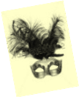***Tragedia dell’Arte***

***A Puppet Show for Marcel***

*We are in his bedroom in his Combray house.*

1. *Introduction*

You open for me that collage

Of photographs you have filed away.

They reassemble to display

Great Duchesses *d’un certain âge*

Who with their poses make a Masque

Wherein beneath the chandeliers

Come Questions to their eyes (with tears)

It only pains their hearts to ask.

The Question what is nobler in

The mind when Beauty, *déclassé*,

Falls to the ranks of yesterday;

The Question how it might have been

If she had followed her desire

When on the terrace, ‘neath the moon

She gasped, and fell into a swoon

To see in his dark eyes such fire.

Come, step into the Masquerade!

The part of ladies in old age

In ways so redolent of the stage

By comic actresses is played

That one is tempted both to smile

And weep, and certainly to say,

*Encore!* in one’s most genial way

To players of such practiced style.

♫

[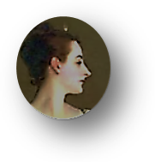](http://inmemoriamc33.com/debussy_fetes_galantes_fantoches.mp3)

[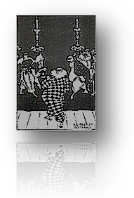](http://inmemoriamc33.com/stravinsky-_suite_no.2_-_harlequin.mp3)2. *The Performance*

♫

Sciatic old Lord HARLEQUIN

Attempts a dashing cartwheel for

His entrance, teeters, hits the floor,

And hides his pain with a forced grin.

None of the troupe at this *soirée*

[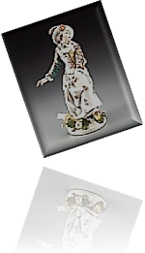](ttp://inmemoriamc33.com/stravinsky_-_suite_no._2__columbine.mp3) Makes sport of him: too tired, too tired.

Though COLUMBINE, who once admired

♫

The stumbling tumbler, and still may,

Comes to his aid. His words are fierce

To the coquette, now *très grande dame*;

Down her white cheeks, with strange aplomb,

Doodle the black mascara tears.

Her with a hairy hand he thrusts

Aside, and through his monocle

Casts ogles at the beautiful

Young courtesan for whom he lusts.

[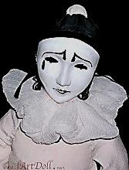](http://inmemoriamc33.com/stravinsky_suite_no.1_for_small_orchestra_pierrot.mp3)

(Her glance, in turn, seems to appraise

*Him* as a rich though paunchy goat.)

♫

PIERROT, he of the wrinkled throat,

Gives Columbine a pitying gaze,

But has no heart to play the game

He used to play. The mandolin?

He gave it up. But he *is* in

The midst of writing, for his fame,

A lengthy novel, a *roman*

*À clef*, of sorts, and a memoir,

Luminous, with a tinge of *noir,*

Of a considerable élan,

Exposing for all time what Time

Has done to *them*, with all the paces

Still to be gone through, though with faces

Weathered, yet, in a way, sublime

Against the sunset fade-away

Of vices they must still pursue.

(And ah, what else ought one to do

At the anti-climax of a play?)

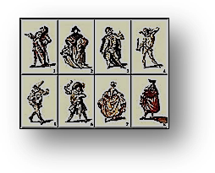3.

IL CAPITANO’s eye for *très*

*Jeunes filles* has grown myopic, dull.

Too weak to wax thrasonical,

He is thin, taciturn, and grey.

DOTTORE, garrulous as Brichot,

No longer writes his weekly column.

His laugh is empty, his eyes solemn;

His lucid moments come and go.

But *he* remembers, old Pierrot,

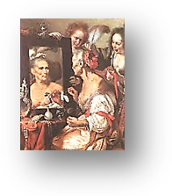 A *père* *Goriot* (oh yes, he married,

Is widowed and a father harried),

How he decried the long-ago

Gomorrhan love-play and carouse

Of Columbine and ZERBINETTA,

How he*, toujours jaloux*, once set a

Trap to expose them in a house

Of ill repute, but they escaped

And robbed the voyeur of his pleasing

Anguish. How it amused her, teasing

The swain whose hapless heart she scraped

Distractedly as with a heel

She scraped the floor in the champagne

Waltzes of yesteryear! The pain

She caused, but would not feel,

Returns now, as he gazes at her,

Shaped into unsaid sentences

He’ll write down on that desk of his

Tonight. Ah, what engrossing matter

Her lightness gave him, frivolously,

For contemplation, serious Letters!

Yes, she is one of the Forgetters.

But *he* remembers. So will we.

We will remember Columbine

Looking so queenly through her tears

At beauty stolen by the years;

What can one do but drink more wine?

4.

Then break the mirror, and burn all

Those *billets doux* the Spirit killeth,

Madonna of the morning, Lilith

By daylight, Eve at evenfall!

The shadows that grow round you are

The umbrage of a shelter for

A face close-up inspection, pore

By pore, would find as secular

As the yew bending over tombs,

And grimaced like a tragic mask

In the full horror of the task

Of dying in these crowded rooms

Where, in the last sciamachy,

The magic lantern shoots its rays

As flames along a paned bookcase

Flickering into obscurity.

[](http://inmemoriamc33.com/debussy_-_clair_de_lune.mp3)

♫



***Musical Program***

**Page 1**

Debussy, *Fantoches*. From *Fêtes galantes.* Text by Verlaine. Véronique Gens, soprano,

Jeff Cohen, piano.

Scaramouche et Pulcinella,

Qu'un mauvais dessein rassembla,

Gesticulent noirs sous la lune,

Cependant l'excellent docteur Bolonais

Cueille avec lenteur des simples

Parmi l'herbe brune.

Lors sa fille, piquant minois,

Sous la charmille, en tapinois,

Se glisse demi-nue, en quête

De son beau pirate espagnol,

Dont un langoureux rossignol

Clame la détresse à tue-tête.

**Puppets**

Scaramouche and Pulcinella,

brought together by some evil scheme

gesticulate, black beneath the moon.

Meanwhile, the learned doctor

from Bologna slowly gathers

medicinal herbs in the brown grass.

Then his sassy-faced daughter

sneaks underneath the arbor

half-naked, in quest

Of her handsome Spanish pirate,

whose distress a languorous nightingale

deafeningly proclaims.

Trans. Clara Claycomb

**Page 2**

Stravinsky, *Suite No. 2 for Small Orchestra*. “Harlequin.” CBCSO, Stravinsky, conductor.

Stravinsky, *Suite No. 2 for Small Orchestra*. “Columbine.” CBCSO, Stravinsky, conductor.

Stravinsky, *Suite No. 1 for Small Orchestra*. “Pierrot.” CBCSO, Stravinsky, conductor.

**Page 4**

Debussy, *Clair de lune.* From *Fêtes galantes.* Text by Verlaine. Véronique Gens, soprano,

Roger Vignoles, piano.

Votre âme est un paysage choisi

Que vont charmant masques et bergamasques,

Jouant du luth et dansant, et quasi

Tristes sous leurs déguisements fantasques!

Tout en chantant sur le mode mineur

L'amour vainqueur et la vie opportune.

Ils n'ont pas l'air de croire à leur bonheur,

Et leur chanson se mêle au clair de lune,

Au calme clair de lune triste et beau,

Qui fait rêver les oiseaux dans les arbres,

Et sangloter d'extase les jets d'eau,

Les grands jets d'eau sveltes parmi les marbres.

**Moonlight**

Your soul is an exquisite landscape

charmed by masquers and revellers

playing the lute and dancing and almost

sad beneath their fanciful disguises!

Even while singing, in a minor key,

of victorious love and the good life,

they do not seem to believe in their happiness,

and their song mingles with the moonlight,

the calm moonlight, sad and beautiful,

which sets the birds in the trees dreaming,

and makes the fountains sob with ecstasy,

the tall slender fountains among the marble statues!

Trans. Peter Low (with alterations)