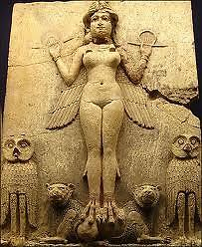
* The Temple Singer *
I. Curator and Priest

Have I shown you the figurine
the temple singer?
Hold it in your hand for a moment.
Imagine the sound
of her voice,
how simple and clean…

An arrow piercing
a sheet of rain.

Water from a source
high in the cedar forests.

A fountain that surges
to the height of its yearning
and falls away.

*
Consider this blue world
pasted on the ceiling
in lapis patches:
It is my Never-Healing Heaven,
the plaster of its wounds laid bare.
I reach out my upturned palms,
try to remember the ancient prayer.
Dry rain sifting
from a tessellate sky
dusts my hair with fine
white powder.
I have forgotten the names of my gods.
II. Empty Room, Open Window
This clay tablet:
I pierced it with signs
fresh as love-bites once—
shaped like your sex:
They meant You.

I rub the clay
like flint to ignite
one scintilla
of that sunburnt noon
and the desert sand relieves
and there rises once again
a city of towers and temples,
gardens and canals: the wonders
of a dream with its own blue sky…
Oh the swelling of that day
and the minute of the hour
and the scent of roses in a bowl!
You naked on your bed of cedar,
your beauty
burning in its fire
like a sacrifice,
you, reaching out your arms to me!

*
Empty room.
Open window.
Nothing.

*

And the scent of roses in a bowl.
III. Cedar and Pine
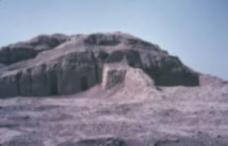
Here in this alcove
absence takes the shape
of tallow smoke.
One memory is another
and their sum is oblivion.
Did I once write a poem
for a temple singer?

I have known many temple singers.

But now once again it is You
only You
walking beside me
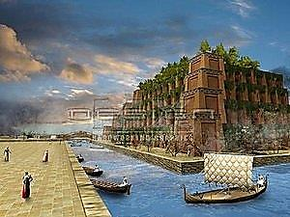
in the cool of the morning
in the garden by the river.

*

I think of the curved planks
you were admiring on the wharf that day
when you said to the shipwright:

I have never seen wood sanded so smooth.
You turned to me in the midday air
and whispered in my ear:
Smell the wood, Love, and it is only you and I
up in the mountains, among the cedar and pine.
And I am still perhaps a little jealous
how in full view of the appreciative youth
you ran your slender fingers
over that curvilinear, unassuming grace—
seaworthy work of his hands.

IV. The Splendid Arrogance of Trumpets
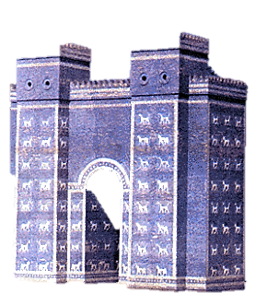
Dawn, inching into colors.
First day of the planting season.
I wake up in your bed.

In a timid nimbus of light
I see you there beside me,
propped on one elbow, gazing
into my eyes with a tender,
slightly abstracted look,
running your fingers through my hair
lightly as birds skim water.
A blaring of brass horns
in the distance fanfares
a procession of soldiers
coming home victorious
through the lapis-covered gate.
Children dancing in the street.
The splendid arrogance of trumpets,
jingle of timbrels shaken.
Women in windows
showering roses and lilies of the valley.

And the young captain
who slew thirty men in battle
walking grim in his terror
of showing how abashed
and delighted he is.
Now you, at the window,
motioning to me: Come and see!

You take from your hair
a single red rose
and let it slip from your hands.

You turn with a smile,
looking just a little
beyond me.

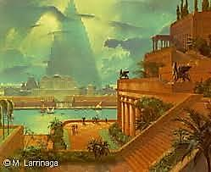
V. The Swiftness of Rivers

Today I sing before my Lord the Moon,
you said. “I must purify myself
in the sacred waters.
My harp needs tuning,
my hair is a scandal of disarray.
Help me put on my necklace,
you gawking idler!—

But O my Belovèd,
How lovely you are in my sight!
How comely are your ears with precious gems,
your arms with bands of gold!

When I look into your eyes
I see sunlight playing
on the surface of the waters.

*

All our days were spent among roses
and finely wrought things,
vessels of bronze and gold.

We laughed as we spoke of love and life
in a dead language.

I have forgotten
how to say the words.
But I remember the laughter.
It is its own language.

I think it is the speech of gods
and swift rivers.

VI. I Remember the Night, and the Moon
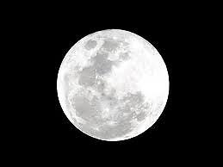
Darkfall. What daylight had repressed
rose up as pallor, with a new answer
to the one immortal question that is night.

Insomnia’s god, your face the color of my bones:
how subtle you are, to shed a light so akin to shadow.
You would smile so faintly at the sacred game,

the Lion-Bird gnawing you away, you ripening
again, like barley in the barley’s season.
I remember now: Moon-Bull. My Lord Nana-Sin!

*

Stealthily now I climb the stairs
to your palace on the temple’s top.
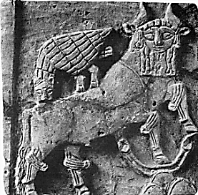
There, at the window, I watch and wait.

Your distance is with me, gliding past
a reticence of copper mirrors, running pale fingers
over lamps grown cold. The city sleeps.

Where is my Belovèd, she promised
she would come! Is she lying
with the young captain, was she lying?

How anxious is the one who waits by the window!
In rhythm with an Age of Waiting
you inch from cloud to cloud. Your halo:

a threshing floor in the sky. Ghostly oxen
tread the circle.—Darkness will have its harvest:
The Goddess gives her husband to the Shades.
VII. Midday’s Roses
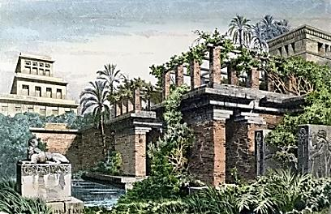

I sometimes revert to the habit
of reading by the light
of an oil-burning lamp
with its fragile flower of flame.

In whatever room I read,
it wakens on the walls the same
fitful shadows of lovers I once knew,
so that I may never cease
to be familiar with all I have lost.

I am reading a book called
Treasures of Darkness.

I know the items in the illustrations:

The lyre painted gold and blue,
with the head of a bull for a prow.
The gold-leafed cosmetic box.
Headdress hung with leaves of gold.

They forgot there ever was a light of day.
They forgot they had ever been touched.

*

O my Belovèd, come before me
in a robe made of midday’s roses,
wearing bracelets of sunlight!

How fresh it still is,
the ancient honey
in my hive of dreams.

*

Stand before me just once more, Belovèd,
stand and be golden in the morning light
so that I may gaze at you and smile
because I am so bitterly happy.

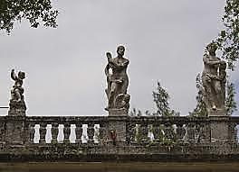
VIII. Water and Stone

Spring rain shrinks
from the garden statuary.
The last bead drops
down and away.

The soil drinks it.
Worm wine. Root manna.
Wet stains grow vague on the balustrades.
A faint chromatic mist floats
from the roof of the portico.
The sandstone’s salmon color
will be restored.

Not yet. There is a seeping-in.
The stone drinks
and its thirst is not slaked.
A puddle steams on a marble slab,
withdraws inward from the sun,
dragging along its unwilling
surface tension.
Gone.
The stone has a jet sheen.
An idea of water subsists.
Is it still wet?

IX. Starlight, Morning Light

At night, when the sky is clear,
I can pick you out
among the crowd of your companions,
unreachable, the Stellified:

Sealed in the ark of your distance
like a secret thing.
You who are dead here,
in my living,
live there, long after I died.

*
Daybreak.
You are sitting by the window
combing your hair,
still dripping.
Sunlight,
its shower of arrows,
softens to a bodiless caress
passing over you.

*
You, Atalỳa, my Belovèd,
you by the window
there!




