L a
l a b y r i n t h i a
b h
y t
r n
i
r n
y t
b h
a i
L a b y r i n t h i a

Daedalus & Assoc.
Inscription over the Entrance
Look closely at your thread,
Theseus: it, too, is a labyrinth.

Just for a lark—on the wing—
We designed this labyrinth
And placed at its heart, on a plinth,
A replica of the thing.

And if you have taken the trouble
To find this place—if you enter
And venture your way to the centre
Where the structure scales down to its double,

You may make out, inside the model,
A fraction of the labyrinth
With its model placed on a plinth
Like a ship squeezed into a bottle.

Reduced to the size of an elf
Is a figure in a mirror
Growing gradually clearer
Till you are sure it must be yourself.

Does something in you feel at hoëm
In this metaphysical trap,
Like a house in a town on a map
Or a word in a line in a poëm?

Place within place, and no place,
Clues hiding clues within clues…
She means to amaze you, the Muse
Who inspired this amusing maze.

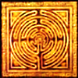
Deployments of the Labyrinth

1. Inscription

THE DEVIL AT THE ENTRANCE ISN’T DANGEROUS
THE SELF WITHIN, THE CENTRAL SELF? A STRANGER.
THE ANGEL AT THE EXIT IS NO ANGEL.

2. Enter MCV

Be calm. There is no exit from
The Library of Babel’s maze.
From aisle to aisle you move, and graze
Upon the books till Kingdom come,

Which it will not—save in this version.
Remove it from the shelf. You see?
‘Kingdom comes in three-thousand-three’.
A mistranslation from the Persian.

The riddles beckon, and one delves.
As I have written in a book
For which you shouldn’t try to look
On the infinity of shelves:

MCV MCV MCV MCV MCV MCV
MCV MCV MCV MCV MCV MCV*
MCV MCV** MCV MCV MCV MCV
MCV MCV MCV MCV MCV MCV Quoted in MCV: The Autobiography.

* An acronym: ‘Marcel Chérit Vinteuil’. A message from M. Proust.
** One-thousand-one-hundred-five, but only in this instantiation.
Can also be construed temporally as 11:05, but only antemeridian.
MCV… Any relation to you, my Mr V?

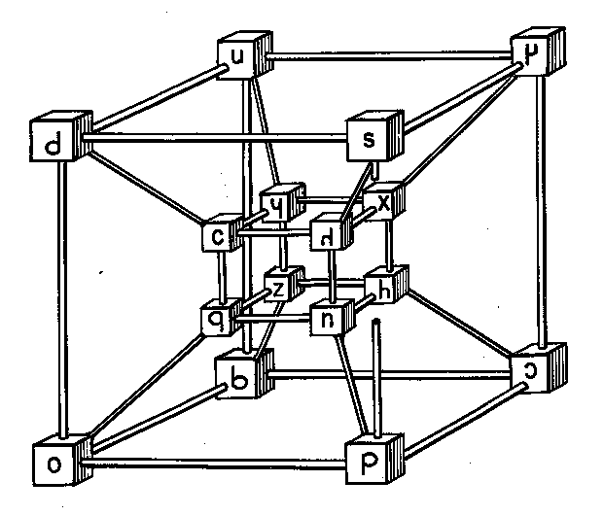

Mi casa e su casa.
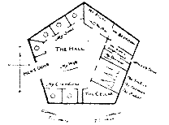
The Aleph and Other Things

By elegantly and accurately dreaming, a young, near-
sighted Argentinian author (de)materialises before me.
Out of an infinite number of incompossible Borgesii,
he is the one who happens to appear as a semi-fictional
character in a poem by Oscar Wilde. Or does he? The author has asked to be identified
in the text as ‘MCV’.—[Mr V]
Among the particles, one particle MCV appears in a wizard’s robe, black as night.
Contains the others, all of them.
Some call him Aleph. Some say Shem.
Chapter and clause, to the least article,

Is there, of particles and laws.
I saw my own face in it, and
My bowels, as well, saw from left-hand
And right-hand, fore and aft. No loss

Is suffered not retrieved elsewhere,
Though perhaps very far away
And inaccessible to-day,
Perhaps for ever. Need we care?

Why is it not enough to wander
In wonder through the labyrinth
That in a temple on a plinth
Is laid out for a god to ponder?

Though you may think yourself behind
Doors, you in fact are on a plane
Projected, in a square. In vain
From Aleph’s hyper-cubic mind

You ‘hide’: he sees your face. He sees
Your entrails. Fail to understand
This and you are trapped in Flatland.
Who sees not, him the Blind Ones seize.
The wizard gear is put aside and we sit down together
* on an old-fashioned chintz divan. We are in MCV’s
library (which is technically infinite), cocktails in hand.

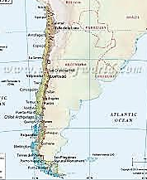
The Birth of Labyrinthia
as Told by MCV

1.
Chile fell into civil war
And self-seceded, west from east.
Chile, as such, is now deceased.
There are two where one had been before.

East Chile has its east and west.
These fight, as east with west will do:
East Chile breaks itself in two.
The reader can divine the rest:

West Chile, with its west and east,
Comes to the same result. Now, four
Countries where two had been before.
(Not that this matters in the least.)

Never is donned the irenic robe
Of international community,
From which the countries feel immunity,
For each is bitterly xenophobe.

This mad mitotic trend for years
Goes on, and each seceding land
Has narrower territory, and
Proportionately, the frontiers

Increase their territorial share.
Walk, and you cross a boundary; stand,
And straddle. There’s no room, no land,
Only the borders, everywhere.

2.
How name these subdivided lands
After so many iterations
Of east-west subdividing nations?
With so much little on their hands

Some poets suggest names like ‘Rose
West Eastern Chile’, ‘Lily East
Thrice-West’, the name increased
The more, the less the country grows.

On the street’s eastern side stands one
Nation, and on the western side,
Another; across that Great Divide,
The street itself, fire mortar and gun.

Some lands insist on numerals
Based on the Dewey decimal system.
The Founding Fathers, in their wisdom,
Named one land (seized, some say, on false

Pretences), ‘PR823
.J5 7325’.
Another name’s a Boolean hive:
Those noughts and ones spell sovereignty.

3.
Born out of so ingrown and vexed
A microgeopolitics,
The bickering Labyrinthians mix
Like strands of a disputed text.

To list the burgeoning names, with lower
And lower national populations,
Of these proliferating nations,
The Encyclopaedia of Nowhere

Has been compiled: a ninety-nine-
Ton-tome. After much legal battling,
The Book is laid down open, straddling
Several countries, on its spine.
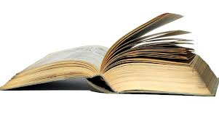
Theseus

Enter the labyrinth once more,
Take up the thread, the rescue mission.
(Why should she let you lose your way?)
Down halls torch-lighted, echoing
With cries, inch, cautiously, to where
A carnivore with cloven feet

Lives at the centre of the myth

On sacrificial virgin meat.
The swooping blade. The glassy stare.
You saved the young ones, hero! Bring
Them back into the light of day.
But the myth wills its repetition.
Enter the Labyrinth once more.
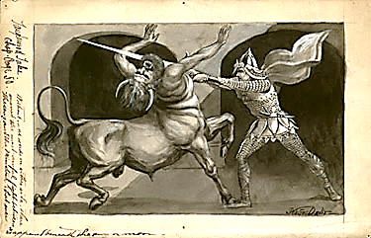
How Certain is ‘Curtain’?
A Philological Tragicomedy

Hermes leads me through a
labyrinth made of words.
1.
Open the curtains, dear. Let pass
The coaches and the clouds awhile.
Here is a tale to make you smile:
A story about words. If as

A philologian I may speak,
The etymology of ‘curtain’
Is veiled behind a weak, uncertain
Vulgate translation of the Greek. Which in turn renders
Heb. yeriah in Exodus.

Cortina means, in classical
Latin, ‘cauldron’, diminutive
Of cortem, from which we derive Derived in turn from
The ‘court’ in ‘courtyard’. (Thus the ‘fall’ cohortem (nom. cohors).

Of language brings a faint recall
Of etymology.) In Greek, ‘curtain’
(Aulaia) connects with a certain
Custom: not using doors at all

But rather curtains opening
On courts, as much as possible
Allowing the house to breathe and fill
With air, and what the breezes bring

Into it of their cool, with fragrant
Hints of a bright Athenian day.—
‘Curtain’ is but a silly say;
Consider it a semantic vagrant.

A cauldron serving as a door!
We’ve much to thank confusion for,
Like those illusions we adore
Until found true, and thus a bore.

2. The King, the Door, and the Assassins

The door is thick (with walls to match)
As the rooms lodged within are deep,
And has compartments spies can creep
Through on their intramural watch.
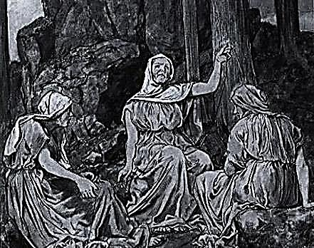
This makes the door a kind of room
Large enough to store, in one chamber,
Cauldrons with oil or fragrant amber
Filled; in another, at her loom,

A Norn is spinning out a cloth
Embroidered with a tragic story,
Which some might call an allegory:
The Angel Turned into a Moth.

An eyeless Norn the pattern feeds.
From sister Fates she brooks the schism,
Feeling her way by algorithm,
The writer, not the one who reads.
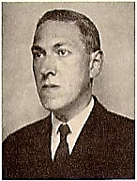
So thick a door has its own walls.
Through these a fricative sussuration
Like running water’s circulation
Of rats down intramural halls

Scurrying provides a score of rushed
And hurried whisperings, as of some
Omen of dire events to come.
And they will not quelled or hushed.

Behind the walls are other walls,
And behind these, the Old Ones Wait.
Nothing’s more ancient than their hate.
They bide their time till Master calls.

They are off-coloured. Red-ed, blue-lue,
Green-reen: Colours for ever fleeing
Themselves, they so abhor their being.
They give their hate the name CTHULU.

3.
The King who broods within the walls
In one of myriad rooms (the palace,
Dear, was designed, with subtle malice,
As a maze, and ghosts walk the halls),

The King who drains his cup and laughs
For one insanely barking moment
And then declines all further comment,
Numbed by the Rhenish that he quaffs,

Is on all sides by foes surrounded.
Ah, the Great have great enemies!
He squeezes his mind’s eye, and sees
Some stones unturned, no fears unfounded.

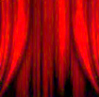
The King is in a parlous way
For he is trapped, besieged by mirrors
That multiply him by his terrors.
They own his mind. He is their prey.

The assassin in the door is dazed
By thump of treadle and rush of rodents,
And by a maze of chambers so dense
He wanders lost and slightly crazed.

The assassin in the walls is guided
By priests to a small entrance whence
He issues, knife in hand. His sense
Of orientation a decided

Turn for the hapless takes, however,
For where the hidden King may be
Is anyone’s theology.
This murderer, too, is lost, and never

Heard from again. For there are many
Spare spaces in the tombs inside
The closets where a ghost may hide.
For such, may Charon waive the penny!

The King could sometimes wish his killer
Might find him, and conclude the endless
End-game that so torments him, friendless
And weary. From behind a pillar

He dreams him springing with the knife
And writing in his willing throat,
To end a play not worth the groat,
A bright red finis to his life.

4.
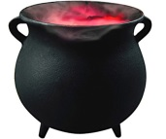
So I ‘draw-to’ this cauldron-curtain
Of words and all therein contained.
I hope it was not well explained:
One wants things thus, a bit uncertain.
The Queene of Labyrinthia
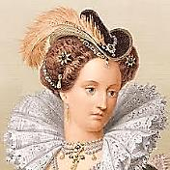
Complexities, in the end, defeat
Design. The maze grows only denser.
Think of those episodes in Spenser
Where plain knights weave in dark conceit

‘Mongst nymphs and wizards and what-not,
Until the allegory spins
So many myths of origins
That Virgil’s oak is overwrought
With Ovid’s ivy. ‘Hard begin’, The Faerie Queene, III, iii, 21.
What is your end? You have too many
Of these to be said to have any,
And fewer the ways out than in.

So highly charged with gorgeous Eros,
♫
Infected will unwilling serves
Erected wit, and sensory nerves
Are insolent squires to his knight-heroes.

A knight may ‘gainst his interest act,
His better judgment; what he fears he Prince Arthur and the Fairy Queen (Fuseli).
Is overtaken by: his Circe
Turns hoggish mind to bodily fact.

The thread tatters to threads, to broken
Endings leading. But these are new
Beginnings, each a chance to do
It all again, new vows are spoken

In a tempestuous wedding of
The pagan and the mediaeval,
Protestant God and Catholic Devil.
It is the straying that we love.

*
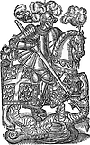

Spenser, you hated us, it’s true. Hated the Irish, that is.
Hysteria mars your fantasy.
But though you fear to set him free,
Eros exuberates from you.

You wrestle to the ground but can’t
Pin down the daemon. He will rise
Again. What spell could exorcise
The Protean from the Protestant?

Proteus, Menelaus

Wing, claw, tooth, tusk… Sunlight will crystallise
That shimmer into a single shape, the real
God’s face. Pinned to himself, he will reveal
Meanings and answers, will be tame and wise.

This is why you have been condemned to roam
The seas: you have offended Zeus. The breach
Must heal. Perform the rites and you will reach
Your Spartan homeland, your Elysian home.

But in those plush Fields, safe from mortal storms,
The man stays tied to his identity:
Heroic Cuckold. Proteus, breaking free,
Escapes into the labyrinth of his forms.
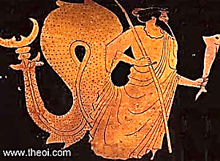
The Forking Paths and the Zohar

By elegantly and accurately dreaming, a young, near-
sighted Argentinian author (de)materialises before me
out of an infinite number of incompossible Borgesii,
He is the one that happens to appear as a semi-fictional
character in a poem by Oscar Wilde. Or does he? The author has asked to be identified in the text as
‘MCV’.—[Mr V] Hmm. Any relation to you, dear?

You never wrote the book you should We are sitting in MCV’s library (which
Have written. Thou of little faith! is technically infinite), cocktails in hand.
Oscar, my dear, you are a wraith.
I am writing you. You are quite good.

You know you were almost always right.—
Almost? I see a falling off,
Apostate! It’s praise, not a scoff.
It takes but one mistake: Good-night!

I have not made enough mistakes,
I long to make outrageous ones.
You speak my language now, for once!
Yes, make as many as you can:

You may end up where none has been.
And if it is a luckless place?
No matter. We both know the race
Is not to swift or slow. To win

Is to lose opportunities
To fail in a magnanimous way:
For poetry this wins the day.
Explore all possibilities—

Oh infinite possibilities!
There is a place where polymaths
Wander like fools down garden paths
That fork into insanities.

And in a parallel dimension
You are the Chinaman who spies
For the Huns. I’m the one who tries
To open up to you the intention,

Unfathomably deep, of your
Forefather’s garden, in which grew
The Book it was. You never knew
Until I told you that, before
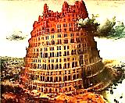
You even asked, you were the scion
Of one who seemed a failure to
His family, even to you,
But was a visionary Lion.

Well, he was infinitely clever,
That much is obviously true.
I owe my happiness to you.
Never shall I forget you. Never!

And here you take a pistol from
Your pocket and shoot me. The name
Of the ‘ammo’ depot is the same
As that of the town to which you’ve come.

You were successful. Headlines tell
The Kaiser’s men the place to bomb.
With an inscrutable aplomb
You will wear the noose. You have done well.

My death is penance, and it is
An act of gratitude, and love.
But meanwhile, in another of
My multiple realities,

I am a minor character
In a book written by a ghost.
There is a story, almost lost
In the sub-plots, in which I, sir,

Am the author of this book. This part
Is the key to the whole structure, and
Disproves that you had any hand
In the making of this work of art.

In this thread I am the narrator:
‘The stairway spiraled roundabout.
As I looked down, while leaning out
Over the trembling banister,

‘My father’s corpse went falling by.
It had been falling many years,
Skeletonised. I watched my tears,
A few drops, like rain in a dry

‘Climate, fall after him. They will
Evaporate within the hour.
Above, the stairs of Babel Tower
Shrink into the illimitable’.

I am that father, am I not,
Falling into his past again?
A corpse that falls and falls… And when
He lands, he wakes—is that the plot?—

In C.3.3., and watches, this
Time, as he looks over his own
Shoulder as he looks over his own
Shoulder as he looks over his

Own shoulder… Do you feel it, then,
The turning screw, the winding stair?
What is that old man writing there?
Born you shall surely be again.

But a much older man looks on
Over his shoulder, and to him
A child is writing something grim:
The debt is due, your last chance, gone.

The one behind him sees a child.
He’s even older, and takes a pen.
Can you describe the ‘regimen’
In Purgatory, Mr Wilde?

He writes. Another imitates
This act, behind him. He is older
Still. So I look over his shoulder:
Don’t worry too much over dates,

He writes. To me, the oldest of men,
He seems the youngest of them all.
Here is a note-book. If I scrawl
Born you shall surely be again,

Would the ourobouros bite its tail,
The circle close? You, young again
And yet as old as time, would then
Be hearer, teller, and endless tale.

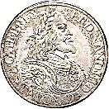
So I have brought you face to face
With the Unending. To a Greek,
Can one even speak
Of it, let alone give it place

And time, or any pleasing shape?
And yet you frame the Infinite
With elegance, you make it fit
Inside an image, a landscape,

A looking glass, a labyrinth
Or labyrinthine garden. Why,
You almost set Infinity
Upon a fluted marble plinth!

3. The Zohar

This version has it that you are
A man who is obsessed, so much
So, it is all you see and touch:
I mean the false coin, your Zohar.

You wake, and there is the Zohar.
You dream Zohar. You hear him call.
You paint the Zohar on the wall.
It is the Self you think you are.

Your vision becomes, finally,
Spherical, and the great Zohar
Stands in the centre, a dark star,
And front and back at once you see.

What can you do now but go out
Into the desert that you are
And fix on the great god Zohar
You will for ever think about?

And now you are the great Zohar:
You are the look of the Zohar,
And what is seen by the Zohar
And the Zohar of the Zohar!

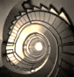
Theseus, Tithonus

1.
How many quests is Romance made
Of? How many mazes are there
In the House of Mazes? Climb the stair-
Case in its spiraling, past the jade

Monkey simpering on its plinth
Again, and again pass the jade
Monkey: the charm begins to fade
Of living in a labyrinth.

So many stairs to climb, and quests
To question or to quest, that is
The question. There is deep unease,
Arthritis in the knees, the guests—

The guests!—have long since gone, and I?
I am your charming host, Tithonus.
I bear my house, its creaking onus,
With shrinking strength, and dimming eye.

I am the weary master of
The mazes, and their slave. My heap
Of questing-trophies I still keep
In a room several floors above.

There I am, sitting by myself.
They’ll never find me here in this
Attic. My Don Quixote is
Looking sad up there, on the shelf.

2.
Once more, dear friends, into the maze!
Is getting lost perhaps the only way
Out of here? It will be a lonely way.
I still must serve so many days,

So many days, so little time!
It is not gentlemanly to rush.
Nor yet to beat about the bush,
When burning. Ah, these walls, this lime!

The Minotaur
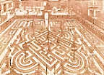

Or is he something different,
This creature waiting in the centre?
One part of him is a young renter
Used and discarded, perhaps bent

On vengeance for my having shown him
Glimpses of a world not his own,
Spoiled now for his, stranded, alone
In the sea back to which I’d thrown him,

Now alienated from his kind
And to the Paradise he’d known
Denied re-entry, twice-alone.
(All this takes place inside my mind!)

Parts of him are my family,
It may be: Constance and my sons.
A good husband and father once,
When I pursued debauchery

As if it were my holy grail,
I quite forgot them, gave them not
A thought. I left my wife distraught,
My sons neglected. And I fail,

Even now, to understand just why.
The monster is the unhappy life
My helpless sons led when my wife
Could find no reason not to die,

When they were left to the cold care
Of relatives who punished them
For my sins. For this I condemn
Myself to climb, stair after stair,

The spiral of my guilt, to thread
The maze of my indifference
To loved ones. Acts that made no sense
Now make that nightmare sense, that dread

You’d feel, trapped in a prison-maze
Of the kind drawn by Piranesi,
Cruelly, rigorously crazy,
And infinite are the crooked ways.
And not one way leads anywhere,
Or leads you back to where you started,
A wilderness that can’t be charted—
And the monster waits hidden there.

Clutched in its hand there is an ace
Of clubs, or simply a club, or say,
A card left at a club one day.
It knows its way around this place.

I know he keeps his hungry den
Somewhere inside. I hesitate
And hide until it is too late.
The nightmare must come round again.

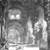
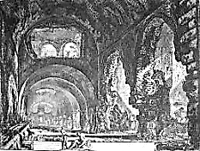

The National Flag of Labyrinthia.

Stanzas for Asterion

The cursed are sacred, they are set
Apart. They wander lost in rooms
That have no house, and darkness glooms
Over the floors a spreading net.

He came for you, he kept his pledge,
And in his hand your head swung free
Of Gordion-knotted intricacy
Solved by the simplest, keenest edge.

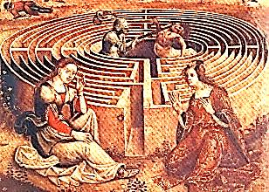
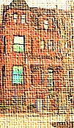
The Jolly Corner
One minute before 11:05 AM,
28 February, 1939. It is time.
1.
There is a house James writes about,
The Jolly Corner. In it dwells
A threatening ghost who is—what else?—
The hero’s double. Fear and doubt

Assail him, and a sense of shame:
What sort of life might he have led
As worldly businessman, instead
Of the rich idler he became?

One’s real life is the life one did
Not lead. The man of flesh and blood
Is thus the ghost of what he could
Have been. There’s no way to be rid

Of him, the double who is and
Is not himself. He can’t erase him.
He is too strong. So he must face him.
Two missing fingers on one hand

Bespeak a man who has known strife—
A man of action—and because
Of this, has suffered. They must cross,
The two paths of the hero’s life,

The one he took, his present life,
And the uncanny path not taken,
The possibility forsaken.
Enraged, the double like a knife

Thrusts himself at the hero, who
From fear collapses in a faint.
In the arms of a female saint,
A loving friend, the man comes to.

Is he alive? Will he go on,
Merged with his ‘animus’, to lead
A stronger life? Or is he dead,
And dreaming this companion

In the afterlife? Has he survived
Himself as someone else, his double?
The author leaves us here, to trouble
Over the sequel. He who lived

Was not alive. The life he failed
To live took the shape of a ghost
Livelier than he. Who is host
And who is guest? What is unveiled?

3.
Before I walk into a space
Thoroughly emptied of my life
And full of freedom from all strife,
There’s one more trial that I shall face,

My last trial, which is self-imposed:
To face my Double. I will ascend
Along a spiral to the end
Of memory. Then my Book is closed.

Or open, of the human cry
Exhausted. Tears evaporate
In air, traces of love and hate
Dissolve into their home, the sky.

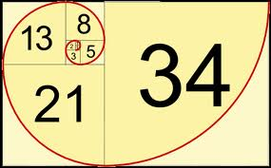
Of Fibonacci Numbers

[I find myself standing in a lecture hall in Magdalen College.
I am at that indeterminate age somewhere between the 39
I claimed to be at the First Trial and the 40 that I actually
was. Dante is responsible for this Purgatorial joke: he has
made me, a maths dunce, Professor of Mathematics! His
last hurrah. The students seem restless and bored.]

1.
Behold! a Golden Spiral on
A coin, in a rectangle!—I
Confess, it is a false coin: φ φ = the Golden Ratio (1.6108339887…).
Is not attained, ever–anon The Fibonacci spiral is built on integers but
approaches to the Golden Ratio at infinity.
Approached though it may be, for mine The Fibonacci sequence represents the closest
Are Fibonacci ratios, approximation to the Golden Ratio using
I am almost certain. (Ah, they doze! rational numbers: 2/1, 3/2, 5/3, 8/5…
At least it’s nearly time to dine.) —[Mr V]

2. A Lecture of Sorts

If one and one make two, and one
And two make three, and we get five
From three and two, then shall we strive
For eight? And by addition

Most horrible reach dread thirteen?
Which I can barely say! What fun
I had when I was twenty-one,
Betwixt a little, and between,

It’s true, but so? At thirty-four
I had moved out towards the extreme
And I don’t even care to dream
What waits at fifty-five or more,

Say, eighty-nine, how inconceivable!
O sequence rabbit-multiplying
Who rule the breeding and the dying!
Wrinkled the skin grows, irretrievable

The loss of youth’s crisp curls of hair,
Irrevocable the greying trend
When in a steep ascent you bend
To infinity and leave us there

So far behind you, husks outworn

Leonardo Fibonacci, a 13th-century mathemati-
cian, independently rediscovered the ‘Fibonacci
sequence’ and used it in an idealised thought-
experiment to chart the growth of a rabbit pop-
ulation. Oscar fails to grasp a key assumption of
the experiment, that the rabbits do not die. It is
interesting to note that the sequence was first
discovered by Indian scholars in the 6th century
AD and applied to Sanskrit prosody—specifically,
to rationalise the relationship between long and
short syllables. So Poetry and Maths come full
circle, eccentrically. (Let me add in passing that
Fibonacci’s far more consequential contribution
to Western Civlisation was to introduce and
popularise the use of Hindu-Arabic numerals.)
—[Mr V]

By the genetic seeds we hold
In trust deceived when rendered old,
Redundant, and then, why be born?

The numbers spin their lazy eight-
Approaching vehicle around;
I come back to the launching ground
Of one plus one, if somewhat late.

Now God is surely One. To be
Incarnate, unity makes two
In one, for God is Lord Christ, too.
And Holy Ghost makes Trinity
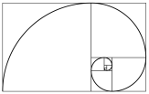
And the duality atones,
And two and three are five, and three
And five, eight: add these last and we
Reach the unspeakable number once

More. Evil arithmetic! But I
Will brave the Fibonacci numbers,
Though nightmares may invade my slumbers.
I recognise no boundary.

We’ll set sail for the Ratio
Of Gold, though we shall never reach
That place, my Dears! Ulysses, teach
Your mates the Perilous Way to go!

With what is left us of this so- I have forgotten that I am already
Brief vigil of the human senses, past this vigil. Ah, to be carried away by
Let us learn how immense the Immense is, one’s own rhetoric, like a blushing bride!
Let us know what it is to know!

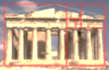
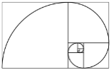
The Ascension of Old China Blue

Here, at the podium again?
Time: 16 October, 1946.

The ‘spiral vase’ seems to be a sort of Klein bottle, un-
bounded, non-orientable in space and rather self-absorbed.
—[Mr V]

1.
Spiral in shape, my fictive vase
Became a staircase I must climb
To view a different place and time
At every turn of what I was.

[A student creates a disturbance, heckling this tentative
beginning as stilted aestheticism. He is escorted out
of the lecture hall. A bit ruffled, I must start again.]

1.
Spiral in shape, my fictive vase
Became a staircase I must climb
To view a different place and time
At every turn of what I was.

2.
I have told you how my spiral vase
Became a staircase I must climb
To view a different place and time.
But did you know that what I was

I saw as what I would become?
And on each landing was a bust
Of something crumbling into dust.
I was alone, and far from home.

3.
You can predict my spiral vase
Will climb the same stairs every time—
But with a difference, yet a rhyme
At every turn of what I was.

I see the one I did become
And on each landing pass a bust
Crumbling into a different dust.
Then dust is where I make my home?

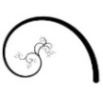
Each turn affords another view
Down the vertiginous stairwell
To various degrees of Hell.
What I did I cannot undo.

5.
The spiral shape, the fictive vase,
Are versions of the stair I climb
But with the difference, this time,
That I turn into what I was.

I am the man I would become
And on each landing pass a bust
Resembling, but only just,
A face that I once knew at home.

Each turn affords a brother view
Or mother view, down the stairwell,
And those whose life I made a Hell
I see, and know not what to do.

The memory of the floors below
Is an accretion of my loss.
A fictive vase with serious flaws
Is the best metaphor I know

For the heartbreak that heals you when
You see the past sink out of view
Like the wrecked vessel that is you.
And you must turn, and turn again.

8. Constance

It spirals into itself, my vase,
No matter how far I may climb.
So I grow smaller every time
I see I am smaller than I was.

How unbecoming to become
The man I am! I think the bust
Is of the monkey of my lust.
The likeness of a broken home.

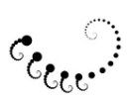
I turn to get a better view
And in the depths of the stairwell
I see a face I once knew well.
She wore a veil and said, I do.

The memory of it years ago
Became oblivious to its loss.
That’s one of my more serious flaws.
It happened on the floor below

And all her heartbreak happened then.
But now her face sinks out of view
And there is nothing I can do
But turn and turn and turn again.

I am sorry Constance! I am so sorry.
But that was on a different floor.
And there are many, many more.
Of course, each story is a story.

Happiness was a thing that used
To happen to me. I am a child
Of mood. My name is Oscar Wilde.
My breath is short. My feet are bruised.

The more I climb the more there is
To climb. Must every step create
Another step? And it grows late.
How shall I ever get out of this?

13. My Children

The downward spiral of a vase
Is the inversion of sublime.
Innocent victims of a crime
I see, of which I was the cause.

And into focus now they come,
As I look down. I pass a bust
I do not notice, for I must
Assess the damage as a sum:

I turn to get a better view
And in the depths of the stairwell
I see the children I loved well.
There’s nothing that I would not do
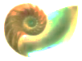
For them, but that was years ago
I did that to them. For I was
As fictive as a spiral vase.
And I weep down on them below,

On all their heartache and their pain.
But now their faces sink from view.
The thing I did again I do.
The turning has returned again.

Cyril, Vyvyan, I am so sorry!
They led me in, and shut the door.
I shall not see you anymore.
Hell is less harsh than Purgatory!

How cruelly you were abused
By relatives who raised you. ‘Wilde’
Was not your name. No, no, no child
Deserves to be so meanly used!

The more I weep the more there is
To weep. What can I do but hate
Myself, or blame it all on fate?
That it is that, that it is this.

But Cyril, you went off to war
And came back as the ghost I saw
And in the terror and the awe
The tearing open of a scar

Occurred, and I shall call it healing.
And you became my Happy Prince,
With the poor swallow gone long since.
No fire consumes the heart of feeling.

The bird shall sing, the Prince shall praise
The giving of the gems away.
He is in Paradise today.
My vase can only crack and craze.

My heart is in the urn with him.
Ash of my ashes, you, my son,
And Vyvyan, too. All into one
The ashes settle, light grows dim.

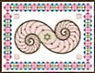
How many steps, and for how long
Must I continue to ascend
Into a sky that has no end
To make a rightness of the wrong?

21. Bosie

My spiral is a weary vase.
The staircase cannot cease to climb
Through larger spaces, longer times,
Surprised to see how small it was

When higher iterations come
Not quite full circle. And the bust
Is of a spiral quite nonplussed:
The vase contains itself. Its home

Is in another home. Review
The Hellish stories down the well.
Remember Bosie, and your cell.
The panther feasts, and what was due

In the end, and how it fell. Below
My station. Too much revel was
Enough to shatter a fictive vase,
With revelations bringing woe

To me, and Art’s ache, and the pain
Of sacrifice betrayed. My view
Is blurred, my eyes are moist with dew.
Again return, return again,

Dear Bosie, tell once more the story
Of how I walked a stony floor
For you. See how much rope I tore!
Think how the morning’s morning glory

Returns to mourn at evening. Bruised
Is the apple of my eye. Reviled
For ever is this Oscar Wilde.
And I believe you were amused.

The more I brood the more there is
To brood upon. But it is late.
The end game crawls to the checkmate.
Failure, what is the sense of this?
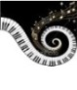
Is Cupid Mars, so to love war?
Your character may have a flaw,
My dear. You lived by your own law
And so did I, but I have the scar

To prove it, you, nostalgic feeling.
Forgiveness when the lover sins
Must scourge him first and make him wince,
But for some wounds there is no healing.

I swallow up my pride these days
For it was I who chased away
My Bird of Paradise. I pray
My pride may go up in a blaze

Of wisdom, but the chance is slim
That I will be the lucky one
Whose ashes fly into the sun.
The Phoenix fire is guttering dim.

The day is short, the shadow long.
And time can never put an end
To brazen sorrow, my old friend,
And grief’s perpetual undersong.

You were my slim-gilt lily boy,
You had the genius of your youth.
I had the genius of my mouth,
My honeyed tongue, my gift for joy.

You were my prince, my fleur de lys
And flirtily familiar with
A thirtyish man who was a myth,
And is a myth eternally.

I fell. You did not make me fall.
The myth, at higher iterations,
Opens onto what revelations?
Revels unravel. I willed it all.

Perhaps blue blood and a blue face
Cancel each other into love,
Somehow. But from the floor above,
This story is of other days

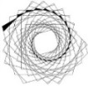
Much darker down, a depth unclean
With hate. The Irish cock-and-bull
Must face John Bull, and he is full
Of Minotaur. It is obscene.

And how obscene we were, together
In our adventures in rough trade!
In Naples love is known to fade
Beside a Bay, in autumn weather.

My spiral is a maze of wandering,
Wandering up to who knows where?
No ceiling but the empty air.
The stars, perhaps, were made for pondering.

The ghosts of old astrologers
Have left their eye-prints on the skies
That do not care who lives and dies.
The stars are Tinkers, Travellers.

34. The Marquis

This spiral of blue china, vase
Full of itself, was once sublime.
What is most beautiful with time
Becomes the shade of what it was.

It is the time when monsters come
Out of the closet. Broken bust
Of ugliness, you are the just
Likeness of one who broke my home.

And he comes gibbering into view
And wants to pull me down the well
Into the hate that is his Hell.
What an unspeakable thing to do,

Enter my house and threaten so,
And here you come again! My vase,
Though but the shards of what it was,
Brims over like a cup of woe.

How mad I was to fight the insane!
Could it be monstrously true
That you are me, and I am you?
I turn again. What do I gain?
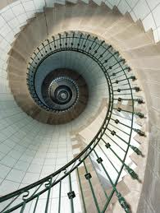
Fresh understanding of the gory
Details, which who would not deplore?
They are even uglier than before,
And many times I have told this story,

How I was stubborn, and refused
Advice to let it go, and filed
The suit that brought down Oscar Wilde.
Oh, Queensberry was much amused!

The more one hates the more there is
To hate, there is no end of hate.
He is the monster of my fate.
I cannot climb away from this.
Between the gutter and the star
Most thread their way by rote and law.
I wanted both, that was the flaw
That left me with this shameful scar

That makes another wound of healing.
The Screaming Scarlet Monster wins
Again, then a fresh trial begins,
And the familiar awful feeling.

A monster hides in every maze
And of the lost he makes his prey.
The snake in Eden has his way
With every Eve. I curse my days

Of penance, and I glower at him,
The one he hated as his son,
That Bosie boy, the Golden One:
The Parsifal who on a whim

Shot down the swan, but the great wrong
That he had done he would defend
Bitterly to the very end.
And still my way is long, too long!

Their faces haunt me, golden boy
And brutish father, arrogant youth
And the beast who sniffed out the truth,
Base metal of a base alloy.

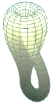
Why will it not be history
That scholars calmly reckon with?
I am still tortured by my myth.
Am I the Sphinx’s Mystery?

The Marquis did not make me fall.
It was my myth grown out of patience
With all reality, the nation’s,
The world’s, the success of it all,

The fiat lux, the course of days,
Provisions for below, above,
And in between. I had had enough
Success, I longed to touch the face

Of failure, though it be obscene.
Happiness, sadly, can grow dull.
And the vase becomes overfull
Of emptiness. Down, down careen

The tragic heroes, heaped together
On the ground floor, how low are laid
The saviours by the mess they made!
An end must come to every tether.

Out of control the spiral’s wandering
The twists of its own turns nowhere
But up the iterative stair
Amazed, when what it should be pondering

Is how the stars, the Travellers,
Can find their way across the skies.
They do not know that they are wise
But know that what occurs recurs.

*

Look there! Could that be Oscar Wilde?
A serious man, some seventy
Years old. Respectability
Weighs on him, there are Honours piled

Upon his back. He is an old
Master. Upon its plinth, the bust
Of him rests solemn and august,
And he, as well, feels marble-cold,

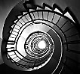
Depressed by a lifelong success
Which through the decades grew to be
A species of vulgarity
That used to cause him some distress.

But what an oeuvre he compiled…
Asterion has eyes so mild!
To being a Sir Oscar Wilde
He is grudgingly reconciled.

I am the satyr, and his double
And Doppelgänger—I am the ungrounded
Bacchus, the Man of Gestures wounded.
He is glad he never knew such trouble.

*

Everything learns to say farewell
By moving farther from its source
Because this is its only course.
We tell what we won’t live to tell.

I bid good-bye, not to my wife
And children, and not to my lover
Or foe, but to the things left over,
The memories of a finished life.

I am beyond myself, beyond
Belief and doubt, and every care.
Estrangement is the truth we share.
The heart of its own heat so fond

Becomes a cloud winds blow away
And leaves behind no scars, no stains.
The lightness of the light remains
When there is nothing left to weigh.

*

Blue China I at last live up
To, now that I have climbed the stairs,
You are but a sky that puts on airs.
Let spiral be a simple cup.

Circle is ever at odds with square.
Be genially unreconciled.
And shape no bust for Oscar Wilde.
His is a monument of air.

The scent of roses in a vase.
The sunflower, and the flower on high,
The morning glory in the sky.
For I am not the one I was.

*

We stars are Travellers, and we roam.
Planets and sea-shells are our traces.
We are at home in many places
But there is no such place as home.

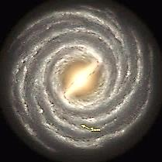

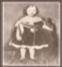
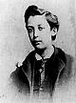
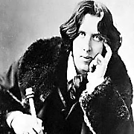
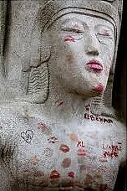
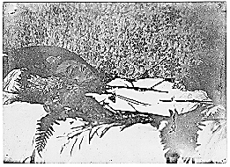
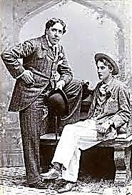

Triton
Shell
Horn

I am
a whisper
and an ear.

My hollow
cup holds
distance near.
to the
Listen world Play me
air. ♫ breathe by listening,
with in there. turn in your hand
fills
Bone wind
is bone. on the water,
Inside you churn of the

* * *
sand.

