From Père Lachaise
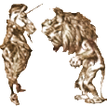
The Empire at Home and Abroad

A group of German university
students gather round my elegant tomb.
1.
Good evening! Kind of you to trot
By on your way to, where, a nice
Café? The Opéra? How wise
You all seem! You’re an owlish lot.

Students, you say? Ah, so was I,
Once. Intellectuals? This visit
Is about edification, is it?
Well, if you must be scholarly,

I wager you would like to hear me
Talk about England in the old
Days, about politics and cold
Economy. Alas, dear me!

This has potential to be boring.
You knew so much, though, Oscar, saw
And lived so much. We hold in awe,
Critical awe, that age, exploring,

Exploiting, brutal and scientific
And decadent, expansionist
And insular…—I get the gist,
My Dear. You’d have me be specific.

Very well, I will set the scenes
And act them out, and bring you up
To date, briefly. Then you will sup
And revel. (Ah! You are in your teens!)

2. The Pre-Raphaelite Years and their Passing

Society still sought its tone,
As there continued, almost daily,
The exchange of Gladstone for Disraeli
And of Disraeli for Gladstone.

Pilgrims to Arthur Liberty’s
Regent Street store, and other art warehouses,
The bourgeois thronged to buy for their houses
The flower-patterned tapestries
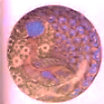
Of peacock-blue, the finely wrought
Stained-glass things, thin as a whisper,
The vine-and-tendril wallpaper
With which pre-Raphaelites sought

To save the harried modern soul
From the brute, levelling onslaught
Of the great factory juggernaut.
But those who paid the steepest toll

To the barons of industry
Could least afford these lovely things,
And they fell to the scavengings
Of the bower-bird bourgeoisie.
The middle class could not decide
Whether to help the hungry poor
Or punish them. But these grew more
And more, and an advancing tide

Of Socialists and Fabians
And Communists and Anarchists
Brandishing pamphlets or their fists,
At times, broke in on the romance

And idyll of the wealthier classes.
(This I was sure of: Socialism
Fails without Individualism,
Detaching oneself from the masses.

How many young souls have I seen
Who should be individuals
Ground down like rows of decimals
In Babbage’s Difference Machine!)

3.
One Anarchist’s bomb would reveal
The Tower Bridge’s quaint façade
(That mediaeval face says ‘God’)
Is built on heartless modern steel.

The scions of the Saboteurs,
Lyonnaise or Silesian weavers,
And Sans Culottes, are true believers
In violent gods, as they rehearse

The Communist Apocalypse
When horsemen storm the Winter Palace
And vent an ancient pent-up malice
Against the boyars’ knouts and whips.

Glorious October! Who can stifle
The bullet, barricade and bomb?
Liberty’s still, though très grande dame
By now, a crack shot with a rifle.

The Marx-intoxicated Masses
And the great Spectre of Revolution
Come alive, horribly: blood-ablution
Of the sins of the Upper Classes,

Its musical accompaniment
The cracking of aristocratic
Skulls and the stutter of automatic
Weapons, and tycoons shot or sent

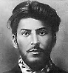
To labour camps with reprobate
Theoreticians of Class Struggle
Whilst cowardly apparatchiks snuggle
Against the ogre of the State.

4.
And Capitalism? The great fact is
How powers-that-be manipulate
And merge beneath its modern State
Religion and sharp business practice,

The latter of which, based upon their
Utilitarian theories (with
Doses of fallen-Adam Smith),
Is quite amoral, laissez-faire

Barbarity in a frock coat.
Thou shalt not kill, but make a killing.
Torture the pence into the shilling.
Worship the stock, and buy the vote.

The indistinguishable herd
Of Nonconformists, clean of face
And conscience briskly-scrubbed, that race
So serious and so absurd,

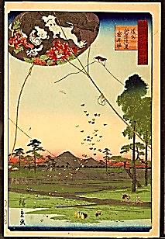
Dissenters, once beneath a ban,
Who helped abolish the slave trade,
Are now Consenters to be made
Slave-drivers of the working man.

Govern the unwilling. Lest, like vermin,
The angry poor should run amok,
Toss them a crumb, for Christian luck.
Give them a lecture, preach a sermon.

5. Trade Winds: The Colonial Adventure

‘Twas to intrepid Commodore
Perry’s gunboat diplomacy
That we owed Japonaiserie.
(What stuff comes through that Open Door!)

And what is Japonaiserie?
The iceberg’s tip. The world, once vast,
Was growing smaller, and was fast
Becoming one society

Riven by violence, and rent
By revolution everywhere.
(The greed of wealth that will not share
Ensures continual dissent.)

Along with foreign goods, ships brought
To our shores strains of speech, exotic
New words that spiced the old demotic
With the tang of the polyglot.

Suttee, Seppuku and Kow-Tow,
Mahatma, Dharma, Hunky-Dory, ‘Hunky-Dory’, from a red-light district
Kiwi, Banana and Satori, in Yokohama, Japan, haunt of sailors.
Pantoum, Kris, Bwana… In they blow

On one great capitalist trade wind.
The growl of Rikki-Tikki-Tavi Sir Charles Napier in the 1840’s conquered
Mingles with Napier’s ‘Peccavi’, this east Indian province. His despatch
Meaning, I have sinned. I have Sindh. consisted of this single punning word. [Oscar] Mr V: Wrong, Oscar. But let us continue below.*
___________________________________________
*This is a popular misconception. The author of the pun was a girl
named Catherine Winkworth, who submitted it to Punch, which
then printed it as a factual report. She went on, by the way, to win
fame as a composer of hymns.—Oscar: Very well. But let us leave
the cramped basement of this footnote! It is rather clammy.
(He exceeds his authority
In a way that secretly pleases the
Foreign Office, for he increases the
Size of our holdings measurably.

Of course, the East India Company
Can see the possibilities.
The public chuckles: At least he’s
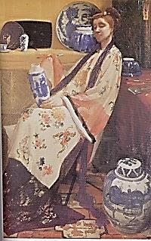
A noble rascal, isn’t he!)

♫
6. The Opium Wars; the Boxer Rebellion

We cook the Dragon’s goose, fill full
Our bellies at the feast, our host
Lord Palmerston, who serves as toast-
Master to delicate John Bull,
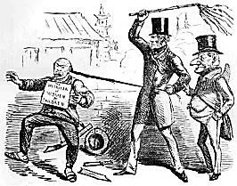

Lord Palmerston (1857) showing the
Chinese what’s what. (Punch cartoon.)

Drug trafficker extraordinaire
To the Chinese, willing to force
Smoke down their throats, to fight two wars
And spread addiction everywhere

To adjust the balance of Free Trade.
We bring them interesting times,
We foreign devils, and our crimes
Are schools in how Empire is made.

To them affliction is a thing
Eternally passing, the one dream
Into the other, what things seem
And are, equally vanishing.

But comes the Boxer, acrobat
Martial and magical in air;
And Chiness Muslims gobble rare Clemens von Ketteler, German Pleni-
The black heart of a diplomat. potentiary to Peking, gratuitously shot a
Chinese boy. In revenge, Kansu Braves
made a meal of the man’s heart (1900).
The peasants fear the officials; the
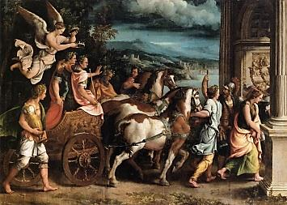
Officials fear John Bull; Bull fears
The peasants: such harsh, clanking gears
Drive the commercial colony.

7. Pius Aeneas

Ah, the colonial adventure
Makes each man pious Aeneas, in
His own mind—a good killer. Sin
On epic scales escapes the censure

Of Conscience by appealing to
The old ideals. (Modernity
Adds sweetening Tartufferie.)
And what can the poor natives do?

What gross enormity can one
Commit but it bears fruit, or tends
To useful ends, and finally blends
Beneath a never-setting sun

Into the glorious old story,
That is, the great reality,
That is, a fact of history
So vast that the details, cruel, gory,

Shameful, atrocious as they are,
Fade, in the sunlight of successes,
To ghosts that trail, as it progresses,
Caesar’s immense triumphal Car?

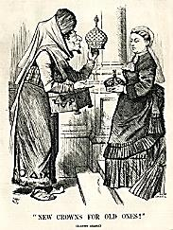
Disraeli offering Queen Victoria an even
more prestigious title: Empress of
India! Her daughter had become German
Empress: that simply would not do!

(His slave, an economical
Philosopher, seizes the hour
To whisper in the ear of Power:
You are immortal, after all.)

What have they done, the English? Made
A little history, that’s all.
Is that so evil? Yes. The Fall
Rendered us so. For since Eve bade
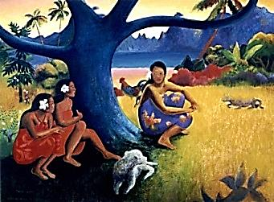
Her husband eat, and he and she
Sinned in their disobedience,
We are all half-devils. Innocence
Is a Tahitian luxury

Gauguin made sure to cure them of—
He was a sort of missionary
Of Decadence: he taught how very
Risky and dangerous is love,

All sicklied o’er with the pale cast
Of death, or at the very least,
Shameful disease. (And yet the East,
I think, will be avenged at last.)

Real missionaries, ever-officious,
Cried, Save the heathen! But did not
Many a Christian in his pot
Curse God, who made him so delicious?

A mere foretaste of what the world
At England’s feet, licking its chop-
Sticks, has in store when conquests stop
And the frayed Union Jack is furled

And packed, and sent back to the roost
To which the chickens, too, will come,
The Foreign Ones, and call it home.
When once the reins of Power are loosed,

As loosed they must be, finally (Rome’s
Imperium ate the dust), the past is
Not what it used to be… As fast as
It drove, the chariot caroms

From off the rebound of its force
And veers from the triumphal path
To muddle through the aftermath
Of altering human history’s course,

Its own course altered. For the arma
Virumque that made others change
Those changes shall in turn estrange:
So saith Fate, or Wyrd, or Karma.

8. A Charming Coda

I broach a somewhat different topic
For your refreshment and surprise:
For in a fit of wild surmise
I have discovered a new Tropic

And fashioned for the clime a novel
Pith helmet and white suit of clothes
To uphold the Mad Dog English pose
So that whilst coolies in their hovel

That barely from the rains gives cover
Poke grains of rice with little sticks
From bowls, I may my sixty-six
Thousand-pound income savour over

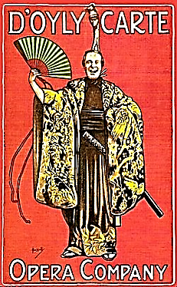
A cold, spiced drink of whisky or rum
And summon up those souvenirs
Of G & S that still wring tears,
And hum the Moon Song of Yum-Yum.
♫

My eyes are glistening, myopic—
But listen! Something is amiss:
Beelzebub is Lord in this
Mosquito-buzz-bedevilled Tropic!

*

