His Grace and I

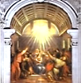

Chats with Cardinal Newman

Table of Contents

His Grace and I:
Chats with Cardinal Newman 3

His Grace and I:
More Chats with Cardinal Newman 6

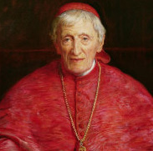
His Grace and I
A Conversation with Cardinal Newman
♫

1.
I kept your portrait, and the Pope’s,

In my rooms in the University.
Was it a gesture of perversity?
A diptych of my fears and hopes.

Reading your books again reminds
Me why I was afraid to meet
With you: the great charm would defeat
Me of a man born to mold minds.

Oh, I have dallied with the Lady
From time to time, your Grace, but faltered
At the Altar. You would say I’ve paltered
With God. My character is shady.

But many a time I have been half
In love with her, the Scarlet Woman.
How like a Siren did she summon
Me in those days! My friends would laugh

To see how earnestly I talked
With priests, and nattered about Rome
As being my spiritual home.
At the church door I stood, but balked.

My own half-heartedness dispirited me.
Worse than religious, a financial
Crisis! Penalties were substantial:
My father would have disinherited me

If I had left the Fold. As ‘twas,
My uncle nearly cut me from
His will for making eyes at Rome
Merely! The flesh is weak, hélas!

And the intellect is sceptical.
Each finds a questionable nutrition,
Whether in money or ambition,
Two gods that rule after the Fall.

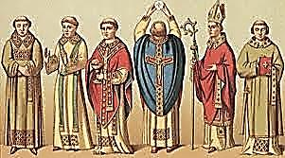
2.
It was so tenderly dogmatic,
Your ‘look’ in the sartorial
Splendour of gravely beautiful
Vestments, say, a stiff flowered dalmatic.

And ah, the comely altar boys
Sweetly composed in solemn rite,
The incense-rich, subdued delight
Of hymns sung in a clear high voice!

You consecrate the Eucharist
With just a soupçon of ennui—
Te deum vitae (pardon me!)—
As with a somewhat languid wrist

You sway the censer. Incense smoke
Drowses communicants like bees,
Drugged by sublimest Mysteries.
You speak the words the Saviour spoke,

You magically consecrate,
With hoc est corpus, daily bread
Into the flesh of One who bled
To heal our wounds, Word increate

And boundlessly creative Holy
Ghost of the blessed Trinity.—
But what can all this do for me,
A moral leper, one whose Noli

Me Tangere is Lazarus’ warning,
Confession of uncleanness, foul
Contagion? My unsightly soul
Wears the veil of a sinner’s mourning.

3.
The primitive, true Revelation
Lives on in Rome, and the tradition’s
Seemingly novel definitions
Are clothing only, and illustration

Of ageless Truth in time unfurled.
The Church’s mission is to fight
A giant evil, and shed light
Upon the darkness of the world.

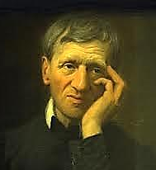
What is this ‘giant evil’, then?
Does it include, say, paederasty
Among the priests? You have a nasty
Imagination. Priests are men,

And men are prey to lust and greed.
In every human institution
Is found some ethical pollution.
We are the flower of Adam’s seed.

4.
There’s talk I shall be made
A saint. They do not know, you see,
That I remain in Purgatory.
Because you countenanced the slave trade?

I felt it wrong, but thought it right
That, being fallen, Man’s condition
Should be so harsh, whilst abolition
Defied God’s plan. I see the light.

I’m glad you see it, Cardinal Newman.
Our social evils cannot all
Be solved by finding texts in Paul!
The righteous can be so inhuman.

One also finds in Paul the text
On resurrection in the flesh.
I trust yours will be cleanly, fresh,
And unambiguously sexed.

You had a boon ‘companion’,
Your Grace, a man who lived with you
Some thirty years—is this not true?
One could elabourate upon

The implications of this fact…
That ex-Dominican who denounced
The Pope: how angrily you pounced
On him, how fiercely you attacked

His morals! With such animus
Did you impugn his character,
You triggered such a public stir,
A jury found it libelous.

5.
But what bad conscience you betray
With your scurrilous imputations.
Your aesthete pose would try Job’s patience.
Yet even a drunken man, one day,

By miracle or luck, may lurch
His way home. At the door I see
You stand. Before you is the key:
The Apostolical, one true Church.

Will the Lord own me as his son?
Surely, I have been prodigal,
Have eaten of the fruit of all
Life’s tempting trees, and battened on

The husks of my humiliation!
Suffering is kindest when most cruel…
Then shall I don the brilliant, jewel-
Encrusted robe of my salvation?

I trust that is a metaphor.
Say rather the garb of humility.
Yes, certainly of great utility,
But one might want to make a more

Dazzling entrance unto God.
The aesthetics of a summer’s day,
Pure monochronos hêdonê,
Give the tang to the angels’ Laud.
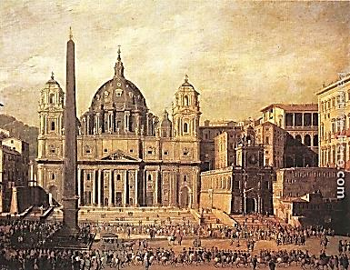
His Grace and I
♫
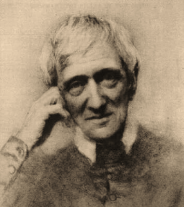
More Chats
with Cardinal Newman

1.
[Thus far we two have had a very
Pleasant discussion touching on
Substantiation, trans- and con-,
And over a fine glass of sherry

Compared notes on the Real Presence
In the Eucharist, the wafer-thin
Line ‘twixt obedience and sin,
The bitter sweetness of His Essence. ]

2.
Substance is, like a pure Idea,
Known only through its accidents.
These only we experience.
The Lord’s ungraspable ουσία

Makes itself actual for us
In accidents of bread and wine.
This daily miracle we define
As Transubstantiation. Thus

Divine Grace is embodied in
A sensuous form. The nourishment
Of this essential Sacrament
Renews us, cleanses us of sin.

But sin is, as it was, also
A mode of self-discovery.
A vice may save our lives to be
The good souls that to Heaven go.

At Lesbos, Aristotle says,
The mason’s rule is made of lead,
Adjustable to help him read
The stones’ uneven surfaces.

One bends the rule for the exception,
As everyone is, or should be.
But fallen is Humanity,
That crooked timber. The deception

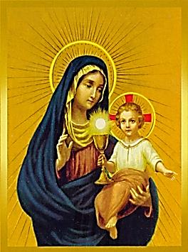
Built into language by its own
Bias and ambiguity
Distributes its perversity
Between the measurer and the stone.

Reason, the universal caustic,
Devours itself. God’s rule is straight.
And He does not discriminate
Between atheist and agnostic.

Like you, I sought the Idea in
The Image. But, being pagan, you
Worshipped the image, not the true
Substance, ουσία. That is sin.

You loved the thing created more
Than its Creator, you pursued
Idol and fetish, which illude
The soul. Then is my soul a whore?

Each of us worshipped Mystery
Almost for its own sake, and saw,
Appalled, how mystery and awe
Were being murdered rationally.

But Art was my religion, my
Mystery, a Mystery we should deepen,
Nor let the grubs of mere Fact creep in.
It was, it’s true, idolatry.

But you, too, had an aesthete’s eye
For images. These Rome could give
In plenty, here your eye could thrive
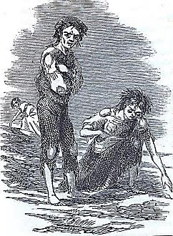
On icons of authority.

3. The Biography of a Conscience

In England ruled the great god Mammon,
Whom Liberalism served a feast.
In Ireland, meanwhile, raged the beast
An Gorta Mór, the Great Famine.

But it was consecrated bread
You hungered for. Anglican fare
Seemed made with insufficient care
And left you feeling underfed.
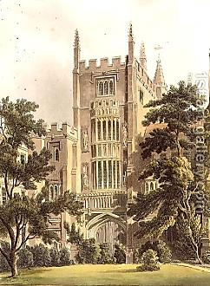
The soul of the High Church was in
Sore disrepair. Crucial improvements
Were needed, and your Oxford Movement’s
♫
Goal was to save it from the sin

Of worldliness (‘economy’)
And schism. Evangelicism
Was one threat; worse, though, Liberalism
Was a great thriving blasphemy

Against the eternal principles
Of the true Faith: its sublime Vision,
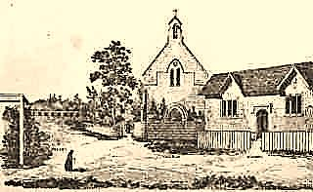
Its rituals and its saving mission
Were ciphers to the Liberals.

Then, in the mirror of your soul,
You saw, one day, to your great terror,
An image of doctrinal error
So twisted out of shape, so foul, Littlemore.

It looked as hideous a fright,
In its own intellectual way,
As the picture of Dorian Gray.
What was it? A Monophysite! What Gothic horror was this!

But when, at Littlemore, you came
To dinner in grey trousers (stood
Modeling a Change of Attitude
You were too subtle a man to name),

The old haeresiarch was gone,
Your gesture said. Henceforth your stance
No longer was an Anglican’s,
But the profession of the one

True Apostolical universal
Catholic Church, with comprecation
Of Saints, Purgatory, veneration
Of Mary: yes, this Great Reversal

You mimed in inter-sacerdotal
Mufti—a coup de théâtre, as ‘twere.
And through the angry public stir
Your new faith stayed entire and total,

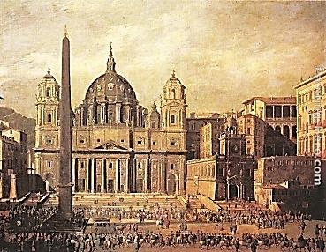
Your soul unerring in devotion.
The stations of your crossing home
From Low to Broad to High to Rome
Lead through grave doubts, and much commotion

You have to pass on lands and seas
Polemical and introspective
(For human logic is defective),
Until at last, your soul finds peace.

Behold! At length the stage is set
For Rome to take John Henry Newman,
A most distinguished catechumen,
Into Saint Peter’s waiting net.

A Passionist baptises you.
Old Adam is at last a new man
And, gainsay all they may, a true man,
Who by his lights, although they grew

Dim sometimes in a gathering doubt,
Ne’er did but what he thought was right
And found his version of the Light
By honest ways, though roundabout.

4.
I was, some made bold to suspect,
A dandy with accoutrement
Of halo, perfumed with the scent
Of sanctity. I and my ‘sect’

Were even accused of ‘foppery’,
And seemed suspiciously ‘refined’
To Christians of the muscular kind.
That ‘die-away effeminacy’

Kingsley ascribed to me was nothing
Compared with the dishonesty
He charged me with, implicitly.
For all my modesty and loathing

Of self-advertisement, I had
To answer such an accusation.
This challenge, then, was the occasion
Of the Apologia. From young lad

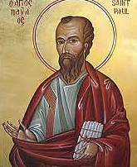
To ageing man I traced the curious
Autobiography of my
Opinions, trudging, with a sigh,
Through old pamphlets.—Reliving furious

Controversies that to some seem
Much erudite ado, and little
More?—Pondering the ancient riddle
Of Antiquity made me dream

Of a Truth pristine, primitive,
Enshrined in doctrine, ritual, and
Tradition, passed from hand to hand
Down the millennia, still alive

In Rome—alas, somewhat corrupt,
But living. What was Protestantism?
A theory, a bookish ‘ism’.
But he who with Christ Jesus supped,

The fisherman Apostle, passed
By firm succession, Pope to Pope,
Power and universal scope
Over the One Church. Thick and fast

Heresies come and have their day.
But Scripture proves that only Rome
Is the Tradition’s lasting home.
The English Church will pass away.

She lured your soul, the sweet, demure
Holy Mother, across the Channel.
‘Twas Milton’s pipes now sounded ‘scrannel’.
She lured you, and you yielded to her.

For, as I’ve said, the only way
To rid oneself of a temptation
Is to yield to it. To the Nation
A traitor, some presumed to say,

(They cursed the Popish harlotry
Of images you venerated
Of martyr and saint, they execrated
Your shameless Mariolatry)

To your own wayward yet steadfast,
Tentative, cautious and yet pure
Nature you kept faith, were most sure
When unsure that your faith would last.
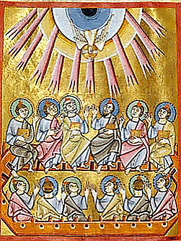
By what a curious, tortuous way
You reached your spiritual home in
The only Catholic church, the Roman!
But there you stayed, and there you stay.

5.
I never saw the Holy Ghost,
The Spirit who descends to save us.
I never saw that rara avis
Of Baptism and Pentecost.

What other prophylactic moly,
Of symbol and higher Mystery
Compounded, could have kept you free
From the Circèan spell unholy

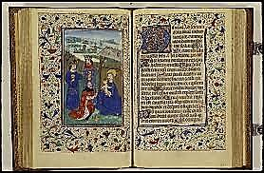
Of panther feasts on offer in
The private rooms of your desire,
The marketplace and barnyard mire
Of heedless hedonistic sin?

Ah, not the herb that Hermes gave you
(Itself a spell)! Only the love
Of the invisible Power above.
But what you don’t believe can’t save you.

6.
At last, at least, your changing soul

From my Notebook

Kingsley, muscular Christian, can
Weight-lift two hundred pounds of sin.
Wrestle the Devil, and who can win?
Good Works’ top athlete, Christ’s he-man!

Came out in an authoritative
Edition, and fulfilled its native
Urge to submit to God’s control.

From sacrament to sacrament
In the incense of the Illative
You found a way to think and live
An unconditional Assent.

Your story has an austere glamour
Consonant with your mind’s precision,
Though your abstract, scholastic vision
Repels me with its frigid grammar.

Where the child Blake saw angels perched
In trees, your mind received ‘impressions
Of dogma’ at fifteen, a prescience
Of all the Tracts to come, researched
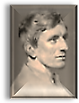
With minute and exhaustive reading
Of the Church Fathers, building thesis
On thesis, founded on φρονησις,
To justify Faith’s special pleading.

The cause for which you fought was doomed
To fail, the tide of Liberalism
Could not be stemmed; Rationalism
Made all the assumptions once assumed,

Including the Assumption, either
Questionable or wholly moot.
The tree was severed at the root.
How could you glue it back together?

‘Twas doomed to fail, your Restoration.
How could a Tory renegade,
Perversely, grandly retrograde,
Undo the history of the Nation?

For history has leached the colour
Element from the English Church.
Good deeds and scholarly research
Can’t keep it from becoming duller

And duller as the years advance.
No purple dyes of tender awe
Can make us see what Peter saw,
The living Radiance in the glance

Of God made Man and Holy Ghost.
The once-fresh Apostolic Creed,
A mystic rose that’s gone to seed,
Mixed with the general compost
Of Western myth, cannot be prayed
Back from the dead, except in art,
The temple of the modern heart.
The Institutional must fade.

The Athanasian Creed

Anathematical, schematic,
The Athanasian Creed turns sword-
Point Trinitarianism toward
Arius, the dangerous schismatic.

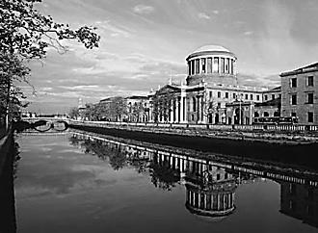
7. The Idea of a University

But let my portrait be well-rounded.
You did defend the Catholics,
The poor of Ireland; candle-wicks
You lighted for them when you founded

The Catholic University, Now University College Dublin.
(A place that served to incubate
The intellect of the first great
Catholic Irish writer, he

Who boldly cried, Non serviam,
And fled the fold of Church and Nation
But never lost his admiration
For your prose style. Would you still damn

James Joyce to Hell as reprobate?
He is your truest ‘fan’: these days
There aren’t that many left, your Grace.
Might you shed some on him? A great

Phronesis would it be, and prudence.
The herd of independent minds
Read Marx, of late. One can’t pick kinds,
One has to welcome any students.

*

O radical who found no root,
You are history. The Via Media’s
A relic of the encyclopaedias,
And you begged questions long since moot.
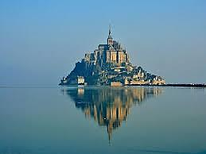
Musical Program
♫

Page 3
Britten, Ceremony of Carols. I: Procession. Boys’ choir unnamed.

Hodie Christus natus est:  hodie Salvator apparuit:  hodie in terra canunt angeli:  laetantur archangeli:  hodie exsultant justi dicentes:  Gloria in excelsis Deo.  Alleluia! Alleluia! Alleluia! | Today Christ is born:  today the Saviour appears:  today on earth the angels sing:  the archangels announce:  today be exultant and say together:  Glory to God in the highest.  Halleluia! Halleluia! Halleluia!

Page 6

Palestrina, Missa Brevis. II: Gloria. The Tallis Scholars, directed by Peter Phillips.

Gloria in excelsis Deo
Et in terra pax hominibus bonae voluntatis.
Laudamus Te, benedicimus Te, adoramus Te, glorificamus Te,
Gratias agimus tibi propter magnam gloriam tuam,
Domine Deus, Rex coelestis, Deus Pater omnipotens.
Domine Fili Unigenite, Jesu Christe,
Domine Deus, Agnus Dei, Filius Patris:
Qui tollis peccata mundi miserere nobis;
Qui tollis peccata mundi suscipe deprecationem nostram,
Qui sedes ad dexteram Patris miserere nobis.
Quoniam Tu solus Sanctus, Tu solus Dominus,
Tu solus Altissimus, Jesu Christe,
Cum Sancto Spiritu in gloria Dei Patris. Amen

Glory in the highest to God. And on earth peace
to men of good will. We praise thee. We bless thee.
We worship thee. We glorify thee. Thanks we give to thee
because of great glory thy. Lord God, King of heaven,
God Father almighty. Lord Son only begotten, Jesus Christ.
Lord God, Lamb of God, Son of Father.
Who take away sins of world, have mercy on us.
Who take away sins of world, receive supplication our.

Who sit at right hand of Father, have mercy on us.
For thou alone holy. Thou alone Lord.
Thou alone most high, Jesus Christ.
With Holy Spirit in glory of God Father. Amen.

Trans. Aaron Green

Page 14
Debussy, Préludes, Book I, No. 10: La cathédrale engloutie (The Sunken Cathedral). Nelson Freire, piano.

“This piece is based on an ancient Breton myth in which a cathedral, submerged underwater, rises up from the sea on clear mornings when the water is transparent. Sounds can be heard of priests chanting, bells chiming, and the organ playing, from across the sea. By the end of the piece, the cathedral sinks back down into the ocean and the organ is heard once more, but from underwater, with a murky, muffled sound. Finally, the cathedral is gone from sight, and only the bells are heard, at a distant pianissimo.” Wikipedia article on this prelude, based on Mark DeVoto, "The Debussy Sound: colour, texture, gesture." The Cambridge Companion to Debussy, ed. Simon Trezise (Cambridge: Cambridge University Press, 2003).

