Sherlock Holmes and Astral Travel
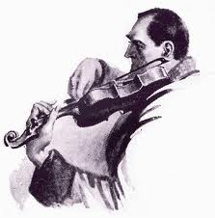

Oscar Wilde Communicates
with Sir Arthur Conan Doyle
via Ouija Board

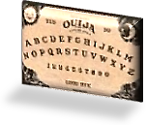
Willow-Ware Cup and Ouija Board
Sir Arthur Conan Doyle and a Visitant

Now that I am fully conscious of being deceased, I look about for something
to do. As spirits somewhat adrift in Purgatory, bored in the Afterlife, full
of taedium mortis in what Tibetan Buddhists call the ‘Bardo’ state,
Gabriel and I decide, like the famous ape, to try conclusions—conduct
an experiment, that is: attempt to communicate with the elusive Living.
♫

Scene: An astral version of Gabriel’s house. Our act of biomancy is performed
within a magic circle: a Great Wall of Blue China—many a vase. Time: 6 July, 1930.

1.
To live up to the Blue Things, one
Must sometimes play the genteel shaman,
Gabriel, wielding with aplomb an
Arcane device. That’s how it’s done.

A piece of china we shall use,
And blue it shall be. We’ll turn up-
Side-down this willow-ware tea cup;
Its divinations will amuse

Us, I am sure, with their divine
Presumption, like an immature
But charming wine, brash and cock-sure
As those who, furthering their design

To trump up business with romance,
Invented Chinese legends, tales
For English designs, puffing sales
On the Free Market Sea. Let’s glance

Back at these fictions. As you know,
One of them is a fine love story,
The other a vision of calm glory.
Let’s see. How does the first one go?

2. First Version: The Persecuted Lovers

A Mandarin’s daughter falls in love
With his accountant, who, alas,
Is of the lowly servant class.
The father hardly would approve

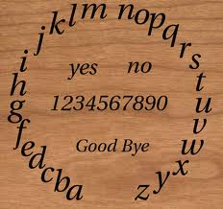
The marriage, nor would ancient law.
This strict man builds a fence around
His daughter’s quarters. Ways are found
Around one they still hold in awe,

For love twice-dear is love forbidden.
So the young, loving couple dare
Elopement, to an island fair.
For years they live there safely hidden.

But by her father she, Koong-See,
Has been pledged to a Duke; he, spurned,
Vengeful, their whereabouts once learned
To the island sends his soldiery
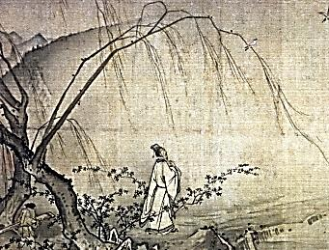
Where in their house they trap the pair.
Their two melodious songs are muted,
By fire the lovers executed.
The gods who made them young and fair

Transform them into turtledoves
Flying above the willow tree,
Beside the temple, can you see?
And note the bridge that for their love’s

Sake they traverse into as fair
A Paradise as ever was
Doomed to be lost at length, alas,
A splendid lie to sell a ware
Milton filtered through Thomas Minton?
In eighteenth-century England, dear!
China? There’s no such thing, and there are
Certainly no such people. (Where are
Paper and pen? We’ll need them here.) So I deny the existence of a second Far
Eastern nation of some importance. Languid
Conqueror, your Empire is expanding!

3. Second Vision: The Persecution of the Monks

My Irish soul weeps as I tell
Of Shaolin Monastery, rased
By the Manchurians, who, amazed,
See monk souls pass out of that Hell

Of smoke and flame and in a boat
Fare to a lovely Blessèd Isle.
There, on a bridge, with tranquil smile,
Three Buddhas greet them as they float
To safety’s shore: the Buddha Past,
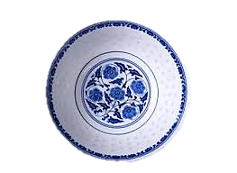
Buddha to Be, Buddha Who Is.
Behold the City of Willows. Bliss!
All shall drink tea, with a repast

Of little rice-cakes; all shall steep
Therein the airy delicacies
And dream a thousand histories
In an eternal Safety’s keep.

*

Thus there has been, more recently,
Stamped on bald porcelain the myth
That the motifs so monkeyed with
Revived a style which destiny

And clever monks had from perdition
Preserved. Of course, those soaring birds
Are the monks’ souls. No human words
Convey the beauty of this vision.

Though by a magic lantern cast
Upon a bedroom wall, the limelight
Wherein we dip our souls is time-light,
Sublimely present-future-past.

Golo goes riding o’er the brass
Door-knob, and there floats Genevieve
In the window, and two doves grieve
Upon a polished looking glass.

The legend of a legend, twice
Removed from real, concocted late,
Their never-love they celebrate
For ever on a floe of ice.

4.
Come, Gabriel, we shall attempt
To commune with the living through
The Ouija Board, that Manitou
Whose punctuation’s so unkempt.

We shall start by contacting my
Long-suffering scribe, good Arthvr V,
Who has persuaded Arthur C Sir Arthur Conan Doyle, member
To take part in the Mystery. of the Society for Psychical Research.
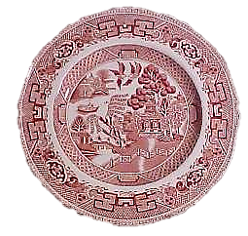
But though we are brave, and have the will, oh where
Is that we seek, which way is true
North, which is the right path thereto?
We’ve map and compass. We’ve a willow-ware

Cup that the surface over-flies
Like the Dove called the Holy Ghost.
From Cadmus’ teeth hath grown an host
Of silent-speaking shapes. There lies

In front of us, to be less vague, a
Fine smörgasbord assortment of
Letters, ox-א to marked ת, Pronounced ‘aleph’ and ‘tav’.
A to Zed, Α to Ω. ‘Alpha’ to ‘omega’, of course.

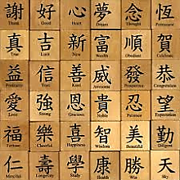
And just in case one day we need them,
The Chinese characters… A storm
Of hieroglyphs, cuneiform
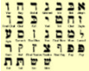
Wedges—if only we could read them!

Spirits dwell in them, as in crypts.
You surely know an Orientalist—
Some Eastern-mystic transcendentalist—
Who can translate the obscurer scripts?

5. Gabriel

Just write them down as best you can,
Oscar. The spirits are urbane
Enough not to befuddle a brain
With words a philologian

Alone could disentangle of
Their sense. Take notes, and use them later
When you become the explicator
Of what comes from beyond, above,

Or who the Hell knows bloody whence?
Even the Sibyl had to edit
Her Leaves, when, to maintain her credit
Amid the swift flow of events,

She made adjustments, day to day,
Small retroactive emendations…
To make precise prognostications,
The clairvoyant must be au fait.

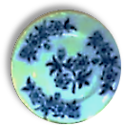
And when it comes to what’s to come,
She is the queen of having it
Both ways, whom years have taught to split
The difference ‘twixt Yes, No, and dumb.

When a great general asked her whether
He ought to wage a war abroad,
DOMINESTES was what the Bawd
Of Wisdom answered. Yes together

With No, according to the grammar:
Domine stes means, Master, stay. My alternatives during the Trials…
Domi ne stes means, Go away.
She is a clever hussy, damn her!

6. Mr V ‘Comes Through’ How do the dead communicate with the living?

Sir Arthur will be with us soon.
He said he would be late… No doubt
With Holmes he is out and about
Sleuthing by the light of the moon.
You have convinced me that the dead
Are able to invoke the living.
But how and why? All this is giving
Some trouble to my muddled head.

It was Josiah Wedgwood’s son,
Thomas, who gave us the sun-print, In the 1770’s.
Light stamped on silver nitrate. (Hint
Of photographs to come.) Thus on

The psychically sensitive plate
Of the mind ghostly light may stamp
A sort of moon-print. That pale lamp
Is the ghost of the sun. The weight

Of moonlight is a feather’s touch.
It is the light ghosts see by, since
Their day’s our night. Thus like the prints
Of ghost-light, like the indelible smutch

Of a dead thumb, my words impress
Themselves in silver on your mind,
A firefly-phosphor, yet a kind
Of radiance, nevertheless,
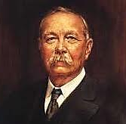
And like the stamp of willow ware
Are they, the pattern of a myth,
Sad legend one may conjure with
Of what’s no longer ‘really’ there.

Ah there he is! Sir Arthur’s here,
And says he quite looks forward to
Conversing once again with you.
Well, Gabriel, coraggio! ‘Steer’

The magic cup. Whilst my left hand
Rests upon yours my right will set .
Down what you spell. So we shall get
Intelligence of Terra Land.
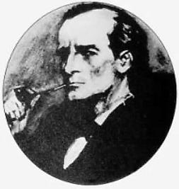

7. The Letters Assemble: Sir Arthur Speaking

I AM SO PLEASED TO TALK WITH YOU
AGAIN OSCAR OH HOW YOU CHARMED
AND DAZZLED WHEN WE MET DISARMED
ENTIRELY WHAT COULD I DO

BUT LET YOU DO THE TALKING AND
TO LISTEN AS ONE LISTENS TO
MOZARTIAN MUSIC IN A NEW
TONALITY I’D SHAKE YOUR HAND

IF HANDS COULD REACH ACROSS THE ETHER
OR WHATSOEVER ELEMENT
ACTS AS STUBBORN IMPEDIMENT
TO THE TWO WORLDS’ COMING TOGETHER

I HAVE MET MANY BRILLIANT MEN
AND WOMEN NONE BUT YOU WAS QUITE
SO MUCH A GENIUS AND HOW BRIGHT
IS OUR GOOD MR V! AND THEN

THERE IS THE GENIUS BESIDE
YOU THE GREAT PAINTER-POET WELL
MET MY DEAR DANTE GABRIEL
I’M TEMPTED TO GO RUN AND HIDE

MY HERO IS AN AMATEUR
AND HARDLY AU COURANT IN MATTERS
SO RECONDITE AS YOU MAD HATTERS
ARE TRIFLING WITH WITH SUCH HAUTEUR
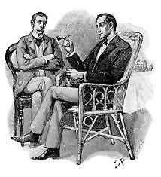
AND GENIALITY AND SENSE
OF FUN THAT THE AFTERLIFE SO SOMBRE
AT TIMES YOU SOMEHOW DISENCUMBER
OF ITS OLD BURDENS BUT OLD FRIENDS

MOTHER AND GALLANT SON ALL GONE
NO ART RECUPERATES THESE LOSSES
NO MATTER HOW HIGH THE SOUL CROSSES
OVER THE FATHER GRIEVES ALONE

MY HOLMES IS BUT A REASONER
WHO SOLVES SMALL PUZZLES WITH PANACHE
HE’S EARNED ME QUITE A BIT OF CASH
I’M HERE TO BE A LISTENER

It takes a genius to create
A genius. This much you have surely
Done. Tut, tut, you speak too demurely
Of what in its own way is great!

Now Holmes’s keen, mercurial mind,
Its quick, athletic causal leaps
(Hare busy whilst the tortoise sleeps)
Bears strong resemblance, of a kind,

To mine, although empirical
In cast, and reasoning with facts.
None but the rare and strange attracts
His art, he sees the Beautiful

In its aspect of sinister
Disguise, grotesque yet commonplace
Detail, the evil-boding face
Wherein the heroic Reasoner

Reads danger, and divines solutions
To one of myriad mysteries London
Teems with, ills done and somewhat undone
When given elegant solutions

In a detective tale’s sharp focus.
(An Irishman in all but birth,
You are a man of sterling worth.)
Yes, with his sober hocus-pocus

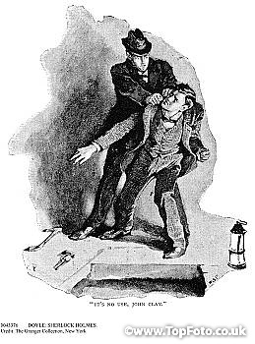
Holmes is an artist, as an actor
Only by Irene Adler bested
In cunning and disguise, invested
In proletarian guise, as factor,

Navvy, old beggar on the docks…
And yet he takes cocaine and smokes,
And all the scales fall as he strokes
His violin, and truth unlocks.
♫

8.
MY HOLMES DID FEEL THE INFLUENCE OF
YOUR DANDYISM ISN’T THERE
A HINT OF DORIAN GRAY SOMEWHERE
IN THE HOLMES SAGA NOT ENOUGH

‘GRAY’ MATTER TO RECALL IN WHICH
STORY IT WAS I THOUGHT YOU ILL
IT WAS BEYOND YOUR POWER OF WILL
THE SICKNESS EVEN MADE YOU RICH

And poor. AH BUT THAT MRS SMITH Hester Travers Smith in her book
DIDN’T SHE HIT YOU OFF OLD BOY Psychic Messages from Oscar Wilde.
IT WAS AUTHENTIC WHAT A JOY --[Mr V]
TO READ YOUR LIVING WORDS A myth!

A lie! Self-propaganda! Sorry,
Dear Arthur, that was an uncalled-
For outburst. You must be appalled!
When will you write another story?

Late in the night, when all alone, and oil
Burns in the bedside lamp, ah, there’s
No cure for common, carking cares
Like settling in with cozy Conan Doyle!

I HAVE A BIGGER FISH TO FRY
IT IS THE URGENT QUESTION OF
THE AFTERLIFE OF THOSE WE LOVE
WHAT HAPPENS TO US WHEN WE DIE

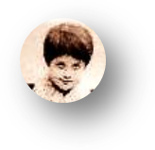

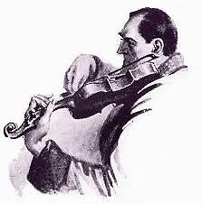
9. But Sir Arthur Remembers More Details

YES HOLMES GREW MORE EPIGRAMMATIC
AND YES NOW I REMEMBER YOU
ARE THADDEUS SHOLTO THE TOO-TOO The Sign of Four (1890).
AND WHAT’S MORE SINISTER AND DRAMATIC —[Mr V]

HOLMES TAKES A PAGE FROM DORIAN ‘The Adventure in the
USING A DOUBLE OF HIMSELF Empty House’ (1903).
OF WAX TO FOIL THE EVIL ELF —[Mr V]
FROM IRELAND, THE OUTCAST MAN,

MORAN I THINK HIS NAME WAS YES
SEBASTIAN MORAN ‘THE WILD BEAST’
So you have gone and made a feast
Of my dishonoured corpse? Confess!

WELL I DO GIVE YOU CREDIT AS
THE ARTISTE WHO SCULPTED THE MADAME
TRUSSAUD-HOLMES OSCAR ‘S HIS FIRST NAME
HIS LAST? I FORGET WHAT IT WAS

OLD BOY MEMORY SO FREQUENTLY
FAILS ME OF LATE IT IS THE DEAD
I CAN RECALL ONLY THE DEAD
AND I AWAIT ETERNITY

Well, Gabriel, what do you think
Of all this? What? I did not see
Lizzie. Where is she? Where is she?
You’ll see her, rub your eyes, and blink. Alas, his eyes, dim with chloral,
see nothing. They well up with tears.

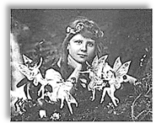
10.
HOUDINI’S FALLEN OFF HAS DROWNED
IN THE STEEL CHEST OF A CLOSED MIND
NO CLAIRVOYANCE COMES TO EYES BLIND
AS SAMSON’S SCEPTICISM-BOUND

I HAVE EXAMINED WITH THESE EYES
THE FAIRIES IN THE PHOTOGRAPH
LIGHT DOES NOT LIE THE SCEPTICS LAUGH The Cottingley Fairies, larking
BUT YOU ARE PROOF THAT NO ONE DIES about in this 1917 photograph.

11. The Great War and the ‘Occult’

After so many shameless years
Of carving up the world like an
Enormous piece of marzipan
(One made of blood, sweat, gold, and tears)

It had to come, the time when they
Would fall to carving up each other,
Brother eat Continental brother,
And the great beast of Empire prey

Upon itself, wolf universal.
For this apocalyptic farce
The previous European wars

Sir Arthur did not live to tell the world
of this psychical encounter. He died
of a heart attack the very next day
(7 July 1930). I trust he is with
his son, Kingsley, who was killed in
the Great War, and with other loved
ones long lost.

Have been but tentative rehearsal.

CATASTROPHE THE GREAT POWERS FELL
INTO LIKE SLEEPWALKERS WITH NO
MORE REASONING THAN THAT OF SLOW
FESTERING BOILS THAT SWELL AND SWELL

TILL THEY AT LAST EXPLODE IN BLOOD
THROUGH THEIR OWN INNER TENSION BOILS
Of greed for those colonial spoils
That dragged all Europe through the mud

The Lads were really all such splendid
fellows indeed it never should
have happened for what earthly good
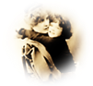
IN THE AFTERLIFE THIS MUST BE MENDED

12. A Spirit Appears

The armies of our grief and loss
Are lighting astral switchboards up
The apocryphal-yet-real teacup
Is moving fretfully across

The letters Garbled telegrams
Dead letters destined to be lost
Like the lives of our sons who crossed
The Channel sacrificial lambs

TO FEED THE CONTINENTAL MADNESS
OH NEVER IN THE HISTORY OF
THE WORLD HAVE THERE BEEN GRIEF AND LOVE
ON SUCH A SCALE SUCH WIDESPREAD SADNESS

Aching, bewildered desparation!
His appearance alternates between that
of the child I loved and the grown man,
in a blood-soaked uniform, hiding his
face—and I know why! I know why!
Papa its Cyril sorry to
break in like this Cyril, it’s you?
those years and years the separation

I miss you better late than never
we meet again are you upset
you cant speak better to forget
good bye papa you were so clever
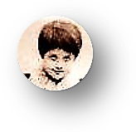
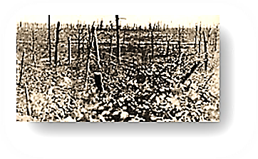
♫
Mr V and I
Astral Travel

1.
Your absence haunts me. It sounds queer,
I know, but I feel quite chagrined.
You are intangible as the wind!
How strange to switch from there to here

And then to now so quickly in space
And time! Death has its privileges.
We ghosts can move with startling ease
From age to age and place to place.

We fly, as ‘twere, on conscious wings—
Or drift, or float, if minded to.
Still, hawk-like, I return to you.
You must have seen some wondrous things.

2. My Travels

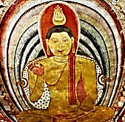
Ah, let me tell you! I have seen
The tawny Ceylonese sunrise
Through a tea-planting girl’s sloe eyes;
Have watched the Nile, swift, emerald-green,

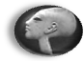
Surge past the ruins of the sacred
City that Akhenaten built,
Muscling a wealth of fertile silt
Down to the shores where the waves break red

And purple beneath dying suns.
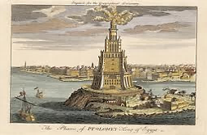
At Alexandria, deep under
The harbour waves, I’ve seen the plunder
Of time, the great stone blocks that once

Composed the wonder of the Pharos.
On high Mount Ida I have stood
Where Troy’s doom burned in the hot blood
And fateful judgment of young Paris,
And watched a Geisha girl in Kyoto
With exquisite composure pour
Tea for her warrior paramour
And pluck sad music from a koto.

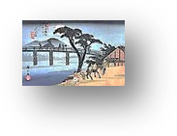
(In a pavilion on the way
Down from Mount Fuji I have seen girls
Make love to girls. This part unfurls
As a print by Hiroshige.)

With the Aborigines I trace
Song-lines, I join them as they sing
Into existence Everything
That IS, and gather it into place.
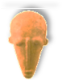
I have seen the Dogon dance delirious
To honour the completed spin
Of its mysterious hidden twin
Around the raging Dog Star, Sirius.

I’ve watched (as strange as this may seem)
From the moon, with these ghostly eyes,
A pearl of calmest blue arise
From darkness like a solid dream,

And only slowly recognised
It as our planet, lone and small
In the void vastness of it all,
A fragile thing ah, to be prized!

As fragile as blue china, and
As rare—which how shall we live up to,
Who drain the tea, and break the cup, too?
Leaving our stain on sea and land.

And sometimes Ruskin joins me there.
Tears fill his eyes, and the earth-light
Trembles in them. The rest is night
And silence, stars, and breathless air.

♫

Musical Program

Page 2

Guzheng: Autumn Moon Over the Calm Lake. (Performer unknown.)

Page 11

Collins and Leigh, Now You’ve Got Yer Khaki On. Sung by Marie Lloyd.

Page 13

Howard Blake, I’m Walking in the Air. Sung by Peter Auty.

Page 15

Bach, The Well-Tempered Clavier, Book I, No. 22: Prelude in b flat minor.

