***L’Enfant est le père de l’homme***

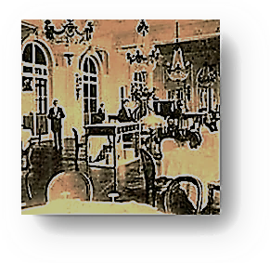

[♫](http://inmemoriamc33.com/saint_saens_vln_sonata_1_mvmt2.mp3)

**\* *Marcel and I* \***

***Reading Proust in Hell***

*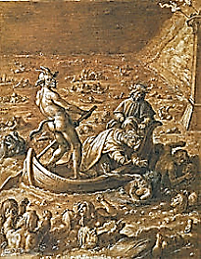**The foreknowledge of the Damned allows*

[♫](http://inmemoriamc33.com/debussy_sonata.mp3)

*me to read* À la recherché du temps perdu

1. *Café Inferno in its posthumous, complete edition.*

There *is* a restaurant in Hell,

But surly are the waiters there,

And dear the mediocre fare.

Much too well-done to be done well

Is the *biftek*; the wine is sour.

The strolling fiddler plays off-key,

And speaking to the maître-d’

Will gain you nothing but a glower.

For who is he but Malacoda?

He smears the patrons with his evil

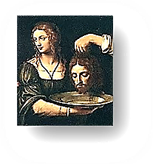 Gossip—a very devil’s devil—

And spits into your hock-and-soda.

No use to make a reservation:

He will not recognise you when

You and your party arrive. But then,

Why be surprised? This *is* Damnation.

Abandon all hope whatsoever

Of decent service. They’re so rude

They’ll keep you waiting for your food

*Garçon*, *you have kept the lady waiting for*

*nearly half an hour. You can be sure that she*

*will take up the matter with the management!*

(So it may seem to you) for ever!

The *tête de Jean* that the *garçon*

Brings, red froth at the lips, turned blue…

His eyes, though glazed, look up at you

Intelligently—*quel frisson*!—

Or *would* look, if they’d ever bring

The meal we have been waiting for

Since Eve bit the apple to its core!

Their tip will be as vanishing

As they are the instant you make vain

Gestures in their direction. Well,

What’s the use? One can hardly tell,

My Dears, to whom one should complain.

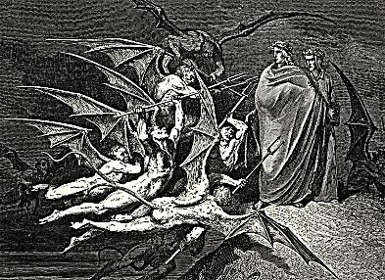2.

Though on my person all the rage

Of Malacoda’s gang were loosed,

I would continue reading Proust.

Prodded with prongs, I’d turn the page

(For the damned have foreknowledge, though

They do not read the newspapers),

Piqued by the Baron’s quest perverse

To know the lowest of the low.

And what more torturing rebuke

Could God deliver, what worse Hell

Than that bad business with Morel,

When ancient privilege’s peruke

Is snatched away by a blue-stocking?

For Madame Verdurin has turned

The youth against you, pride has earned

You, sir, a cruel and a mocking

Humiliation. One’s heart melts.

Were you so easy to outplay

On the chessboard of that soirée?

From there a short step to the welts

Upon the back, the paid-off lout,

The queenly progress through the Stations

Of long and lingering flirtations

With brothel-boys on the way out.

Charlus, stout, sadic old Narcissus,

Ah, how affectedly you talk

And oh, how gingerly you walk,

Nursing those angry, crimson kisses!

3.

Poor Palamède! What so obscene as

The spectacle of talent wasted

On pleasures stale as soon as tasted?

Old lion sporting with hyaenas,

What transformation have we here?

Charlus! Your shock of hoary hair

Is such, one can’t help but compare

You with the grizzled, mad King Lear.

What *três grande dame* whose painted face

Seems not at times somewhat macabre

In the light of a candelabra,

A death-mask shrunk and glued in place?

Down, down, brightness falls from the air

And, with it, rightness, fitness, thought

Of any but the wrong thing sought:

Plague take us, but we did not care!  *I think I was at least in part the model for*

*this lovingly sculpted Decadent, though most*

*insist it was the Baron de Montesquiou.*

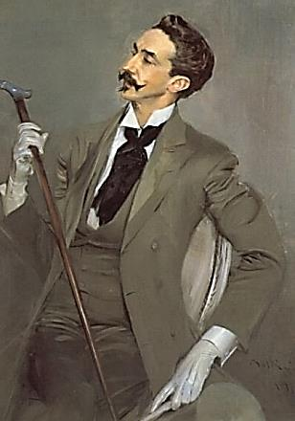 ***Meeting in the Afterlife***

*18 November, 1922. At this point I had already*

1. *fore-read the complete version of Proust’s great Book.*

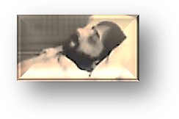As nervous as a fluttered dove

He flew to me from his death-bed

Tonight. I’m cradling his head.

I think that I may be in love.

Cannot a spirit put its mouth

To the mouth of a breathless ghost

And breathe a kiss into the lost

Soul till he wakes and is a youth? *He has shed the beard, the terrible beard*

*that grew upon him on his deathbed.*

2.

*Oh my poor stomach! What am I*

*Going to do? It’s killing me.*

[♫](http://inmemoriamc33.com/faure_cortot2.mp3)

Ah, *that* is a *fait accompli*.

But you cease dying once you die.

*Did you say ‘die’? What, am I dead,*

*Then, Oscar? You* are *Oscar Wilde,*

*Aren’t you? I recognise those mild*

*And dreamy eyes. I’m still in bed,*

*Aren’t I? Where is Françoise? I’ll ring*

*For her.* She will not come, Marcel.

It’s useless now to ring the bell.

You’ll only tire yourself, poor thing.

*The last three volumes, Oscar, oh!*

*They’re still unfinished, incomplete!*

*To come so far, and meet defeat!*

Your brother’s making sure that no

Such thing will happen to your Book.

My dear, have faith. He’ll see the last

Three volumes through the press. A vast

Fame will reward those pains you took.

*It’s true! Outside of time we dwell*

*Free in the present-future-past!*

*You are not as I saw you last,*

*Though. You did not behave so well,*

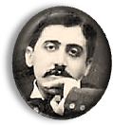*Oscar, beating that brusque retreat*

*At the sight of my parents there!*—

I *do* apologise, *mon cher*.

I was ungracious in defeat.

I had designs upon your person,

Ah, most particularly, dear.

The advance was blocked at the frontier,

The lie of things could only worsen—

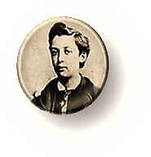*Say nothing more; I understand.*

*But you know, I am no forgetter.*

Beside you sits, I hope, a better

Oscar, holding your dear young hand.

3.

I think of your great Book, Marcel,

That *rêve de bonheur* made a fact

Through mercies of an artefact.

Again unto myself I tell

The tale of how dear Monsieur Proust

Learned how to write his story, now

*Our* story, as he lived it; how

He coaxed the Phoenix home to roost.

The Book ends at the point where you

Are finally ready to begin

The writing of that Book, and in

The Book, make a child’s dream come true.

4.

*A mind should line its hearing’s walls*

*With cork, and dive into the spell*

*Of reverie where the phantoms dwell,*

*And write no word whose note is false,*

*But, through the brakes of clause on clause,*

*As long and tortuous a way*

*As one must take to clear the fray,*

*Should struggle towards that hill-top pause*

*From which we see, in vast refrain,*

*The distance we have covered, hear*

*The church bells, and, resolved now, clear*

*And broad, the sentence becomes plain.*

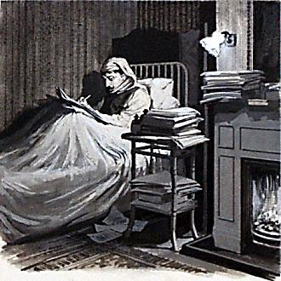*To spend much time with friends, to share*

*Their routine trivialities,*

*Is a sort of mental disease,*

*Almost like talking to a chair.*

*In each of us there is a flower,*

*A seed. Time is, will be, and was*

*Prenatal, present, posthumous.*

*I wove into my Book the power*

*Of Time to wither and make whole.*

*Stretched taut across the fourth dimension,*

*Every moment feels the tension,*

*Every detail. Time has a soul.*

*There are mementos that it keeps.*

*While clock-time marches like a guard*

*Before a tomb, and wears a hard,*

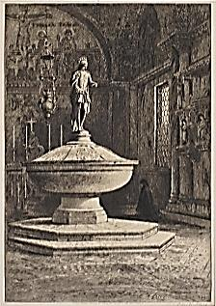*Precise expression, soul-time leaps*

*Nijinsky-like, stage-right or –left.*

*Time heals, much as the sea heals, over*

*The wreck it makes of friend and lover,*

*And leaves us all richly bereft.*

*Though vast and complex in its form*

*My Book is really but a dress*

*That I have pinned together, less*

*A structure than a coat to warm.*

6.

You wrote of life. I, an escapist,

Imagined things as otherwise,

Not as they were. I, in *your* eyes,

Must seem a high-aesthetic Papist.

*Oscar, you were a child of mood.*

*Avidity and appetite*

*Starved in you half your power to write.*

*What have you learned? What understood?*

You cut me to the quick, Marcel,

And why I never undertook,

Like you, the writing of that Book

Your questions show me all too well.

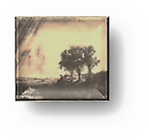*You built your personality*

*On a Narcissus pond (unstable*

*Foundation!) like Charlus, unable*

*To comprehend the enmity*

*His arrogant intelligence*

*Inspired,* says Marcel, his hand smoothing

My brow, which I find very soothing.

My dear, you make *transcendent* sense!

*You are a giant mayfly.* Of

What moment? *Everything you touch*

*You make less real.* Lie on this couch.

You look tired. *Jealousy and love…*

Come, dear Marcel, you’ll catch a cold!

Here, let me wrap my coat around you.

I am so lucky to have found you.

*Never again shall we grow old.*

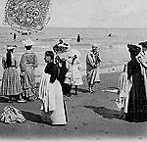***All my Albertines***

[♫](http://inmemoriamc33.com/hahn_offrande.mp3)

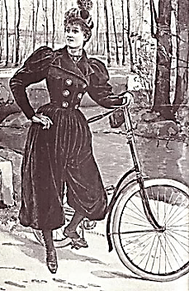

1.

[♫](http://inmemoriamc33.com/franck_zimerman_danczowska2.mp3)

I look back on my life, and see

The afterglow of a mirage,

A senseless bit of *bricolage*

With but the eternal mystery

Of failure to commend it, like

A tarnished badge. *Your* memory

Was a *triumphant* Mystery!

*Out of the dark, rare moments strike*

*A match that shows them as bright rooms*

*In which one moves about, assesses*

*The furniture, admires the dresses…*

*Like Scarbo when he shrinks or looms*

*To play Nightmare above your bed,*

*Time shifts our shapes: as Albertine-*

*Balbec, Gomorrah’s libertine,*

*Becomes the Captive, then the Dead.*

Anatomised, young Albertine

Your merciless jealousy exposes

Modeling in unconscious poses

Certain *laws*… All that fill your scene

Are cajoled sitters for a portrait

Self-caricatured by passing time,

Their features twisting as a rhyme

From an unwilling word is tortured,

As wisdom comes from jealousy

Inflicted by, let’s say, Odette,

Swann’s Venus whore—though Swann’s flaws set

The stage for that man’s tragedy.

But time is on *your* side, though bribed

There by that self-consuming fire,

The poet’s visionary desire.

Some antidote you had imbibed

Kept you young, and let you fill pages

With poetry within and poison

Without; you kept your marvelous poise on

A sturdy style built for the ages.

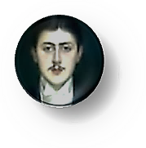What Swann lacked, richly you possessed:

Power to change from socialite

To high-aesthetic Stylite.

For literature you saved your best.

*All of my Albertines stood here*

*Beside me, crowding my mind’s eye.*

*‘Ah, I should like, before I die’,*

*I thought, ‘to make them all appear*

*Before my readers’ eyes for ever.*

*In doing so I shall discover*

*Myself compounded, of the lover,*

*Of the betrayed, in jealous fever,*

*Of the small boy and writer dying.*

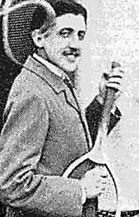 *They form the spectrum of the eternal*

*Human in me, and the diurnal.*

*Surely it is a thing worth trying,*

*Regaining our lost time in art!’*

*We chart time to the millisecond*

*But there’s a kind we leave unreckoned:*

*The clockless dream-time of the heart.*

2.

The last, perhaps the greatest of

Romantic masterpieces, yours,

With Pater and Ruskin one joined force,

And somewhere, dove-like, far above

These two, cloud-throned in the Oversoul

Itself, floats our good Emerson.

And you are also Wordsworth’s son,

Who recollect in words the whole

Tumult and outcry of emotions

In reverie and tranquility—

But unlike Wordsworth, wholly free

Of self-conceited moral notions.

You are a man of wit and charm.

Laughing, you strum the tennis racket,

Look natural in a dinner jacket,

And take your reader by the arm.

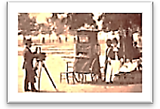In dreams and the gratuity

Of the *mémoire involuntaire*

You knew, because you *felt* the share

Of joy and healing sympathy

Building its music all around

The body and deep into the soul

In life’s worst sufferings, how the whole

Self is the Giant from the ground

Built up who rises into spire-

Pierced, wide blue reaches beyond size.

What has time written in his eyes?

*Elegy for a Child’s Desire.*

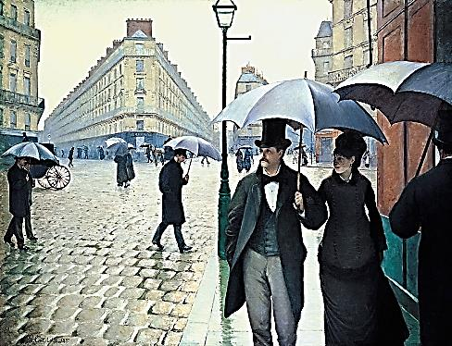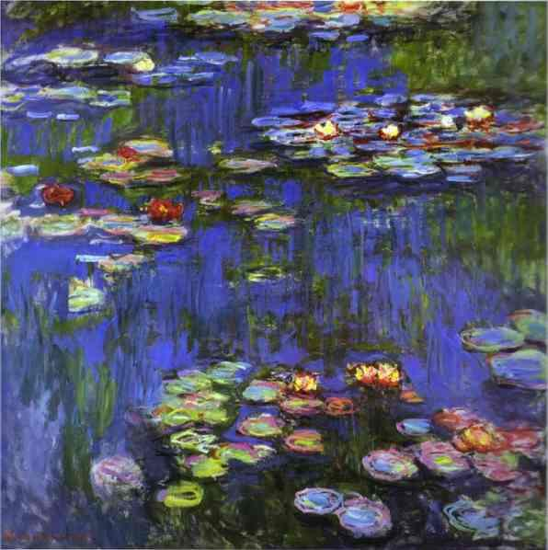

[♫](http://inmemoriamc33.com/faure_chanson.mp3)

[♫](http://inmemoriamc33.com/debussy_jardins_gieseking.mp3)

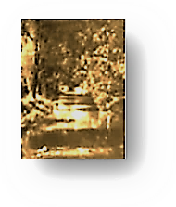***Marcel Takes Me to Combray***

[♫](http://inmemoriamc33.com/debussy_danse2.mp3)

1.

*My friend, you need a change of weather!*

*What if I took you to Combray,*

*For a walk on the Guermantes’ Way?*

*We shall be children there together.*

*For this Combray is located*

Dans le département de mon

Enfance*. The place itself is gone,*

*The church bombed, all the people dead,*

*But Combray* time *exists: it is*

*A place deep in my memory,*

*Dream-dyed, part of the sensory*

*Motor of my desire, my bliss.*

Then shall we go by motor car?

*Make sure the driver is discreet.*

*One never knows whom one may meet.*

Marcel, how singular you are!

Then let us go there, you and I,

To Combray, in a motor car,

I said.—And so we travelled far

Afield, ‘neath a memorious sky,

To Guermantes’ Way… Sweet were our walks

Past lily-pads afloat upon

The waters of the slim Vivonne.

How long and searching were the talks!

2.

*This river is the Lethe of*

*Remembrance. All the time lost, and*

*Things past, here take us by the hand.*

*And everything is what we love.*

*We walk like deer, with quiet plash*

*On grass, amid such plenty hushed,*

*Snuffing the scent of thyme, hoof-crushed,*

*And musts so heady they abash.*

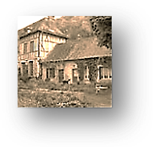*Did I not say the only true*

*Paradise is the paradise*

*That we have lost?* Regained? *A wise*

*Child knows to leave behind a clue*

*To lead him back, a trail of crumbs.*

*From all the places whence he came*

*The magic resonance of a name*

*Shines him a path, and home he comes.*

3.

Out of a cup of tea, a flower,

A garden, houses and a town

Spring forth and give, before they drown,

The taste and fragrance of the hour

Spent with long-dead, belovèd people,

Whom we shall never meet again.

With tea-soaked crumbs of madeleine

And pointing finger of a steeple

You build a shelter made of sky

For all the life that died beneath it,

For the blue breadth, which, as we breathe it,

Is counting down to nullity.

But as the days go winding down

A Book raised up amid the swell

Cherishes what is perishable

As a church steeple guards a town.

[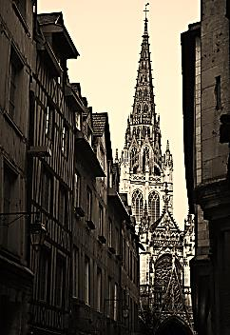](http://inmemoriamc33.com/faure_offertory.mp3)

[♫](http://inmemoriamc33.com/faure_sanctus.mp3)

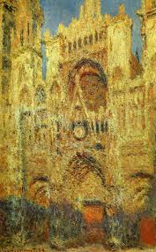

***I Take Marcel to London***

[♫](http://inmemoriamc33.com/faure_pq3.mp3)

Marcel, my dearest, come with me

To the magnificent capital

Of my spectacular rise and fall!

*Avec plaisir, mon cher ami.*

Then here is London, grim and grand:

Circle and Square and Bridge and Abbey,

Glorious, curious, or shabby,

And much of it was made by hand!

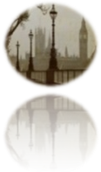

We’ll stare like peasants, all agog,

At the great Gog known as Big Ben;

A giant in a smoky fen

He’ll seem in the industrial fog.

We’ll take the bracing, sulfurous air

At Gardens Kew and Kensington.

We’ll look up at Lord Nelson on

His high perch in Trafalgar Square.

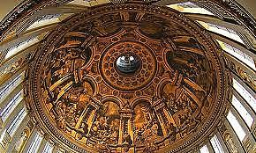

Old St. Paul’s, with its ‘dizzy top,’

Its Whispering Gallery, where sound,

Leaving the lips, runs circling round

And at the ears comes to a stop;

The hotel whose unwilling guest

So many a Personage has been,

The Tower, of course: *these* will be seen.

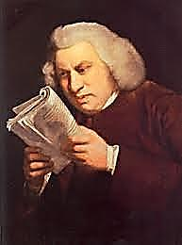And so much more, my dear! The West

End’s signs shine gaudy, luminous

Over the Theatre’s broad scene

Whilst down the streets of Golders Green

Go motor car and omnibus…

(‘Depend upon it, sir, when once one

Is tired of London, one is tired

Of life’. How *he* would have admired

Ellen Terry, my great good Johnson,

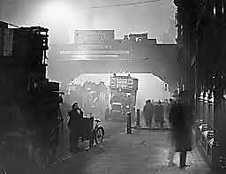Her style of acting and her figure.

‘But it will never do’, he’d sigh.

‘Gone are those halcyon days when I

Could ply Love’s sword with proper rigour’.)

And on into the Whistler fog,

Dimly a-glimmer, let us plunge,

From which a tall armed man might lunge

At you and, snarling like a dog,

Demand your life, or—favours… Fancy,

Dear, how enchanted and enchained

Charlus would feel, whilst a thug strained

At the barbed whip and called him ‘Nancy’

And spat upon in him in that room

Across from us, on the third floor

Of that brick house! Upon the door,

Then, shall we knock? No, let the gloom

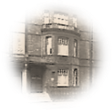

Swallow that *louche* establishment.

I have another house to show you.

I’m sure they will be charmed to know you,

My wife and sons. Ere I was sent

To prison by society,

I lived there. It is in Tite Street,

[*♫*](http://inmemoriamc33.com/faure_pq4.mp3)

Chelsea. They would all love to meet

You, if you care to come to tea.

*Oscar, I won’t do unto you*

*As you unto me! My exceeding*

*Good taste and my superior breeding*

*Remain intact; they bid me do*

*As you desire, and get to know*

*Your family, whom I’m interested*

*In, anyway.* Ah, she is dead,

Marcel, and Cyril is laid low

Upon the field of battle, slain.

*But, Oscar, they can live again,*

*Can come within your memory’s ken*

*And stand before you without strain*

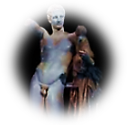*Or ceremony or formality.*

How Constance bites her lip! Her eyes

Are swollen. *Vyvyan is nice.*

*See them, Oscar, in their reality.*

*Is it alive, the sound, the feel*

*Of the creak in the hallway floor*

*As you creep in through the front door,*

*The twinge of guilt: does* that *seem real?*

*The Hermes there beside your desk*

*Bearing the infant god of wine:*

*Is he your Muse? Hermes, divine*

*Surrogate mother?* How grotesque

You make it sound! Where is the charm?

*You see no hint of parturition?*

*Should a mere herald on a mission*

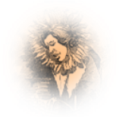*Dandle so fondly on his arm*

*The god of madness before Zeus?*

*I’d call his smile maternal, very*

*Protective and proprietary.*

Well, botany *is* rather *loose*.

There *are* self-pollinating flowers.

Male-and-female created He

Them in themselves. *Phylogeny*

*Repeats androgyny*. Ah, towers

The sunflower over all green glory!

(Constance attempts a smile. The boys

Are full of laughter, such sweet noise!)

‘Father, tell us another story!’

Cries Cyril. *Such a handsome boy!*

Exclaims Marcel. But Vyvyan,

Cyril and Constance have turned wan,

They fade, and with them, all my joy.

[♫](http://inmemoriamc33.com/faure_pq2.mp3)

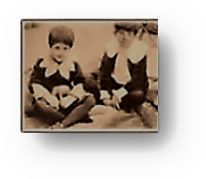

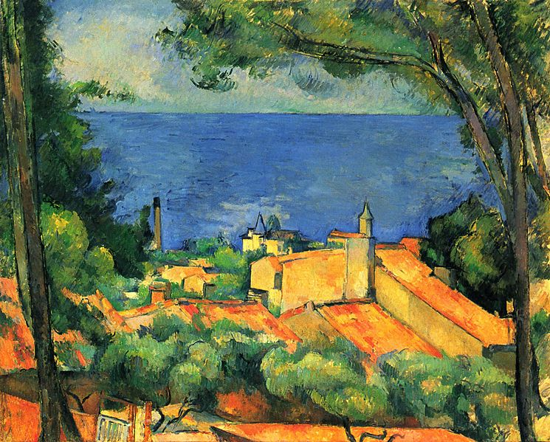

[♫](http://inmemoriamc33.com/faure_pavane_chorus2.mp3)

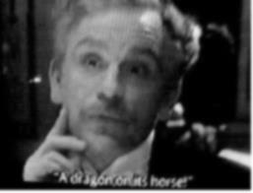***Poor Palamède!***

***A Vignette for Marcel***

*Le Baron de Charlus.*

The house, which is so proud to wear,

In its Saint-Germain cul-de-sac,

A faded old memorial plaque

To some illustrious forebear,

Lives only on the Nights of Nights.

Drawn curtains block the prying view

And freely all within pursue

Their private, intimate delights.

The evening, at this time alone,

Is endless: never yawns the dawn.

‘Neath lanterns on the high-walled lawn

There is much converse, one with one.

You burned intensely once among

Your circling satellites, dark star.

Now, how superfluous you are,

A stinging man who has been stung!

Morel to Madame Verdurin

Has consecrated his attentions.

Yours is the name that no one mentions.

You hear a passage from Chopin

The selfish young Charles has arranged

For violin. How he can play!

While you, a wilted old nosegay,

Furtively eye the youth, estranged

By stratagem, from outside in

The garden, where the fountain dowses

A tippler, and a dowager drowses.

Your smile has never looked so thin.

You are in Hell, poor old Mémé.

It is in you. The Night is endless.

You stand by the acacia, friendless

And fading gradually away.

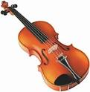***Tragedia dell’Arte***

[♫](http://inmemoriamc33.com/chopin_nocturne2.mp3)

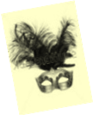 ***A Puppet Show for Marcel***

*We are in his bedroom in his Combray house.*

1. *Introduction*

You open for me that collage

Of photographs you have filed away.

They reassemble to display

Great Duchesses *d’un certain âge*

Who with their poses make a Masque

Wherein beneath the chandeliers

Come Questions to their eyes (with tears)

It only pains their hearts to ask.

The Question what is nobler in

The mind when Beauty, *déclassé*,

Falls to the ranks of yesterday;

The Question how it might have been

If she had followed her desire

When on the terrace, ‘neath the moon

She gasped, and fell into a swoon

To see in his dark eyes such fire.

Come, step into the Masquerade!

The part of ladies in old age

In ways so redolent of the stage

By comic actresses is played

That one is tempted both to smile

And weep, and certainly to say,

*Encore!* in one’s most genial way

To players of such practiced style.

[♫](http://inmemoriamc33.com/debussy_fetes_galantes_fantoches.mp3)

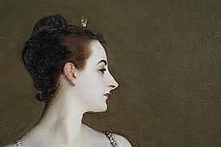

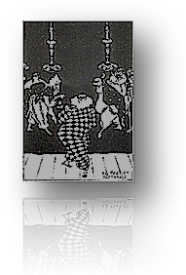2. *The Performance*

[♫](http://inmemoriamc33.com/stravinsky-_suite_no.2_-_harlequin.mp3)

Sciatic old Lord HARLEQUIN

Attempts a dashing cartwheel for

His entrance, teeters, hits the floor,

And hides his pain with a forced grin.

None of the troupe at this *soirée*

Makes sport of him: too tired, too tired.

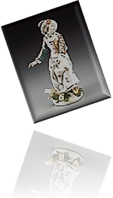 Though COLUMBINE, who once admired

[♫](ttp://inmemoriamc33.com/stravinsky_-_suite_no._2__columbine.mp3)

The stumbling tumbler, and still may,

Comes to his aid. His words are fierce

To the coquette, now *très grande dame*;

Down her white cheeks, with strange aplomb,

Doodle the black mascara tears.

Her with a hairy hand he thrusts

Aside, and through his monocle

Casts ogles at the beautiful

Young courtesan for whom he lusts.

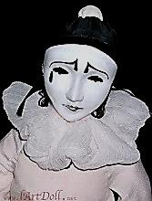

(Her glance, in turn, seems to appraise

*Him* as a rich though paunchy goat.)

[♫](http://inmemoriamc33.com/stravinsky_suite_no.1_for_small_orchestra_pierrot.mp3)

PIERROT, he of the wrinkled throat,

Gives Columbine a pitying gaze,

But has no heart to play the game

He used to play. The mandolin?

He gave it up. But he *is* in

The midst of writing, for his fame,

A lengthy novel, a *roman*

*À clef*, of sorts, and a memoir,

Luminous, with a tinge of *noir,*

Of a considerable élan,

Exposing for all time what Time

Has done to *them*, with all the paces

Still to be gone through, though with faces

Weathered, yet, in a way, sublime

Against the sunset fade-away

Of vices they must still pursue.

(And ah, what else ought one to do

At the anti-climax of a play?)

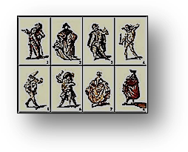3.

IL CAPITANO’s eye for *très*

*Jeunes filles* has grown myopic, dull.

Too weak to wax thrasonical,

He is thin, taciturn, and grey.

DOTTORE, garrulous as Brichot,

No longer writes his weekly column.

His laugh is empty, his eyes solemn;

His lucid moments come and go.

But *he* remembers, old Pierrot,

A *père* *Goriot* (oh yes, he married,

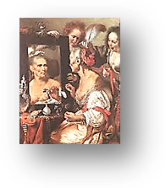 Is widowed and a father harried),

How he decried the long-ago

Gomorrhan love-play and carouse

Of Columbine and ZERBINETTA,

How he*, toujours jaloux*, once set a

Trap to expose them in a house

Of ill repute, but they escaped

And robbed the voyeur of his pleasing

Anguish. How it amused her, teasing

The swain whose hapless heart she scraped

Distractedly as with a heel

She scraped the floor in the champagne

Waltzes of yesteryear! The pain

She caused, but would not feel,

Returns now, as he gazes at her,

Shaped into unsaid sentences

He’ll write down on that desk of his

Tonight. Ah, what engrossing matter

Her lightness gave him, frivolously,

For contemplation, serious Letters!

Yes, she is one of the Forgetters.

But *he* remembers. So will we.

We will remember Columbine

Looking so queenly through her tears

At beauty stolen by the years;

What can one do but drink more wine?

4.

Then break the mirror, and burn all

Those *billets doux* the Spirit killeth,

Madonna of the morning, Lilith

By daylight, Eve at evenfall!

The shadows that grow round you are

The umbrage of a shelter for

A face close-up inspection, pore

By pore, would find as secular

As the yew bending over tombs,

And grimaced like a tragic mask

In the full horror of the task

Of dying in these crowded rooms

Where, in the last sciamachy,

The magic lantern shoots its rays

As flames along a paned bookcase

Flickering into obscurity.



[♫](http://inmemoriamc33.com/debussy_-_clair_de_lune.mp3)



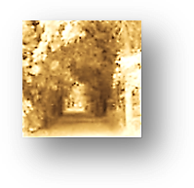***Farewell for Now***

Your soul is lighter than my own.

Why? *Happiness, fulfilled endeavour.*

Then will we see each other, ever?

You rise beyond me. I am alone.

*You are not fulfilled.* The Book… It’s true.

*Ascend the Purgatorial hill.*

*When you have reached the top, I will*

*Be waiting there to welcome you.*

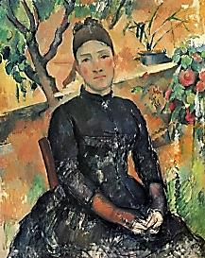Adieu, then, dear—but have you no

Time for one last, small glass of sherry?

It calls to you, your Sanctuary?

Good-bye, then. It is better so.

Go, go, it’s better that you go!

Your tie is crooked. Let me set

It straight. There. Now we must forget

Each other. Listen, soft and low,

*Maman* is from the Garden calling.

She has been waiting for you all

These years. Can you not hear her call?

Go, go, these partings are appalling!

[♫](http://inmemoriamc33.com/faure_berceuse2.mp3)

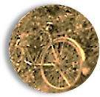

***Musical Program***

**Page 1, *L’Enfant est le père de l’homme* (title page)**

Saint-Saens, *Violin Sonata No. 1 in D Major*, Op. 75*.* I: Allegro agitato. Frank Peter Zimmermann, violin, Enrico Pace, piano.

This may or (possibly) may not be the famous “petite phrase” from the violin sonata by the fictitious composer Vinteuil in *À la recherche du temps perdu.* Several other real-life candidates have been suggested, including Fauré’s first violin sonata and Franck’s (only) violin sonata, as well as works by his friend and lover, Reynaldo Hahn. (Debussy may have been a general model for Vinteuil, but his the violin sonata appeared five years after the publication of *Du côté de chez Swann.*) From Susan Scheid’s [*Prufrock’s Dilemma*](http://prufrocksdilemma.blogspot.com/2012/08/will-real-vinteuil-sonata-please-stand.html)blog:

*The year before, at an evening party, he had heard a piece of music played on the piano and violin. At first he had appreciated only the material quality of the sounds which those instruments secreted. . . . But then at a certain moment, without being able to distinguish any clear outline, or to give a name to what was pleasing him, suddenly enraptured, he had tried to grasp the phrase or harmony—he did not know which—that had just been played and that had opened and expanded his soul, as the fragrance of certain roses, wafted upon the moist air of evening, has the power of dilating one’s nostrils. . . . This time he had distinguished quite clearly a phrase which emerged for a few moments above the waves of sound.*

 —Marcel Proust, from À la recherche du temps perdu, vol.1: Du côté de chez Swann

Many origins of the petite phrase have been put forward, including Franck’s Violin Sonata in A Major (1886) and Fauré’s Ballade, for piano and orchestra, Op. 19 (1881). However, Proust was unequivocal about the origin of the petite phrase: as he wrote to Jacques de Lacretelle, “the ‘little phrase’ of the Sonata—and I have never said this to anyone—is . . . the charming but mediocre phrase of a violin sonata by Saint-Saëns, a musician I do not care for.”

*Why would scholars keep searching for a source for this musical phrase if Proust identified it himself? And why would he, in the same breath, seem to cast aspersions on the composer of an idea that would have such profound ramifications for him? A possible source for both areas of confusion is a bit of autobiographical revisionism on Proust’s part. The cyclic theme that pervades Saint-Saëns’s Violin Sonata No. 1 in D Minor, Op. 75 (1885)—the very one that provided the inspiration for Vinteuil’s petite phrase—had earlier symbolized for Proust his passionate love for Reynaldo Hahn. . . . the memory of Saint-Saëns’s passionate sonata may have brought up a painfully acute remembrance of things past. (Byron Adams)*

From Alex Ross’s blog, [*The Rest is Noise*](http://www.therestisnoise.com/2009/08/):

What does Vinteuil’s Septet sound like? Scholars have suggested various sources: one passage or another might echo the music of late Beethoven, César Franck, Debussy, or Proust’s onetime lover Reynaldo Hahn. The chamber works of Gabriel Fauré may resemble most closely the cultivated, compressed music that Proust describes—in particular, the “violet mist” that Vinteuil summons with certain of his textures, “so that, even when he introduced a dance measure, it remained captive in the heart of an opal.” As for the Vinteuil Sonata, the description of the "little phrase" was originally pegged to Saint-Saëns's First Violin Sonata, the character of Vinteuil having been a late addition to the inaugural volume. Wagner also lurks behind the scenes. Jean-Jacques Nattiez, in his book Proust as Musician, notes that the narrator was originally supposed to undergo a series of epiphanies while listening to Wagner operas, but Proust then decided that Marcel should “experience his revelation through an imaginary work of art, for according to the logic of the novel a real work always disappoints: attainment of the absolute could only be suggested by a work that was unrealized, unreal, and ideal.” Thus, a passage that in an early draft was intended to describe the Good Friday Spell in Parsifal—“like an iridescent bubble that had not yet burst, like a rainbow that had faded for a moment only to begin shining again with a livelier brilliance”—was reassigned to Vinteuil. This blend of French refinement and German grandeur is, as Nattiez says, a blueprint for In Search of Lost Time

**Page 2, *Reading Proust in Hell***

Debussy, *Sonata for Flute, Viola and Harp*. III. Finale: Allegro moderato ma risoluto*.* Chamber Music Society of the Lincoln Center.

**Page 5, *Meeting in the Afterlife***

Fauré, *Dolly Suite*, Op. 56. I: *Berceuse*. Alfred Cortot, piano.

**Page 8, *Meeting in the Afterlife***

Reynaldo Hahn, *Offrande*. Text by Verlaine, originally entitled *Green*, from *Romances sans paroles*. (Hahn, a musician and composer best known for his songs.) The composer sings and accompanies himself on the piano.

Voici des fruits, des fleurs, des feuilles et des branches

Et puis voici mon cœur qui ne bat que pour vous.

Ne le déchirez pas avec vos deux mains blanches

Et qu'à vos yeux si beaux l'humble présent soit doux.

J'arrive tout couvert encore de rosée

Que le vent du matin vient glacer à mon front.

Souffrez que ma fatigue, à vos pieds reposée,

Rêve des chers instants qui la délasseront.

Sur votre jeune sein laissez rouler ma tête

Toute sonore encore de vos derniers baisers ;

Laissez-la s'apaiser de la bonne tempête,

Et que je dorme un peu puisque vous reposez.

Here are the fruits, the flowers, the leaves, the branches,

Here my heart that beats only for your sighs.

Shatter them not with your snow-white hands,

Let my poor gifts be pleasing to your eyes.

I come to you, still covered with dew, you see,

Dew that the dawn wind froze here on my face.

Let my weariness lie down at your feet,

And dream of the dear moments that shed grace.

Let my head loll here on your young breast

Still ringing with your last kisses blessed,

Allow this departure of the great tempest,

And let me sleep now, a little, while you rest.

Trans. A. S. Kline (with alterations)

**Page 9, *All my Albertines***

Franck, *Violin Sonata in A Major.* IV: Allegretto poco mosso***.*** Kaja Danczowska, violin, Krystian Zimerman, piano.

**Page 11, *All my Albertines***

Fauré, *Chanson d’amour* (“Song of Love”), Op. 27, No. 1. Text by Armand Silvestre. Barbara Bonney, soprano, Warren Jones, piano.

J'aime tes yeux, j'aime ton front,

Ô ma rebelle, ô ma farouche,

J'aime tex yeux, j'aime ta bouche

Où mes baisers s'épuiseront.

J'aime ta voix, j'aime l'étrange

Grâce de tout ce que tu dis,

Ô ma rebelle, ô mon cher ange,

Mon enfer et mon paradis!

J'aime tout ce qui te fait belle,

De tes pieds jusqu'à tes cheveux,

Ô toi vers qui montent mes vœux,

Ô ma farouche, ô ma rebelle!

I love your eyes, I love your forehead,

oh my rebellious and fierce one.

I love your eyes, I love your mouth

on which my kisses will tire themselves out.

I love your voice, I love the strange

gracefulness of everything you say,

oh my rebellious one, my dear angel,

my hell and my paradise!

I love all that makes you beautiful,

from your feet to your hair,

you to whom my hopeful pleas ascend,

oh my fierce and rebellious one!

Trans. Peter Low

**Page 12(Monet, *Water Lilies*)**

# Debussy, *Estampes.* III: *Jardins sous la pluie* (“Gardens in the Rain”). Walter

Gieseking, piano.

**Page 13, *Marcel Takes Me to Combray***

Debussy, *Danses* (*danse sacrée et danse profane*) for harp and strings. Ann Mason

Stockton, harp. Concert Arts String Ensemble, Felix Slatkin, conductor.

**Page 14, *Marcel Takes Me to Combray***

Fauré, *Requiem,* Op. 48. II. Sanctus. Atlanta Symphony Orchestra and Chorus, Robert Shaw, conductor. (Illustration on next page: Monet, *Rouen Cathedral*

*at Sunset*.)

Holy, holy, holy

Lord God of Sabaoth,

Filled are heavens and earth

with your glory.

Hosannah in the highest.

Trans. Nick Jones

Sanctus, sanctus, sanctus

Dominus Deus Sabaoth,

Pleni sunt coeli et terra

Gloria tua.

Hosanna in exelcis.

**Page 16, *I Take Marcel to London***

Fauré, *Piano Quartet No. 1 in C minor*, Op. 15. III: Adagio. Emanuel Ax, piano,

Isaac Stern, violin, Jaime Laredo, viola, Yo-Yo Ma, cello.

**Page 17, *I Take Marcel to London***

Ibid.

**Page 18, *I Take Marcel to London***

Ibid.

**Page 19 (Cézanne, *Bay of Marseilles, View from L’Estaque*)**

Fauré, *Pavane*, Op. 50. Text by Robert de Montesquiou. Chorus of l'Orchestre de Paris, Stephen Betteridge, director. Orchestre de Paris, Paavo Järvi, conductor.

C'est Lindor! c'est Tircis ! et c'est tous nos vainqueurs !

Cest Myrtil! c'est Lydé ! Les reines de nos coeurs !

Comme ils sont provocants! Comme ils sont fiers toujours !

Comme on ose règner sur nos sorts et nos jours!

Faites attention! Observez la mesure !

Ô la mortelle injure!

La cadence est moins lente! Et la chute plus sûre !

Nous rabattrons bien leur caquets!

Nous serons bientôt leurs laquais!

Qu'ils sont laids! Chers minois !

Qu'ils sont fols! Airs coquets !

Et c'est toujours de même, et c'est ainsi toujours!

On s'adore! on se hait ! On maudit ses amours !

Adieu Myrtil! Eglé ! Chloé ! démons moqueurs!

Adieu donc et bons jours aux tyrans de nos coeurs!

Et bons jours!

It's Lindor! It's Tircis! and all our vanquishers!

It's Myrtil! It's Lydia! The queens of our hearts!

How they provoke us! How they are always so proud!

How they dare to control our destinies and our days!

Pay attention! Observe the beat!

O the mortal injury!

The cadence is slower! The fall more certain!

We shall beat back their cackles!

We will soon be their stooges!

They are so ugly! Such darling little faces!

They are so foolish! Such coquettish airs!

And it's always the same, and so it shall always be!

We love them! We hate them! We speak ill of their loves!

Farewell, Myrtil! Egle! Chloe! mocking demons!

So it is farewell and good day to the tyrants of our hearts!

And good day!

Trans. Ahmed E. Ismail

**Page 20, *Poor Palamède!***

Chopin, *Nocturne in C-sharp minor*, op. posth. (arr. for violin). Midori, violin.

**Page 21,** ***Tragedia dell’Arte***

Debussy, *Fantoches*. From *Fêtes galantes,* by Verlaine. Véronique Gens,

soprano, Jeff Cohen, piano.

Scaramouche et Pulcinella,

Qu'un mauvais dessein rassembla,

Gesticulent noirs sous la lune,

Cependant l'excellent docteur

Bolonais cueille avec lenteur

Des simples parmi l'herbe brune.

Lors sa fille, piquant minois,

Sous la charmille, en tapinois,

Se glisse demi-nue, en quête

De son beau pirate espagnol,

Dont un langoureux rossignol

Clame la détresse à tue-tête.

***Puppets***

Scaramouche and Pulcinella,

brought together by some evil scheme

gesticulate, black beneath the moon.

Meanwhile, the learned doctor

from Bologna slowly gathers

medicinal herbs in the brown grass.

Then his sassy-faced daughter

sneaks underneath the arbor

half-naked, in quest

Of her handsome Spanish pirate,

whose distress a languorous nightingale

deafeningly proclaims.

Trans. Clara Claycomb

**Page 22,** ***Tragedia dell’Arte***

Stravinsky, *Suite No. 2 for Small Orchestra*. “Harlequin.” CBCSO, Stravinsky, conductor.

Stravinsky, *Suite No. 2 for Small Orchestra*. “Columbine.” CBCSO, Stravinsky, conductor.

Stravinsky, *Suite No. 1 for Small Orchestra*. “Pierrot.” CBCSO, Stravinsky, conductor.

**Page 26,** ***Tragedia dell’Arte***

Debussy, *Clair de lune.* From *Fêtes galantes.* Text by Verlaine. Véronique Gens,

soprano, Roger Vignoles, piano. (Illustration, next page: Collin Campbell Cooper:

*A Garden in Granada in the Moonlight*.)

Votre âme est un paysage choisi

Que vont charmant masques et bergamasques,

Jouant du luth et dansant, et quasi

Tristes sous leurs déguisements fantasques!

Tout en chantant sur le mode mineur

L'amour vainqueur et la vie opportune.

Ils n'ont pas l'air de croire à leur bonheur,

Et leur chanson se mêle au clair de lune,

Au calme clair de lune triste et beau,

Qui fait rêver les oiseaux dans les arbres,

Et sangloter d'extase les jets d'eau,

Les grands jets d'eau sveltes parmi les marbres.

***Moonlight***

Your soul is an exquisite landscape

charmed by masquers and revellers

playing the lute and dancing and almost

sad beneath their fanciful disguises!

Even while singing, in a minor key,

of victorious love and the good life,

they do not seem to believe in their happiness,

and their song mingles with the moonlight,

the calm moonlight, sad and beautiful,

which sets the birds to dreaming in the trees,

and makes the fountains sob with ecstasy,

the tall slender fountains among the statues.

Trans. Peter Low (with alterations)

**Page 26,** ***Farewell for Now***

Fauré, *Berceuse*, Op. 16. Renaud Capuçon, violin, Michel Dalberto, piano.