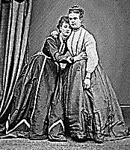
From Père Lachaise
The Good Victorians

I am asked about the Victorians’
1. Perverted England legendary (and alleged) prudery.

My Dears, don’t listen to that mush
About the good Victorians.
We did all that they do in France, Park and Boulton
But with a guilty cough, hush-hush. (Fanny and Stella).

Ah, sail the seas! You’ll find, in all
This wide world, no Tartufferie
Quite like the English variety.
I’ll give you a little roll-call.

One Arthur Munby, mysophile, Poet, journalist, photographer.
Was smitten by squat working girls
With brawny arms. For him the pearls
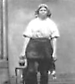
And the sophisticated smile

Of a young lady held no charms
Compared with dirty fingernails
And great red fists clutching slop-pails
And ah, those hairy underarms!

The library of erotica
Milnes kept would have made even Tiberius Richard Monckton Milnes, Baron
Blush. Wouldn’t he have waxed delirious Houghton, parliamentarian, patron
Over that pornocopia! of literature, friend of Swinburne.

Pocket-books cried up ‘Poses Plastiques’ Or ‘Tableaux Vivants’.
And ‘Foreign Language Schools’. (Of aught
Those cunning linguists might have taught
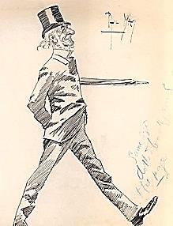
A modest tongue declines to speak.)

Gladstone would walk the streets, to try
And save his ‘fallen angels’. They
Had doubts about his motives: Hey!
They’d shout, Look, here comes old Glad-eye!

How often with a flail he scored
His naked back for thoughts of lust!
But how could punishment be just
That felt so much like a reward?

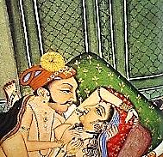
(My father-in-law, Horatio
Lloyd… Well, there were Uranian rumours,
Dears, and in one of his strange humours
He once ‘exposed’ himself, you know...)

The Suffolk docks FitzGerald haunted
Were full of strapping fellows he
Dreamed would fill up the vacancy
In him with all the love he wanted.

And Burton’s Kama Sutra, and Richard Burton, scholar, adventurer,
Young Swinburne’s whips and chains, and staid translator of The Arabian Nights
Old Ruskin’s girls: well, it all made and The Perfumed Garden, as well.
For a most interesting land,

Despite the Evangelical,
The Philistine, and our good Queen. Delicacy prevented the Parliamentarians
(For what could the word ‘lesbian’ mean from even mentioning the subject to
To one with thoughts so virginal, the Queen, and so lesbianism was not
covered in the Act I mention below.

Reared by a prude in isolation?) The dreadful ‘Kensington System’,
And what went on in public schools instituted by her priggish mother.
Was only a mystery to fools.
Think of the history of our nation:

William the Second’s gowns; Edward
The Second and Piers Gaveston;
King James the First. I could go on…
More recently, perhaps you’ve heard

Of the scandal of Cleveland Street, 1889, involving telegraph boys
Where in a shadowy house, boys would and some very high-born clients,
Eke out their incomes with a good including Lord Arthur Somerset
Side-line as prostitutes? They’d meet and, possibly, royalty, in the person
of Albert Victor, Duke of Clarence.

With gentlemen of a certain taste
And retire upstairs to their bliss.
The law knew something was amiss:
Arrests were made. A problem faced

The Crown, but it had strings to pull:
The poor boys received sentences,
But their distinguished clients? These,
Being rich, well-born and powerful,

Were handled with the softest gloves.
Some went abroad temporarily,
But all, Duke, Earl, and Royalty,
Went on pursuing their strange loves.

2.
An open secret, a dark fact
Was that the rich thought it their right ‘Droit de seigneur’, in medieaval parlance.
To exploit the poor. And still, despite
The Criminal Law Amendment Act, 1885. Under Section 11 (the Labouchère
Amendment) I was tried and convicted
A wealthy man felt free to dandle for ‘gross indecency with male persons’.
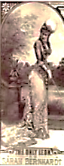
A small white-slave girl on his knee,
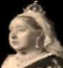
Most often with impunity.
When I was ‘caught’, and caused a scandal,

The system itself was compromised.
The Marquis threatened to expose
Uranians in high places; those
Men made sure I was sacrificed— ‘The only Léon’ as
Sarah Bernhardt.

A patriotic act, you see...
What, the Prime Minister in the dock?
God save the Queen from such a shock!
I took a bullet for Rosebery.

(And so was Palinurus culled

Henry Labouchère, MP, author of the ‘Blackmailer’s Charter’ (Section 11 of the Criminal Law Amendment Act) making acts of ‘gross indecency’ between male persons a crime punishable by imprisonment. A man, ironically, I much admired in my youth. He remarked, regarding the (maximum) two-year sentence I received, that he wished his legislation had provided for a longer one.

His comrades’ safety to ensure:
Unum pro multis dabitur
Caput. This law can’t be annulled.)

3. .
There is, as far as I can tell, an
Increasing tolerance for all sorts
Of love these days. But in the courts
Poor Uranus is still a felon.

We’ll win the fight, if we but dare. ‘Gross indecency’ is technically a mis-
Either the law, Dears, or the love: demeanour—small consolation to Oscar.
One of them must go. Time will prove —[Mr V]
The love’s not going anywhere

