* Yeats and I *
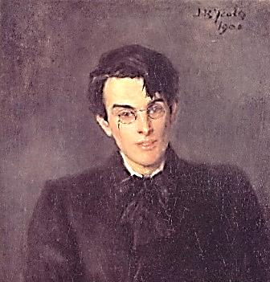

First Epiphany
A sort-of protégé of mine, lately a
student of soul-magic and member of
On Hermes wings of magic thinking the Hermetic Order of the Golden Dawn,
Across the astral plain I come appears out of the Celtic Twilight mists
To assist at your martyrdom, to comfort me in my cell in Reading Gaol.
The bitter cup that you are drinking.

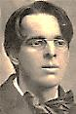
I read in the newspapers how
The prostitutes danced in the street,
As if a rival had met defeat:
‘He’ll ‘ave his ‘air cut reglar now!’

‘Give me The Winter’s Tale. What’s Lear
But poor life staggering in the fog?’
Do you recall your monologue,
Poor bare forked king? Whither from here?

No, not where science leads. Its knowledge
Increases unreality,
Cutting through every certainty.
It has no centre; it is all edge.

The undying Archetypes of Art:
You taught me these alone are real.
The truths that we both know and feel
Live in the educated heart.

What mythic role remains for you?
Hamlet-as-Scapegoat-Masochist?
The Man of Action who has missed
(Or found?) his moment? What to do?

It won’t be long. That’s understood.
And just as well. Whoever thought
That I could comb grey hair? (You ought
To use that line, Yeats. It’s quite good.)

If living seems a tedious task
Hereafter, a posthumous existence,
Suffer from an ironic distance,
Laugh at the world through your death-mask.

Yeats, I will bear the unbearable weight
And be gay, tragically gay.
You are the hero of the play.
Be stronger, colder than your fate.

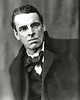
Second Epiphany

The child is father to the man…
The child in you made you the best
Of fathers. When I was your guest
I looked on as your six-foot span

Contracted to a crouched position
To play with Cyril and his toys.
You revelled in his raucous noise.
And then you granted me permission

To tell the child a fairy tale.
I, after several hems and haws,
Said: ‘Once upon a time there was
A giant…’ He let out a wail,

The frightened little boy, and fled.
You fixed on me a look of stern
Reproof that caused my cheeks to burn,
And my clean-shaven face turned red.

Though Cyril, being firstborn, was
Your favourite, you loved Vyvyan, too.
And yet, depriving them of you…
Why must they suffer for your flaws?

Imagine how things might have been!
But you grew scarcer, stranger, farther…
They watched that distant star, their father,
Into the utmost darkness spin.
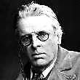
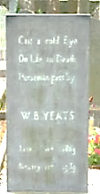
January 28, 1939
Death of Yeats

Yeats:
I took too little care of this!
Mosaic-stiff, hierarchical
Byzantium was my all in all,
Aristocratic dreams my bliss,

Disdain for lowly shepherds, scorn
For mere democracy, derision
Of any thought that was not Vision—
How ugly are the gates of horn

Through which a dream occult comes true.
The Nightmare clothes itself in steel!
The Focke’s gyre, the muddy wheel,
The barking columns marching through

The waste they make, and call it war!
Did I will this in dreams, do I
Bear some responsibility?
‘Love, and do battle’! There they are!

I can see past the temporal
Horizon far enough to say
The Malebranche are at play
In parachutes. (O second Fall!)

Rough beast born not in Bethlehem
But in the bloody bedlam made
Of Poland! The goose-step parade
Proceeds through Europe. Who will stem

The blood-dimmed tide? Don’t let your second
Sight trouble you too much. I think
This Malacoda’s doomed to sink,
When the final tally is reckoned,

Beneath the weight of his own evil.
Hell’s Valkyries will sniff their meal,
Stave in the door, though made of steel,
And back to his own natural level

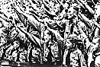
Spirit him on their wingèd horses.
The Antichrist, a small man, would
Be Satan himself if he but could,
And will be, till the free world forces

Back this subaltern to his real
And stinking place where he has rank,
Poking with fork the pitchy tank
Guffawing as the grafters squeal.
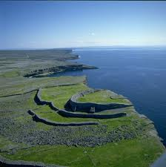
The Good Green Land
Yeats, Joyce and the Myst

1. The Song of the Faeries

Come home, Wilde Oscar, come home to the good green land of Eire!
Than your father Usheen you have wandered further and longer by far.
Great were your triumphs, and greater your trials! How sorrowful-weary
And haggard your face is, and your grey eyes, how haunted they are!
The unappeasable host, can you hear them, the legions of Faery?
And the lone pipe, and the wheels of Cuchulain’s battle-car?

Now really, that’s a bit de trop.
I’m not a Celtic Twilight man.
My mind is cosmopolitan—
Though I heard the sidhe-cry, long ago.

2. God is Crazy Jane

We both loved Beauty, Wilde, past right or wrong.
We knew the truth of masks, that without strife
Of contraries, as Blake knew, life is not life.
I’m no believer. Intellect is as strong

As its capacity for doubt. It can
And must remain a little sceptical
Even confronted by the Illimitable
In all its vast intimidating span—

To which a vast uncertainty responds
In kind: that, too, is infinite, because
The mind is so, being riddled by the loss
Incurred with every gain. How cast in bronze

Or fix for-ever in mosaic azure
And gold the hesitant and questioning
Gesture of so mercurial a thing,
Of all things the immeasurable measure?

My weakness and my strength, was my self-doubt:
It made me waver where the hazel-tree
Stood still, stand still when the horses of the sea
Bid me turn wave and join their tumultuous rout.

When Niamh, let us call her, spirit of Youth,
Invited me to live beyond all age
In the green land of the Young, I turned the page
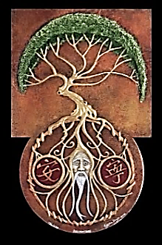
And read how one must wither into the Truth.

My verses were restless with a Celtic lilt,
For the heart that was in them was molten and fluid.
I gave to my dreams the names Rose and Druid
And saw the Druid vanish, and the Rose wilt.

God is a wanderer, too. Down in his least
Details he dwells, a beggar’s mask he wears,
And then a king’s. He climbs his winding stairs.
The Sexless Angel marries the Rough Beast.

The Intellect can never fully parse
That riddling grammar, speech of Crazy Jane.
Say God is wise, but Wisdom’s half-insane.
Our eyes see by the raging of the stars.

God is the Rose and the invisible Worm.
Riddle to riddle the truth-seekers range,
Seeking an island in the sea of change.
The island wanders, and the sea holds firm.

‘In dreams begin responsibilities’,
You wrote. Yet you were irresponsible,
In your heart’s core, and half-in-love with Hell.
That’s why I trust you. You stayed crazy-wise.

3. When I Was an Irish Rat Joyce McMocking.

I’ve not been so be-rhymed since old Pythagoras’
Time, when—it has been falsely claimed—I was
An Irishrat. It wakes the rhythmic saws
Of Slumber’s all it does, this Myst mandragorous.

To meet the Countess, you must walk away.
To write of Mother Ireland, move to France.
If that sounds too much like the old Romance,
Make sure to die in Switzerland someday.

We all must suffer our metempsychotic break-
Downs, be the worm, the tree, the bee and the clover.
In my next life I’ll be no more a rover,
But spend my days in the cottage by the lake.
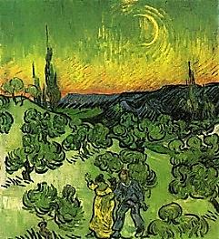
The Phases of the Moon
A Consultation with Yeats

What is it about Thirteen and Fourteen
That so compels me? They are where you are.
Or somewhere in between them: they are phases
Of the interior moon that guides and governs
The migratory movements of our souls.

So what the spirits said to George is true: Yeats’s wife. One of the fruits of her
The soul does have moon-phases twenty-eight— many automatic writing sessions was
Or is it twenty-six? At full and dark Yeats’s esoteric book, A Vision.—[Mr V]
There is no human life. In the twelfth phase
One lives and dies a hero’s rôle, like Nietzsche
Or Hector—even, a little bit, like you,
When your astounding folly gave your life
The royal purple of tragedy, perhaps
A little threadbare, and not quite your size.
You were, or you were meant to be, a man
Of action. Then, the action… So I am
Between the thirteenth and the fourteenth phase?
Your hero days are past. Weak as a worm
You have become, and there is war within you.
I read this in your ‘Phases of the Moon’:
‘The soul begins to tremble into stillness,
To die into the labyrinth of itself’.

My soul has trembled into stillness such
As you perhaps could not imagine, Yeats.
And I have died into the labyrinth
That is my self: it was an empty place,
And, like all empty places, full of ghosts.
And now I do it all again, the trembling,
The dying, the stillness and the labyrinth…
This time you can escape, to Phase Fifteen,
Where spirit and symbol become absolute,
And Choice and Chance are one. Here, in the realm
Of Poetry, vanishing is fulfillment.

Then, I suppose, I shall ‘pern in a gyre’.
And what will be your next phase, may I ask?
I lay them out before me like a pack
Of cards. I shuffle and reshuffle, and still
I cannot quite decide. What do you think?
I think you’d look quite dashing in a Twelve.

Please give my best to Mr Africanus. Yeats’s guiding spirit, Leo Africanus.—[Mr V]

