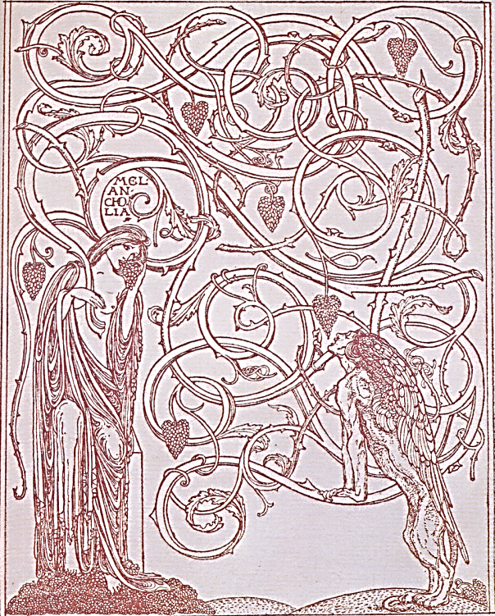
♫
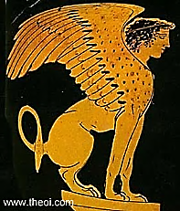
L’Appel du Silence

Paris is in my blood, in the air!
It draws me by remembrance of
Things past, and sweet, and gone. Above
The Channel I fly, and I am there.

In the Hôtel Voltaire (‘twas when Summer of 1874. Oscar’s
I had just won my Demyship) mother accompanied him
I let The Sphinx begin to slip to London, Geneva, and Paris.
Into existence through my pen. —[Mr V]

Was it for this I came, to see
Myself write the first draft of my
Fatality? No. I think that I
Have some quite other place to be.

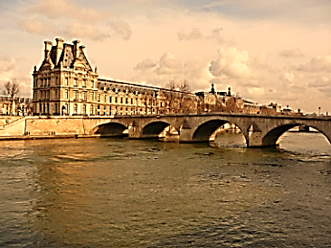
I walk in a distracted mood
And ask a man the time of day.
He looks right through me on his way.
Must these Parisians be so rude?

I should have asked directions—where?
The Pont Royal… Now, as once then,
It carries me across the Seine.
The Quai du Louvre… Where from here?

Along the Quais I go until,
At Boulevard Henri IV, I
Turn left. I do not know the why.
But my feet know the way. And still

Northeast I press, past roundabout,
Up boulevard and avenue,
Until at last I reach the Rue
Du Repos, and I do not doubt

The place on my right is the last
Place where so many are to be found,
To which I all along was bound:
The future that is now my past.

I walk into a haunted city
Of trees and statues and allées.
They have built here in Père Lachaise
Such monuments to useless pity,
One weeps with pity for such waste
Of beauty on the shores of death!
Children of stone, who hold no breath!
Oblivion honoured, grieved and graced.
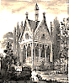
Here lie among the poplar trees,
And have lain for some thousand years,
The pair whose tale still wakens tears,
Poor Abélard and Héloïse.

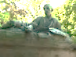
Propped on one elbow, Gericault
Lies on his tomb in his beret
With brush and easel, as if to say,
I stay; let others come and go.

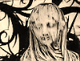
A child is standing all alone,
Her face behind a chiselled veil.
I weep, for she is small and pale,
I weep, for she is made of stone.

A woman sits, resting her head
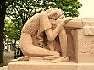
Upon her husband’s knees. She will
Not leave him, though the years pass, still
She grieves, though she is long-since dead.

With finger to his lips, a man
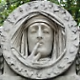
Appears perplexed in the extreme
That life should be a fleeting dream
And death of an eternal span.

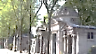
I turn left at an intersection
And stop short, for look! Just around
The corner, thrust up from the ground,
Two hands grope for the Resurrection.

And left now into Avenue
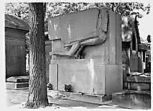
Carette, where, crammed in side-by-side
Like row-houses, yet dignified,
Tombs weather the endless tourist’s view.

My trepidation beckons me
Hesitantly towards a tomb
Of special mortuary gloom.
An angel guards it vigilantly.

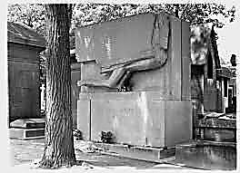
He is so familiar I weep
And so uncanny I am afraid.
The statuary is well made,
Solemn, and worthy of its keep,

Assyrian, hieratic, cold.
His eyes are closed, his mouth is shut.
He guards a secret, yes, but what?
ÆNIGMA is his name. How old

Is he, who hoards his message so?
One could grow old, counting the years.
Does the Angel of Pity shed no tears?
Riddle to which I do not know

The answer, could it be there is
No answer? Yes: it is ‘The Sphinx’.
The crossroads of all broken links.
Who are you? Cunning beast, is this

Your question? ‘Alien tears will fill
For him / Pity’s long broken urn.’
Who wrote that? Memories return
To me, return against my will.

The lines are so familiar.
And now I notice what I had
Not noticed, since it was too sad.
And says he: This is where you are.

But what are you? I am a child.
I am a man. I am an aging
Man, in my brain the fever’s raging—
I am dead. And I am Oscar Wilde.

♫

